 | Embassy of India  Ashgabat | 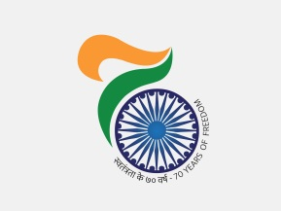

Embassy of India
Ashgabat

India participated in Cultural Exhibition at Islim Cheshme (Serhatabat)

On the sidelines of Ground-breaking ceremony of Afghanistan Section of TAPI Gas Pipeline Project on 23rd February, 2018 at Islim Cheshme (Serhatabat) a cultural exhibition depicting of handicrafts of the participating countries was organized. Embassy of India, Ashgabat put up pavilion in the exhibition displaying handicrafts items from India.
***
23rd February, Ashgabat

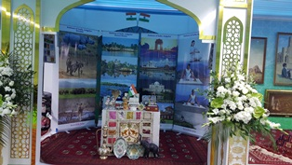

Indian Stand at the Exhibition

