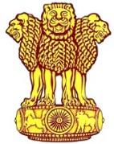 | Embassy of India  Ashgabat | 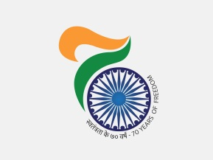
Visit of MOS (MJA) to Turkmenistan
H.E Shri M J Akbar, Hon’ble Minister of State for External Affairs arrived in Ashgabat on 21st February, 2018 to lead Indian delegation in 25th Steering Committee Meeting of TAPI Gas pipeline project on 22nd February, 2018 at Mary and to represent Indian delegation in Ground breaking ceremony of Afghan Section of TAPI pipeline project scheduled from 23rd February, 2017 at Islim Cheshme (Serhatabat), Turkmenistan.
Hon’ble Minister was received by Mr. Berdyniyaz Matiyev Deputy Foreign Minister of Turkmenistan on arrival to Ashgabat airport.
On the sideline of the visit, MOS called on to H.E Mr. Gurbanguly Berdimuhamedov, Hon’ble President of Turkmenistan on 22nd February, 2018 at Ruhyyet Palace, Mary.
***
23rd February, 2018, Ashgabat

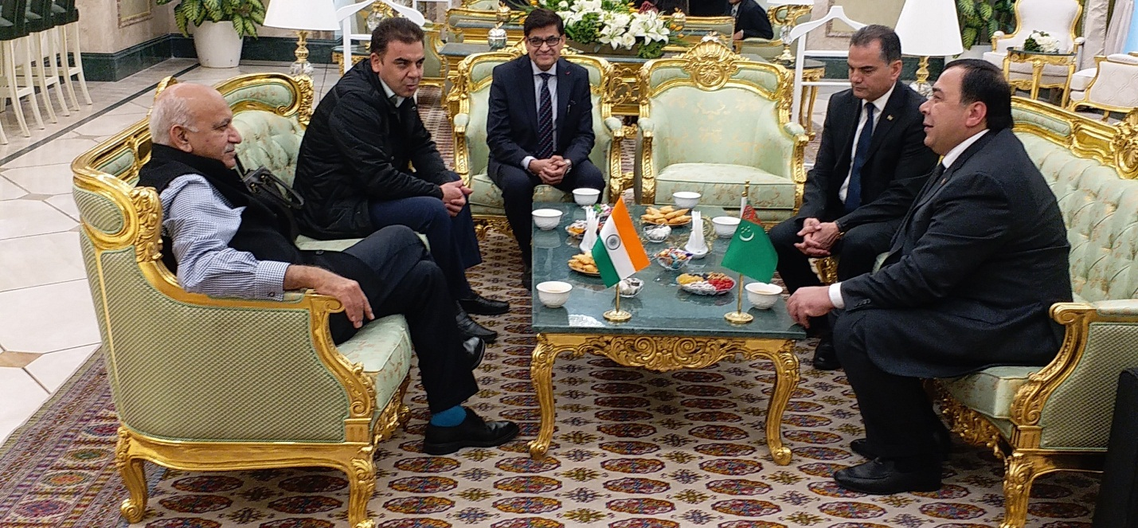

H.E Shri M J Akbar, Hon’ble Minister of State for External Affairs being received on arrival by Mr. Berdyniyaz Matiyev Deputy Foreign Minister of Turkmenistan on 21st February 2018 at Ashgabat

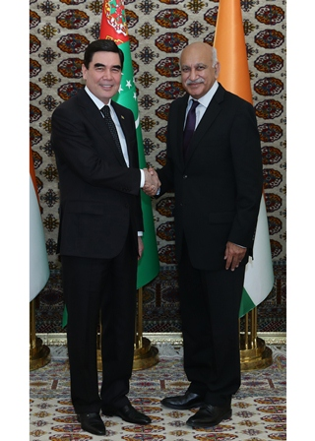
H.E Shri M J Akbar, Hon’ble Minister of State for External Affairs, meeting with H .E Mr. Gurbanguly Berdimuhamedov, Hon’ble President of Turkmenistan on 22nd February, 2018 at Ruhyyet Palace, Mary

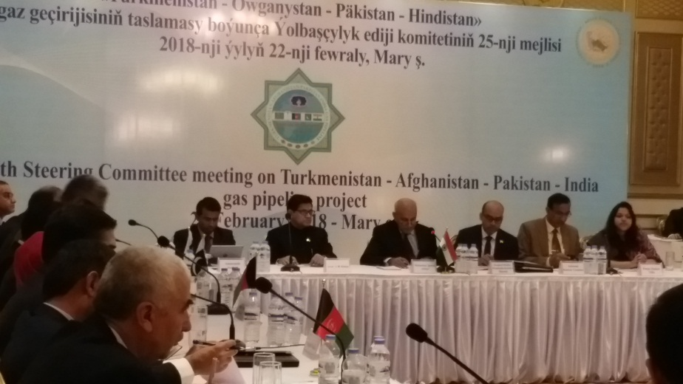
H.E Shri M J Akbar, Hon’ble Minister of State for External Affairs at 25th Steering Committee Meeting of TAPI Gas pipeline project on 22nd February, 2018 at Mary
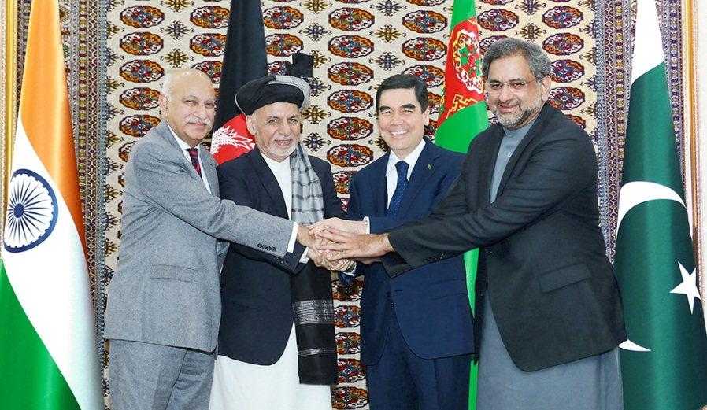
H.E Shri M J Akbar, Hon’ble Minister of State for External Affairs with Leaders of other participating countries at ground-breaking ceremony of Afghan Section of TAPI Gas pipeline Project on 23rd January, 2018 at Islim Cheshme (Serhatabat), Turkmenistan

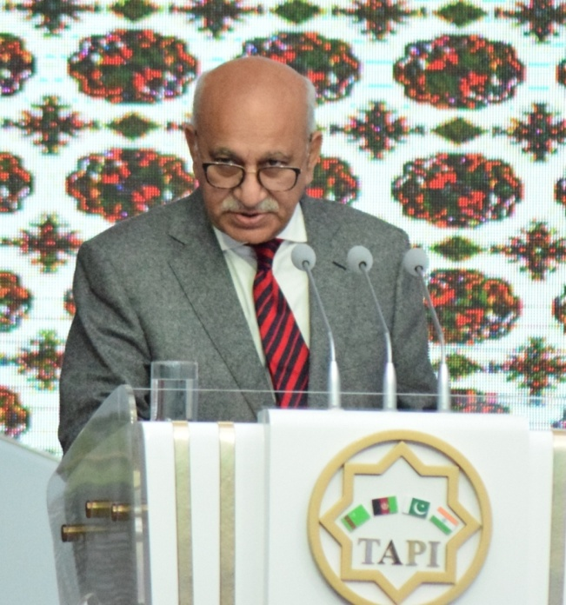
Shri M J Akbar, Hon’ble Minister of State for External Affairs addressing at the Ground breaking ceremony of Afghan Section of TAPI Gas pipeline Project on 23rd January, 2018 at Islim Cheshme (Serhatabat), Turkmenistan

***

