upper town deeped into the atmosphere of charming India
27 Aug 2017 16:33
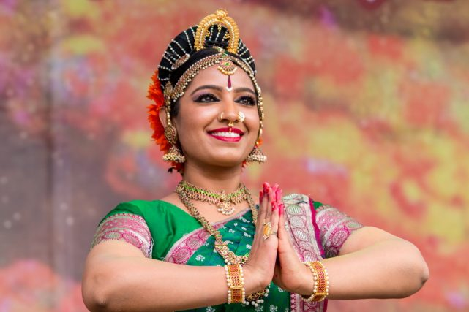

by: Alesia Zagorskaia
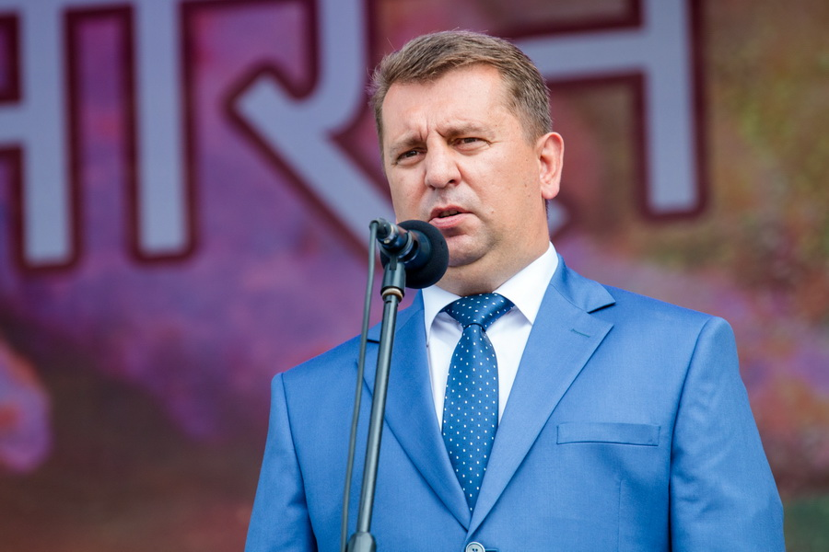
- Recently, the Upper Town has become not only the historical, but also the cultural center of our city. We host here days of national cultures. This time, the distant India is representing its culture. The Organizers promise a beautiful and rich program. I am confident that the holiday will become a vivid confirmation of the friendship between our countries, the Deputy Chairman of the Minsk City Executive Committee Andrei Domoratsky delivered a welcoming speech.
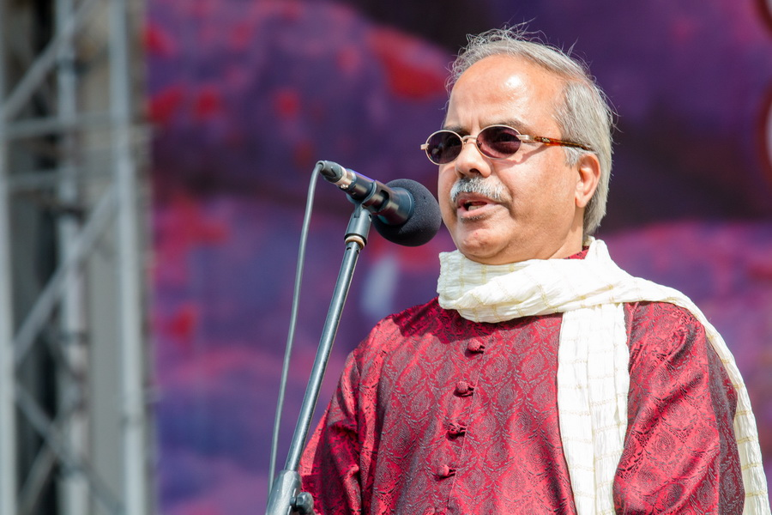
The Ambassador Extraordinary and Plenipotentiary of India to Belarus Pankaj Saksena underlined that the event is timed to the 70th anniversary of India's independence and the 25th anniversary of the establishment of diplomatic relations between India and Belarus. He thanked Minsk City Executive Committee, diplomatic representatives, pharmaceutical and tourist companies, who helped to organize this holiday.
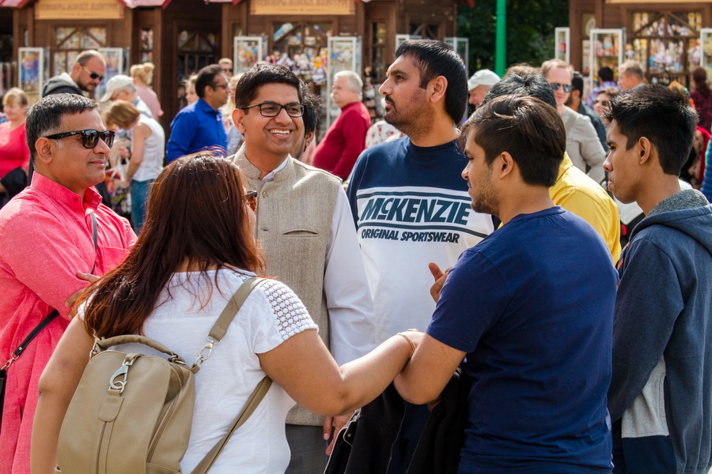
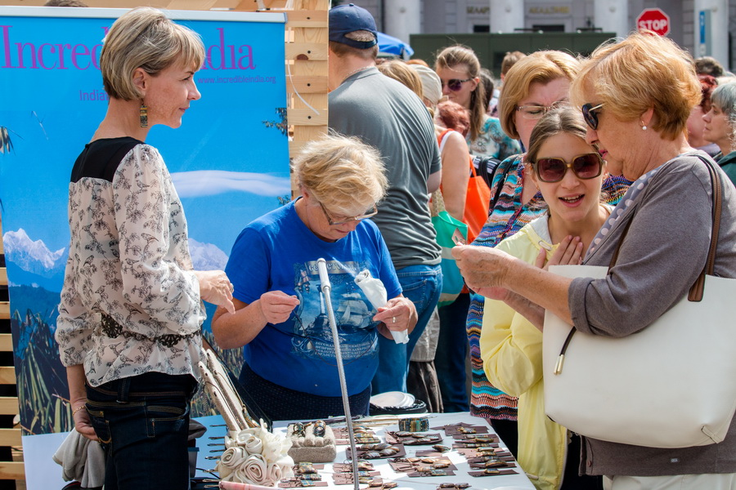
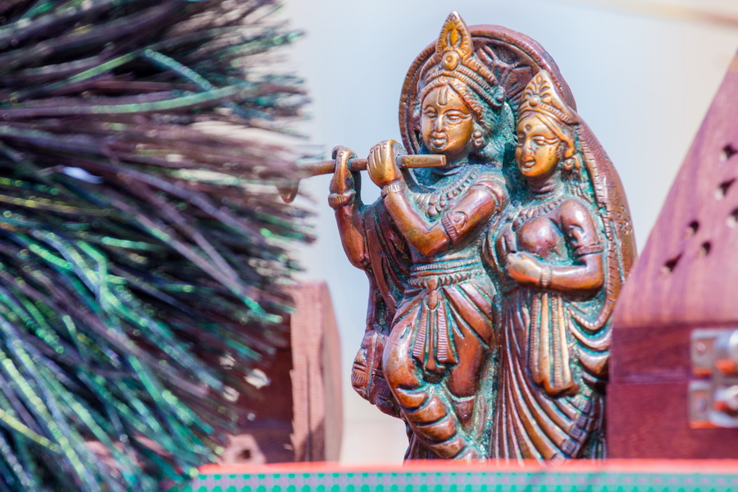
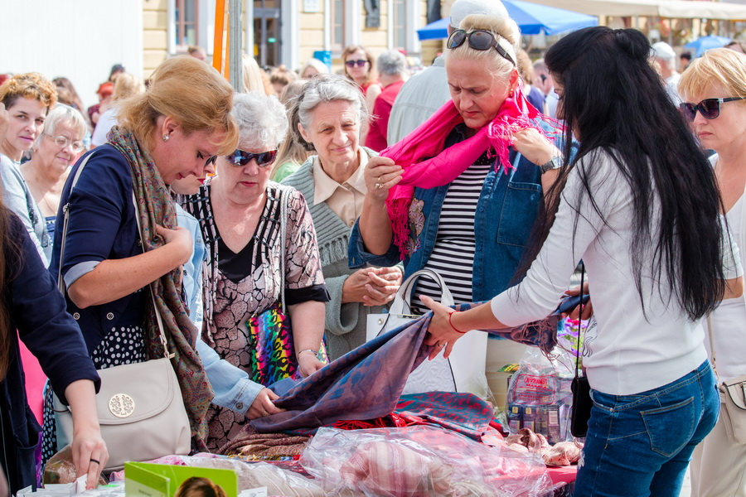
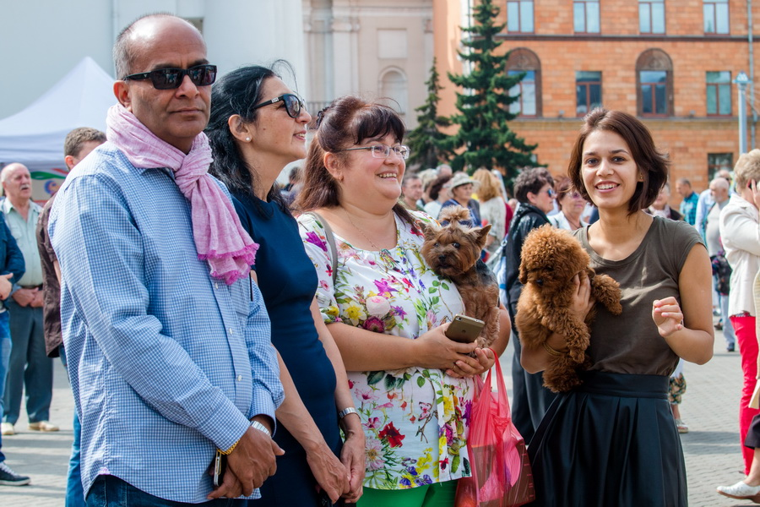
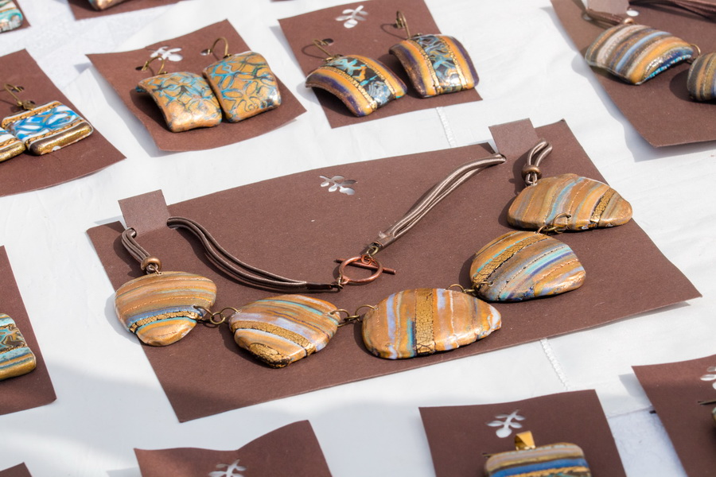
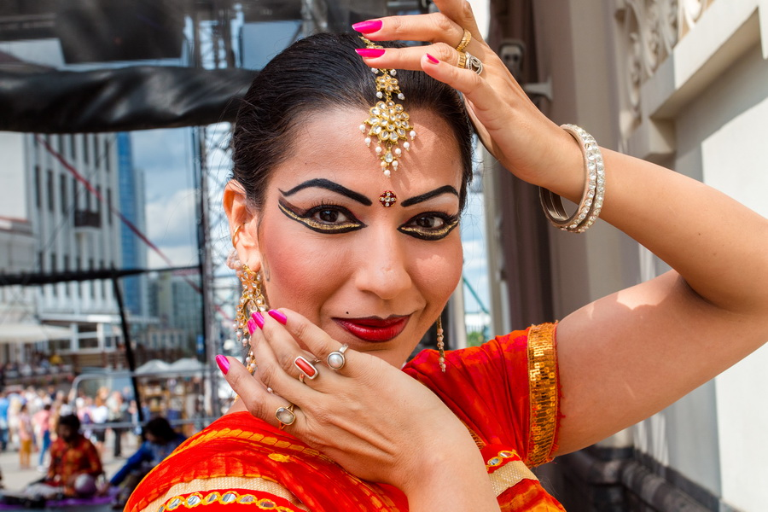
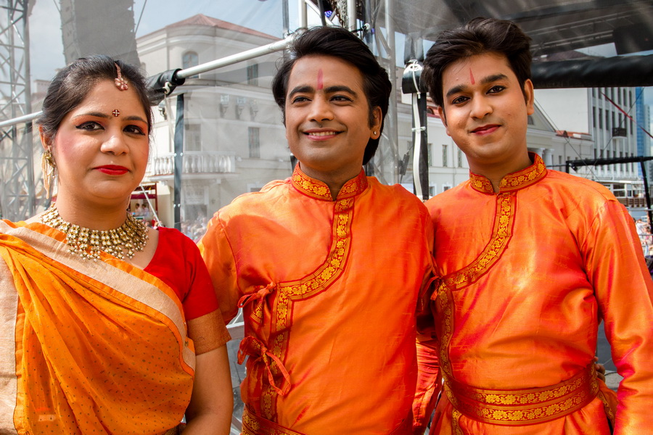
On Sunday, the town gathered many people. This is easily explained: this part of Indian culture - yoga, dancing, Ayurveda - is popular among Minskers. In the city, there are few private schools in these areas. Therefore, in addition to brown-eyed Indians in bright saris the blue-eyed compatriots came.
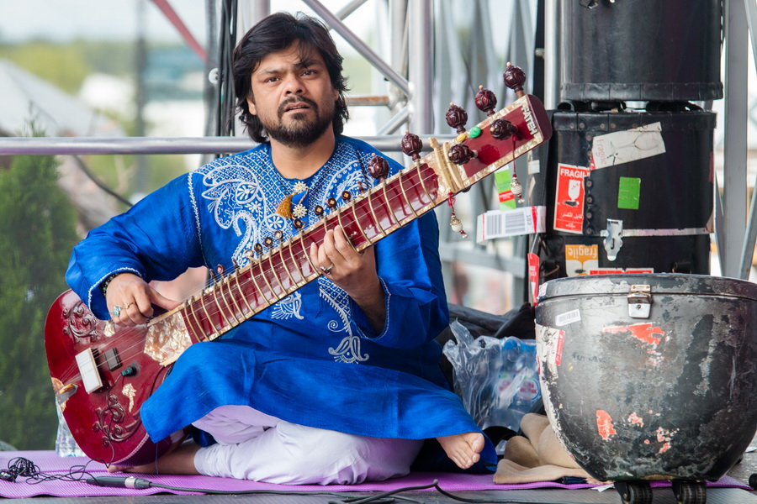
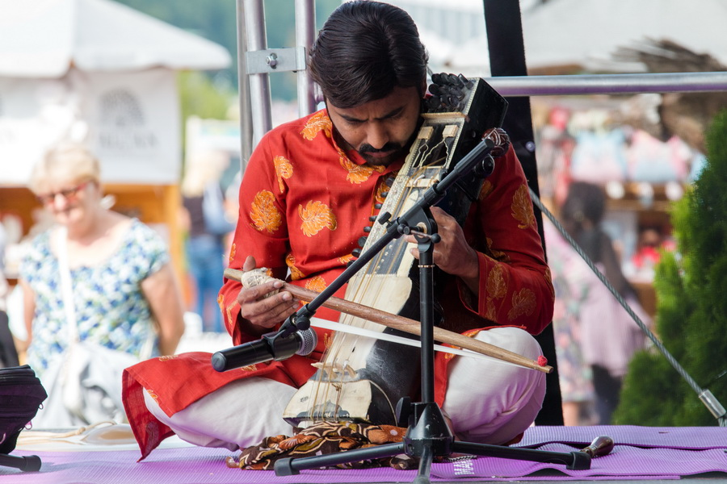
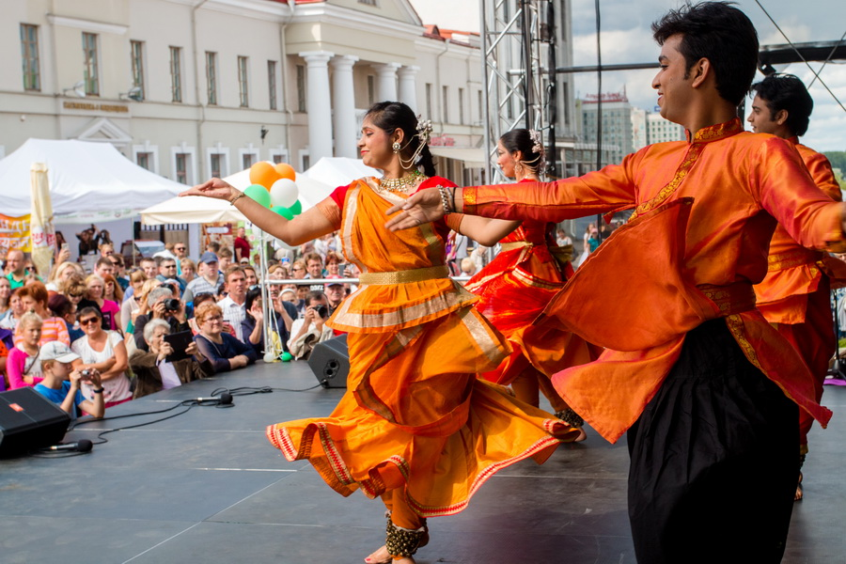
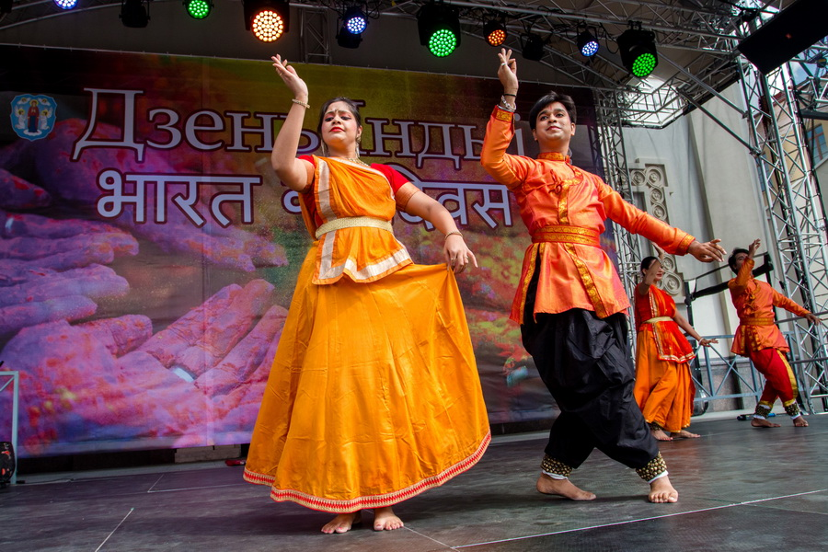
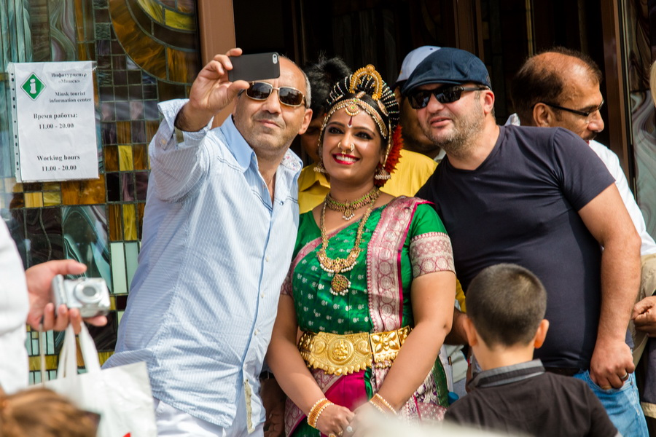
Under the mysterious melodies of the distant country, people enjoyed dishes of Indian cuisine (one of the metropolitan restaurants prepared 500 portions of rice with chicken in curry for free), mastered yoga. They listened to lectures on Ayurveda (the traditional system of Indian medicine), participated in master classes on Indian dance, painted the hands of mehendi.
- Mehendi is a painting by henna on body. Fancy flowers and fluttering butterflies will not last long: henna is quickly washed off, said the master Irina Chechet.
Also, here one could buy Indian tea, spices, cosmetics ...
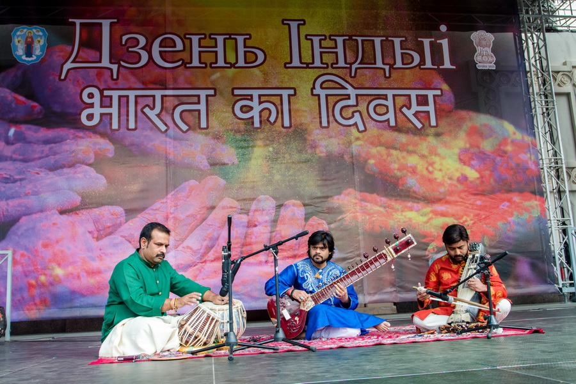
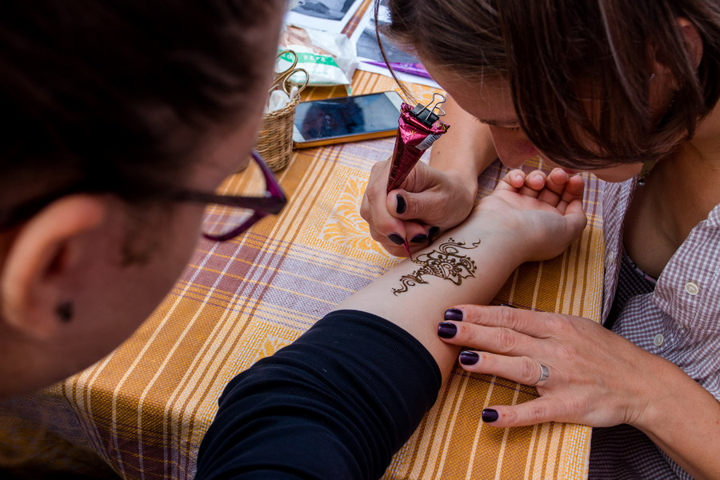
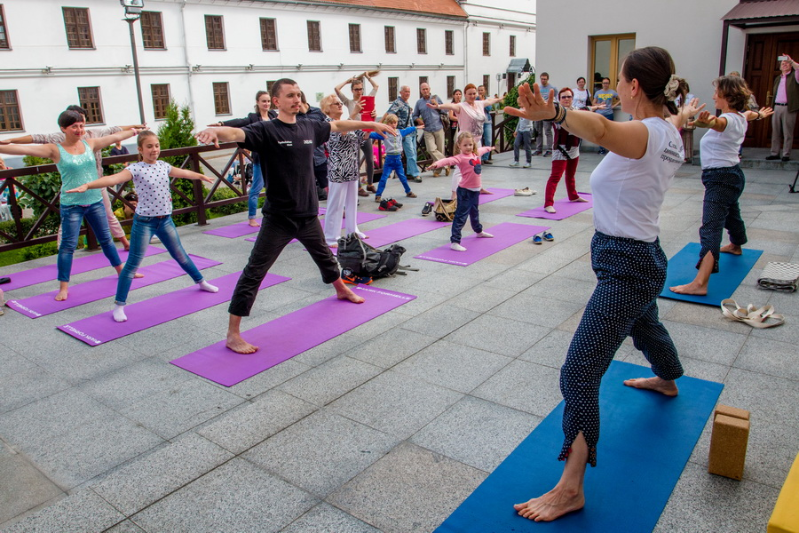
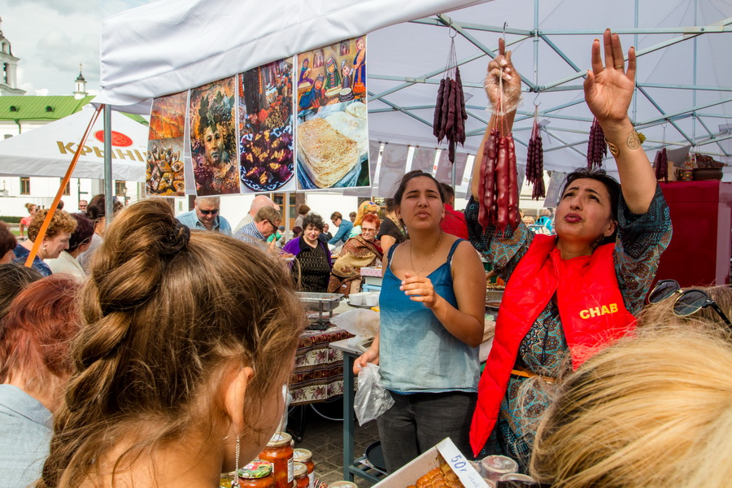
To learn a lot of interesting things about India: the anchors hosts of the holiday Anna Shalyutina and Andrey Good talked about this country with fascination.
The organizers did their best. They prepared over thousand copies of brochures about India, which flew in no time; presented national costumes; showed the traditional wedding ceremony.
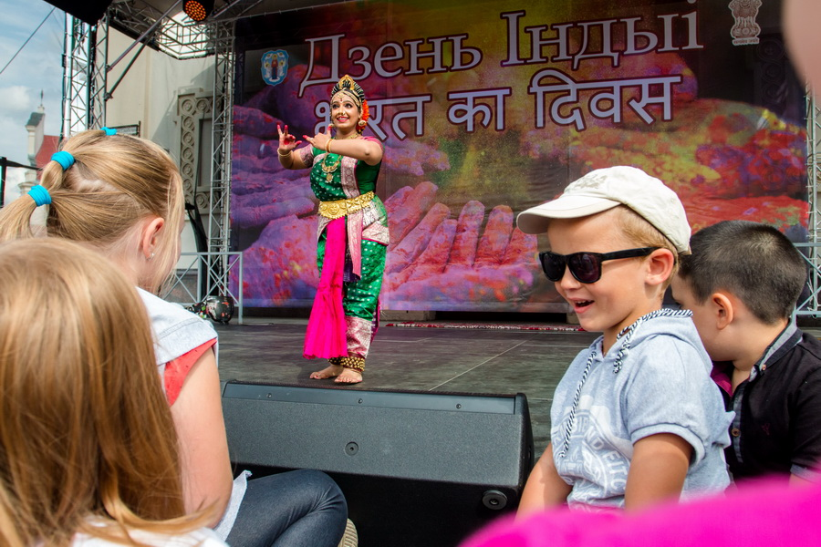
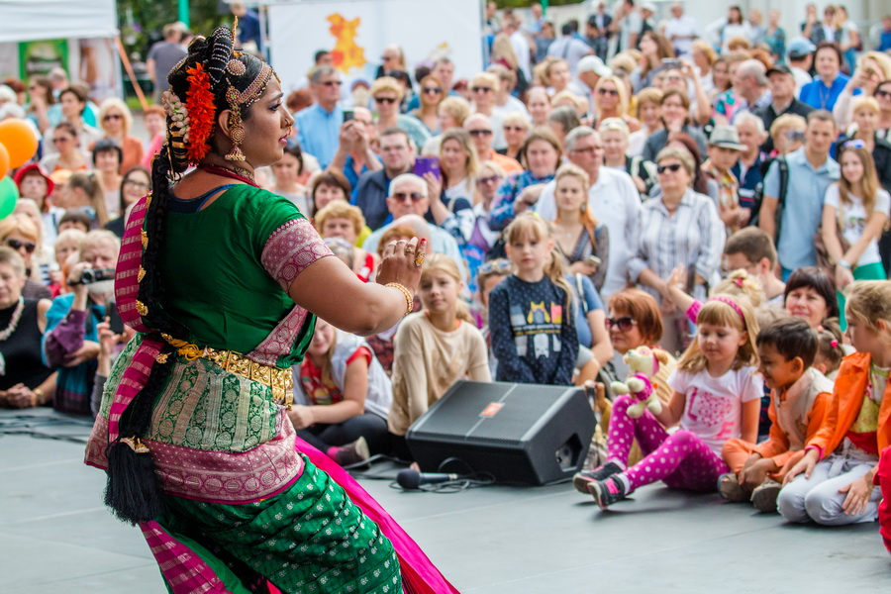
Specifically for the holiday, a team from India under the leadership of Svati Vangnu Tiwari, came as well as the performer of Kichipudi dance Mrs. Vimmy Esvar. The unique atmosphere of enchanting India was created by local collectives.
Note
The event was organized by the Embassy of India in Belarus and the Minsk City Executive Committee.
Photo by Sergey Pazhoha
http://minsknews.by/blog/2017/08/27/verhniy-gorod-okunulsya-v-atmosferu-charuyushhey-indii/

