Photo report: Day of India in Minsk
Regions 27.08.2017 | 19:25
Day of India was held in Minsk on August 27. A dance group of 8 people led by Swati Wangnu Tiwari came from India to present music and dances to Belarusian audience. The group of Katak dance performers, music on a tabla, sitar, saranga and a vocalist with a harmonica are known all over the world. The famous Kichipudi dance performer Vimmi Esvar came to Minsk from Dubai. At the festival local dance groups which were trained in India showed their skills. There were classes on yoga, lectures on ayurveda and master classes on Indian dance.
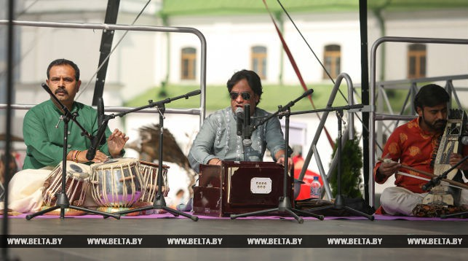
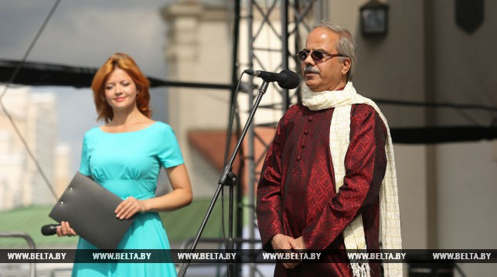
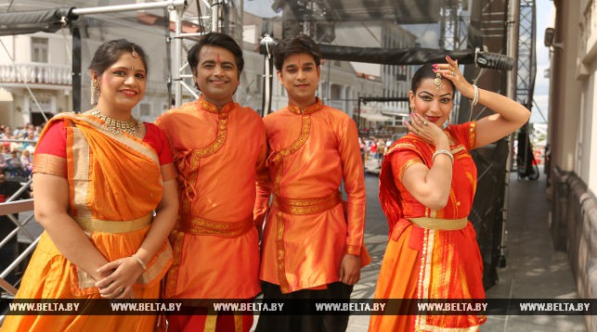
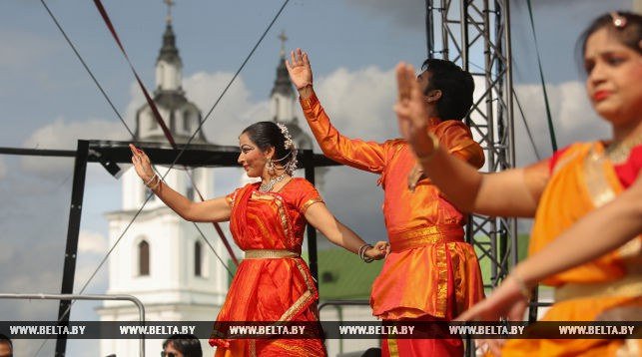
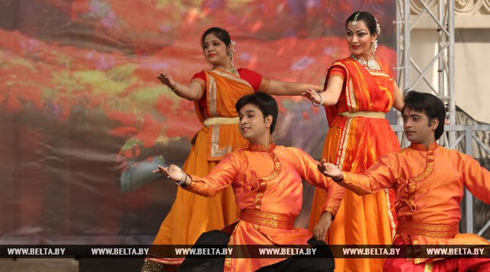
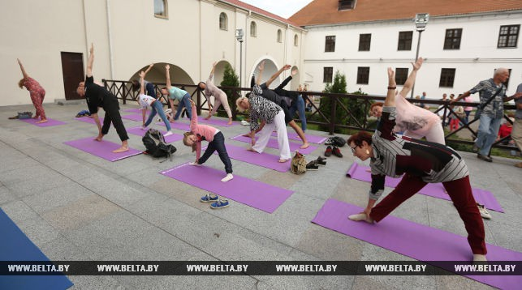
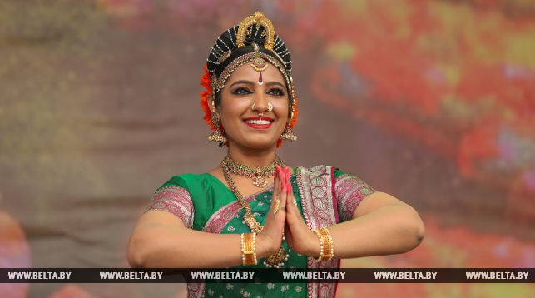
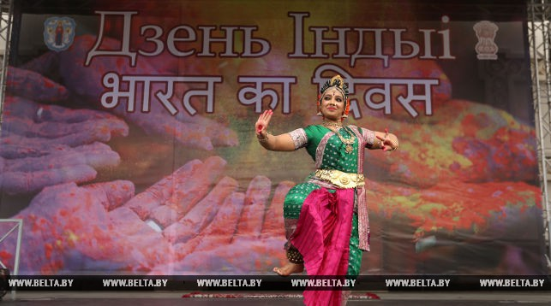
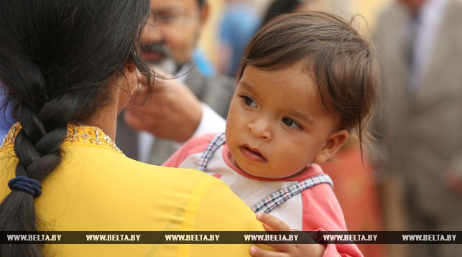
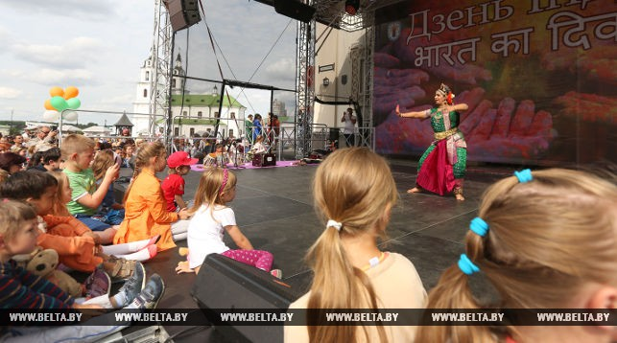
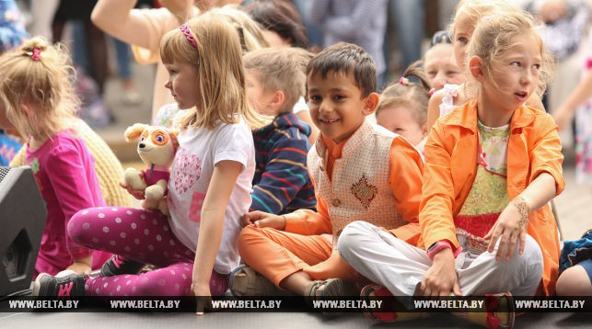
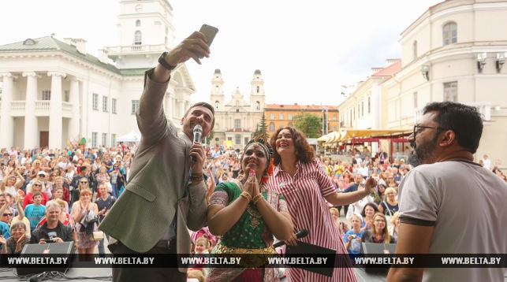
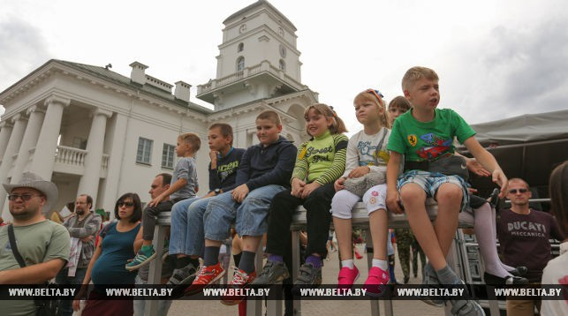
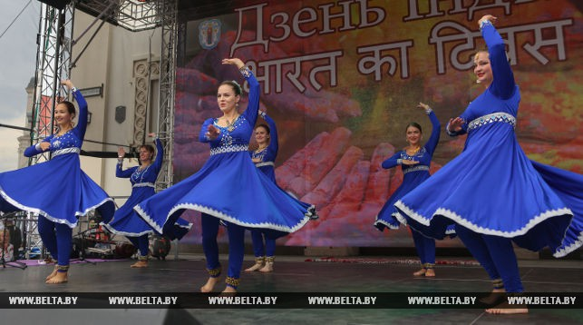
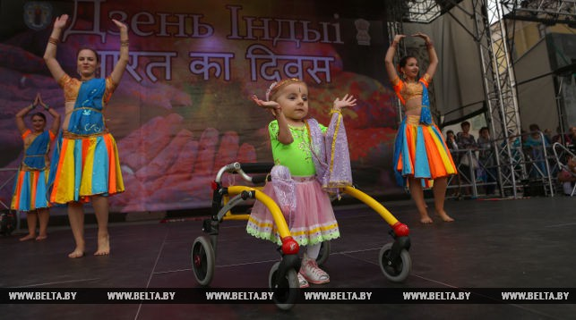
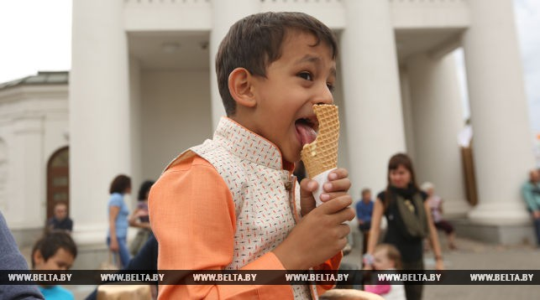
Вы можете найти эту страницу по следующему адресу:
http://www.belta.by/regions/view/fotoreportazh-den-indii-proshel-v-minske-263574-2017/
БЕЛТА - Новости Беларуси, © Авторское право принадлежит БЕЛТА, 1999-2017гг.
Гиперссылка на источник обязательна. Условия использования материалов.

