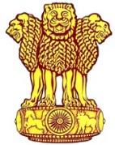 | Embassy of India  Ashgabat | 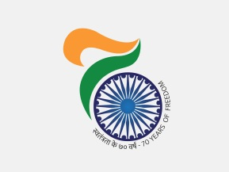

AIMAG 17: India picked its Seventh Gold on 25th September. 2017
India picked its seventh gold medal on 24th September, 2017. Sourav Kothari won gold in Men’s English Billiards singles. Indian pair of J Vishnuvardha and P Thombare won silver medal in Indoor Tennis Mixed Doubles. India’s tally of medals, as on 25th September, 2017, reached to 29 including 7 gold 8 silver and 14 bronze.
***
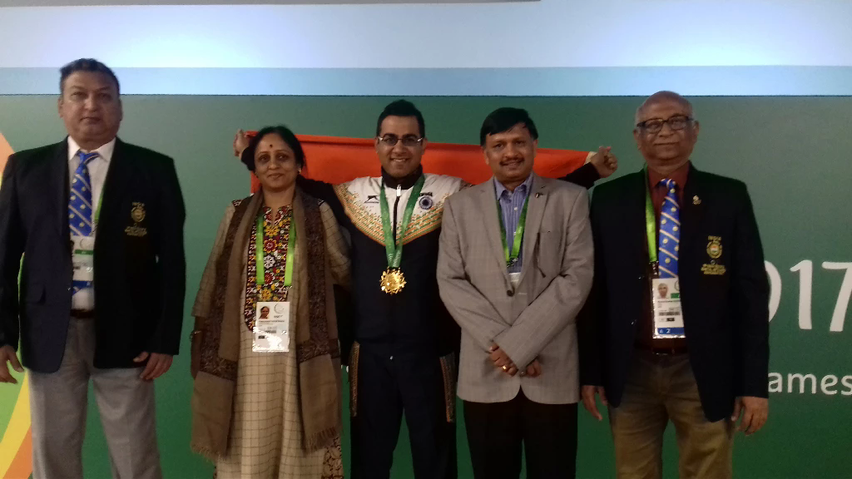
AIMAG 17: Sourav Kothari (center) winner of gold medal in Men's English Billiards Singles with Ambassador of India in Turkmenistan Dr. T V Nagendra Prasad(Second from right).

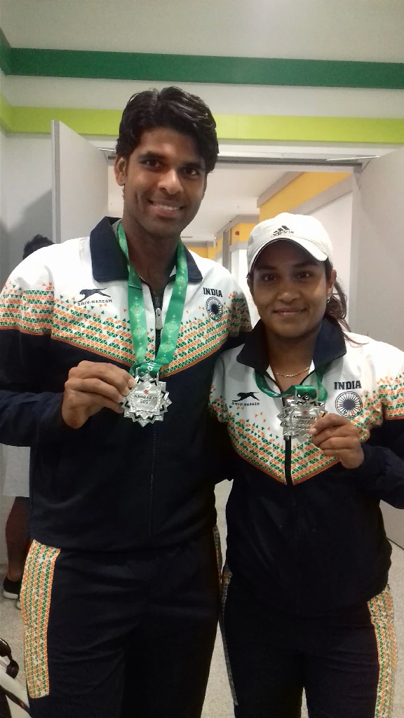
AIMAG 17: Indian pair of J Vishnuvardha & P Thombare winner of silver medal in Indoor Tennis Mixed Doubles proudly displaying their medals
***

