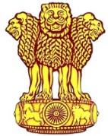 | Embassy of India  Ashgabat | 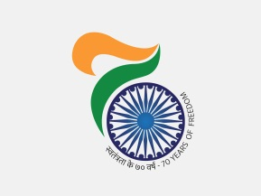

AIMAG 17: India picked up two more gold on 19th September. 17
India clinched two more gold medals on 19th September, 2017. Ms. Chitra P Unnikrishnan picked gold medal in women’s 1500 meter and Mr. Lokshmanan Govindan picked up gold in Men’s 3000 meters. India’s tally of medals, as on 19th September, 2017 reached to 7 including 3 gold 2 silver and 2 bronze.
***
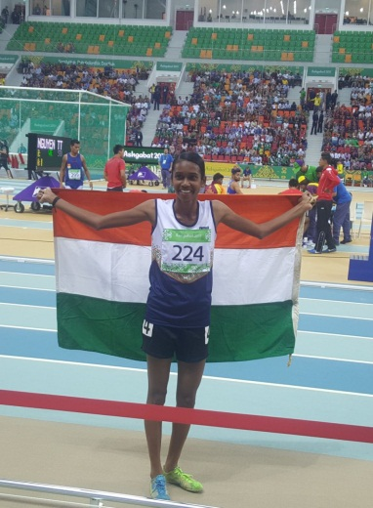
AIMAG 17: Chitra P Unnikrishnan winner of Women’s 1500 meters gold medal
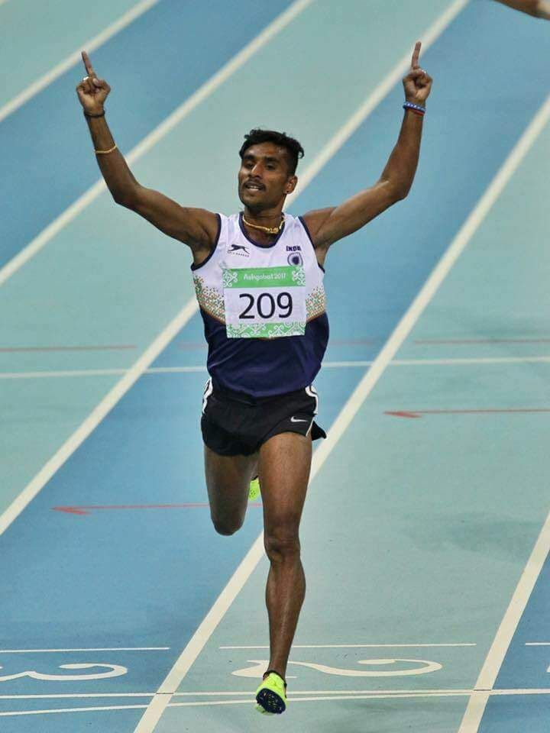
AIMAG 17: Lakshmanan Govindan winner of Men’s 3000 meters gold medal

