Vth Asian Indoor & Martial Arts Games, Ashgabat, Turkmenistan : Visit of Hon’ble Hon’ble Minister for Petroleum and Natural Gas & Minister for Skill Development and Entrepreneurship

Shri Dharmendra Pradhan, Hon’ble Minister for Petroleum and Natural Gas & Minister for Skill Development and Entrepreneurship visited Ashgabat on 17th September 2017 to attend the Opening Ceremony of the Vth Asian Indoor & Martial Arts Games (AIMAG 17). Mr. Vepa Hajiyev, First Deputy Foreign Minister of Turkmenistan was at the airport to welcome and bid farewell to the Hon’ble Minister.
AIMAG 17 is scheduled from 17-27 September, 2017. A total of around 6000 participants from 65 Countries from Asia and Oceania region are participating in the event. Visit of Shri Dharmendra Pradhan, Hon’ble Minister for Petroleum and Natural Gas & Minister for Skill Development and Entrepreneurship signifies close ties between peoples of the two countries originating from the old times and also personal attention and close contacts between the two countries. Shri Pradhan represented Government of India at the event.
He also met Indian athletes at the Olympic village and conveyed his best wishes to them.
On the sidelines of the visit, Hon’ble Minister had bilateral meeting with Hon’ble Mr. Maksat Babayev, Deputy Chairman of the Cabinet of Ministers of Turkmenistan. Both sides also discussed issues of mutual interest and cooperation in the energy sector.
***

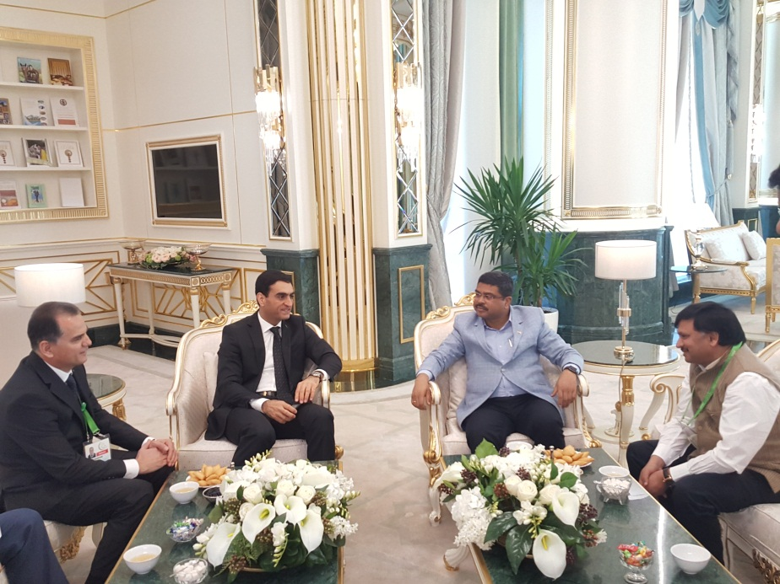

Shri Dharmendra Pradhan, Minister for Petroleum and Natural Gas and Minister for Skill Development and Entrepreneurship being received by at the airport by Mr. Vepa Hajiyev, First Deputy Minister of Foreign Affairs of Turkmenistan on 17.09.2017
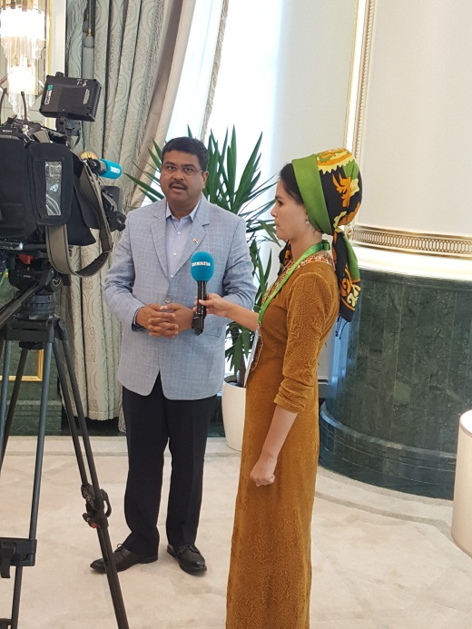

Shri Dharmendra Pradhan, Minister for Petroleum and Natural Gas and Minister for Skill Development and Entrepreneurship interacting with Media.

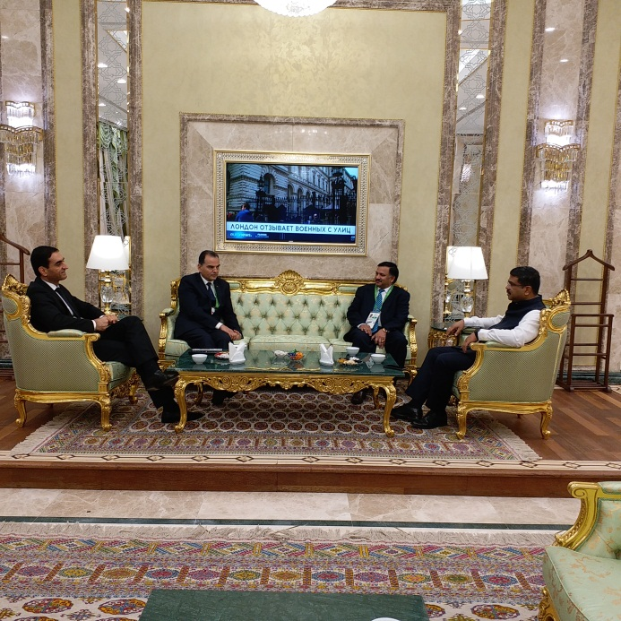

Shri Dharmendra Pradhan, Minister for Petroleum and Natural Gas and Minister for Skill Development and Entrepreneurship being seen off by at the airport by Mr. Vepa Hajiyev, Deputy Minister of Foreign Affairs of Turkmenistan on 18.11.2017

***

