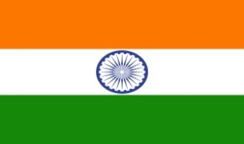
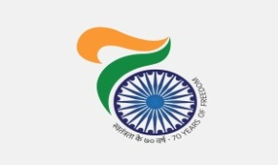
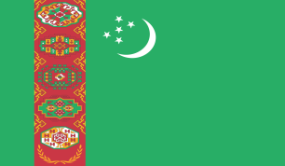

India @ 70: “Kuchipudi” dance Programme in Turkmenbashy, Turkmenistan on 25th August, 17
As part of “Freedom 70” celebration commemorating 70 years of Independence of India, Ministry of Culture of India, sponsored “Kuchipudi’ group led by Ms. Achutamanasa to Turkmenistan. The 2nd performance was at Cultural-Sport Complex of oil Refinery plant, Turkmenbashy on 25th August, 2017.
The event was started with lighting of traditional lamp by Mrs. Aybolek Ashirova, Head of cultural Department at Turkmenbashy, Government of Turkmenistan and H. E Dr. T V Nagendra Prasad, Ambassador of India to Turkmenistan.
Audiences , which included Officials of the Government of Turkmenistan , local Citizens and Indian citizens residing in and near Turkmenbashy , attended the performance in big numbers. The venue was packed to capacity. The performance was well appreciated.
***
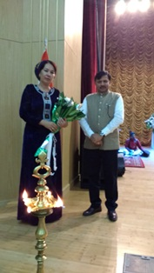
Freedom @ 70 Kuchipudi dance performance at Turkmenbashy Inaguration of the cultural show by Mrs. Aybolek Ashirova, Head of cultural Department at Turkmenbashy, Government of Turkmenistan and H. E Dr. T V Nagendra Prasad, Ambassador of India to Turkmenistan

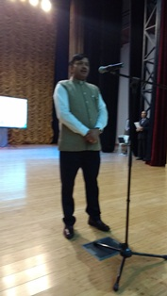
Freedom @ 70 Kuchipudi dance performance at Turkmenbashy Ambassador H E Dr. T V Nagendra Prasad addressing the Audience
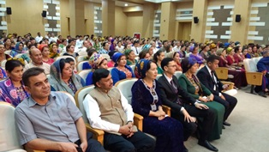 | 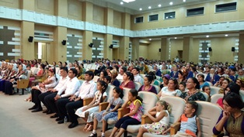
Freedom @ 70 Kuchipudi dance performance at Turkmenbashy Audiance enjoying performance
.

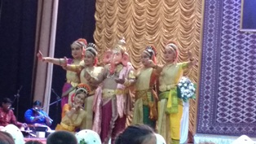 | 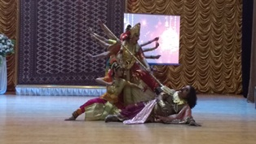
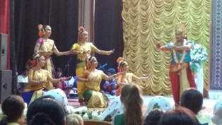 | 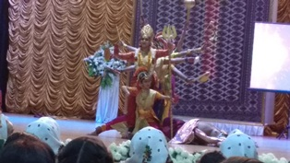
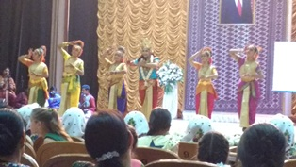 | 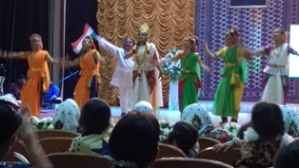
Freedom @ 70 Kuchipudi dance performance at Turkmenbashy snapshots of Performance

