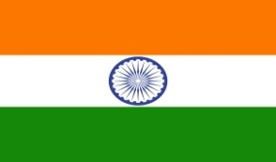
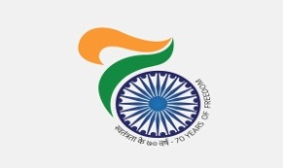
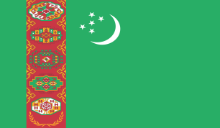

India @ 70: “Kuchipudi” dance Programme in Ashgabat, Turkmenistan on 24th August, 2017
As part of “Freedom 70” celebration commemorating 70 years of Independence of India, Ministry of Culture of India, sponsored “Kuchipudi’ group led by Ms. Achutamanasa to Turkmenistan. The first performance was at Magtymguly National Musical Drama Theatre, Ashgabat on 24th August, 2017.
The event was started with lighting of traditional lamp by Mrs. Bahargul Abdiyeva, Deputy Minister in Ministry of Culture, Government of Turkmenistan and H. E Dr. T V Nagendra Prasad, Ambassador of India to Turkmenistan.
The theater was packed to the capacity attended by Heads of Foreign Missions, Members of Diplomatic Community, officials of the Embassy and their family members, Officials of the Government of Turkmenistan and local Citizens. The event was well covered by local Audio-visual and print media.
Despite “Kuchipudi” being a new dance form to the Turkmen, the performance was well received. All appreciated the live classical music and magnificent dance movement by the group.
***
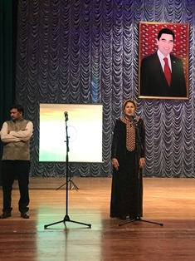
India @ 70- Kuchipudi Dance performance: Mrs. Bahargul Abdiyeva, Deputy Minister in Ministry of Culture, Government of Turkmenistan addressing at the audience.
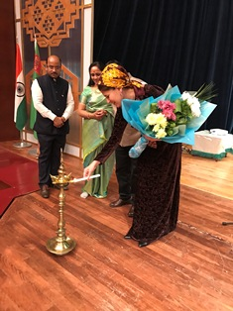
India @ 70- Kuchipudi Dance performance: Lighting of Lamp
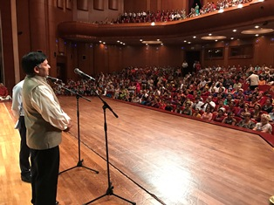
India @ 70- Kuchipudi Dance performance : H. E Dr. T V Nagendra Prasad, Ambassador of India to Turkmenistan addressing to the audience.
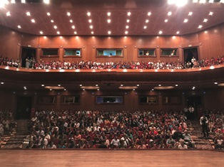
India @ 70- Kuchipudi Dance performance: audience enjoying the show.

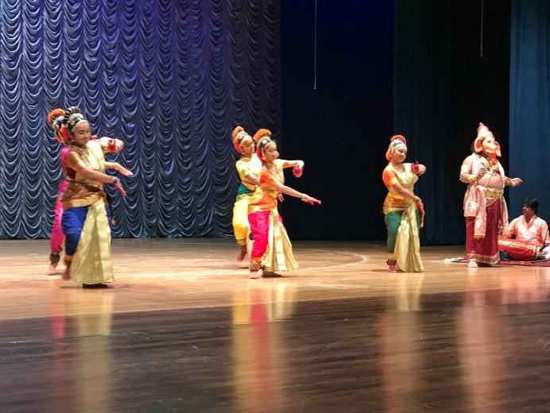 | 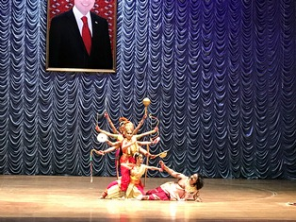
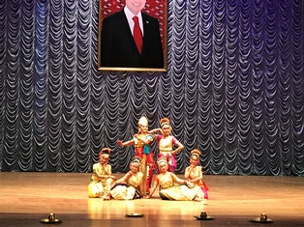 | 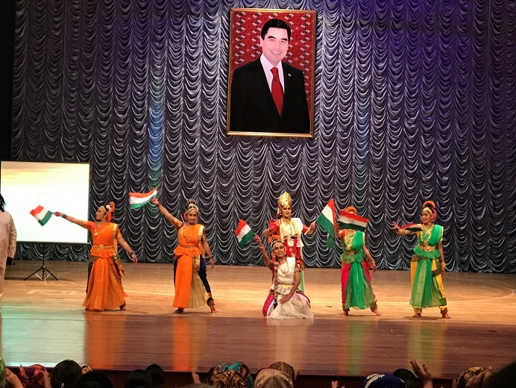
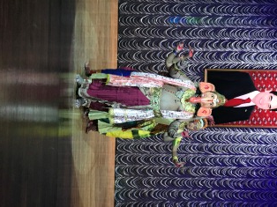
India @ 70- Kuchipudi Dance performance : Snapshots of the event.

