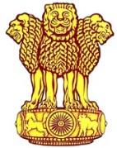 | Embassy of India  Ashgabat | 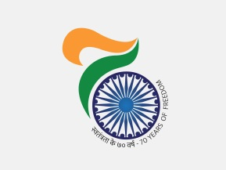

FIFA U- 17 World Cup 2017

Incredible India is hosting the FIFA U - 17 World Cup 2017 in October, 2017 in Indian cities; Delhi, Goa, Guwahati, Kochi, Kolkata and New Mumbai. The opening ceremony of the event will be on 6th October, 2017 and the final match will be held in Kolkata on 28th October, 2017
This gives an opportunity to sports enthusiasts to enjoy the excitement of the game and visit various cities of incredible country INDIA. The host cities are spread over different geographical locations and have rich historical and cultural attractions providing an opportunity to explore the rich traditions of India and glimpse of modern India.

For further information for the games kindly visit
http://www.fifa.com/u17worldcup/index.html
For further information about the places of touristic interesting in host cities kindly visit.
Delhi http://www.delhitourism.gov.in/delhitourism/index.jsp
Goa http://www.goatourism.gov.in
Guwahati http://www.assamtourism.org
Kochi http://www.keralatourism.org
Kolkata http://www.wbtourism.gov.in

