 | Embassy of India  Ashgabat | 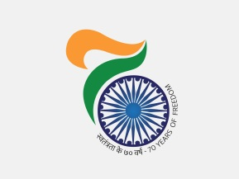

Pledge taking ceremony on 75th Anniversary of the “Quit India Movement”

Country is celebrating 75th Anniversary of the “Quit India Movement” on 9th August, 2017. To mark the occasion Ambassador of India to Turkmenistan H. E Dr. T V Nagendra Prasad administered pledge to all India based officials of the Embassy to create a New India that is strong, prosperous and inclusive; an India that will make our freedom fighters proud.

***

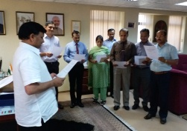
1Ambassador of India to Turkmenistan H.E. Dr. T V Nagendra Prasad administrating New India pledge to all India based officials of the Embassy

