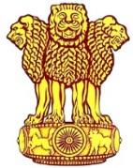 | Embassy of India  Ashgabat | 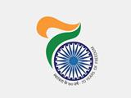

India Participated in International Exhibition “Health-2017”

Annual International Exhibition “Health-2017” of Turkmenistan was held in Ashgabat on 21-22.07.2017. The companies/firms from India, Germany, Switzerland, Turkey, Belarus, USA and Russia are participating. Around 21 Indian pharma companies participated in the exhibition. Stride Shasun, Ajanta, JMB Pharmaceuticals, Marion Biotech, Akriti Pharmaceuticals, Sigma Laboratories, Medeor, Oxford, Zee Laboratries, Alice Medicare, West Coast, Curex Pharma, Serum Institute etc were some important participants from India. . Indian companies made presentations on various subjects concerning healthcare. The cooperation between India and Turkmenistan has been steadily growing. Ambassador Dr. T.V. Nagendra Prasad also visited the Exhibition and interacted with Indian businessmen participating in the exhibition.

To harness the opportunity, the Embassy organized an Interactive Business Meeting for Indian Pharma Companies on 21.07.2017. Around 40 Indian Businessmen/ delegates participated in the meeting. The interactive session was very fruitful as they discussed issues/ challenges faced by them in doing business. The Indian delegation highly appreciated the initiative of the Embassy and expressed that such interactive business meeting shall provide much needed platform to get information on Turkmen market.

***

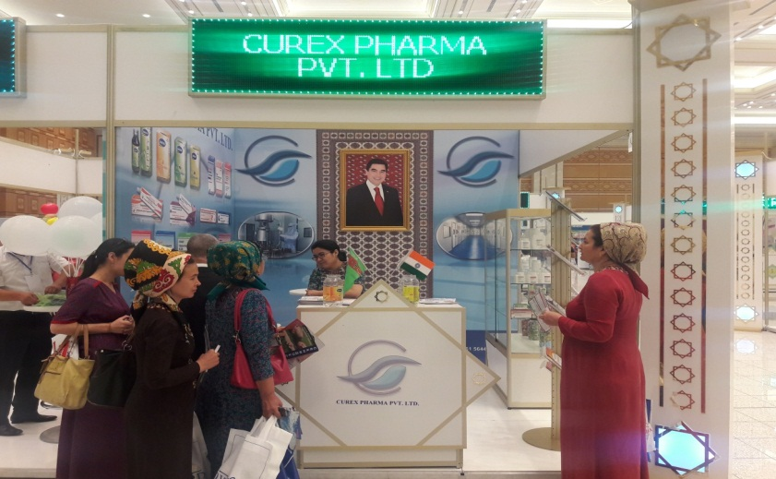
Health 2017: Indian Companies at the Exhibition
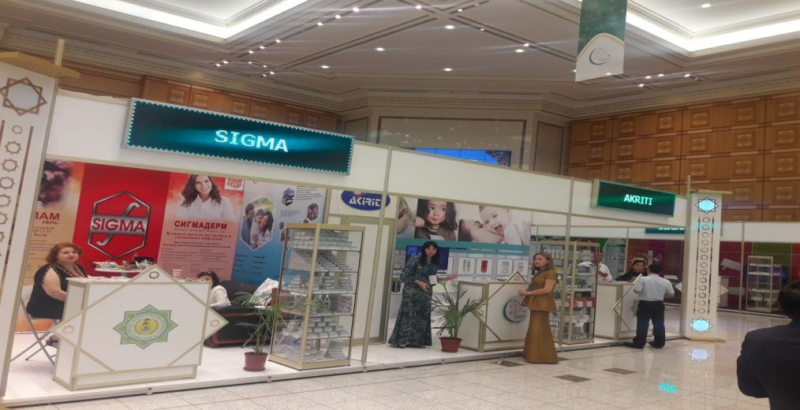
Health 2017: Indian Companies at the Exhibition

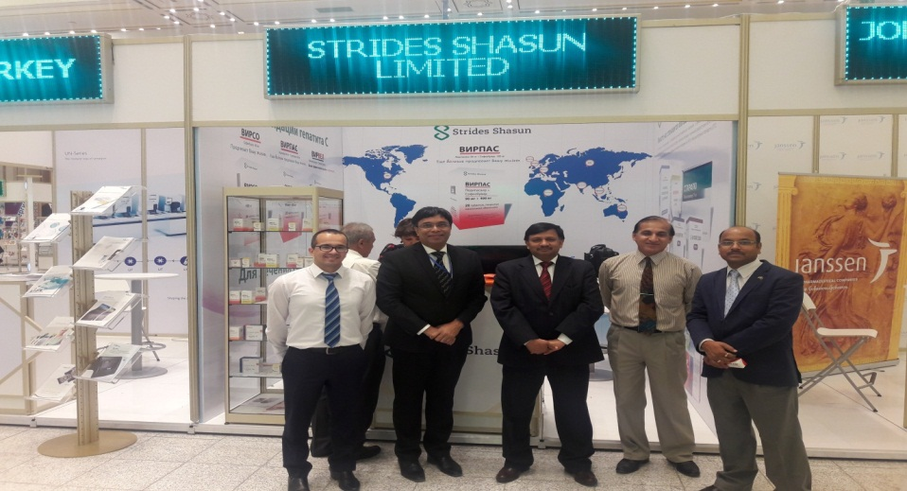
Health 2017: Ambassador of India to Turkmenistan Dr. T V Nagendra Prasad and Embassy Officials visiting the Exhibition
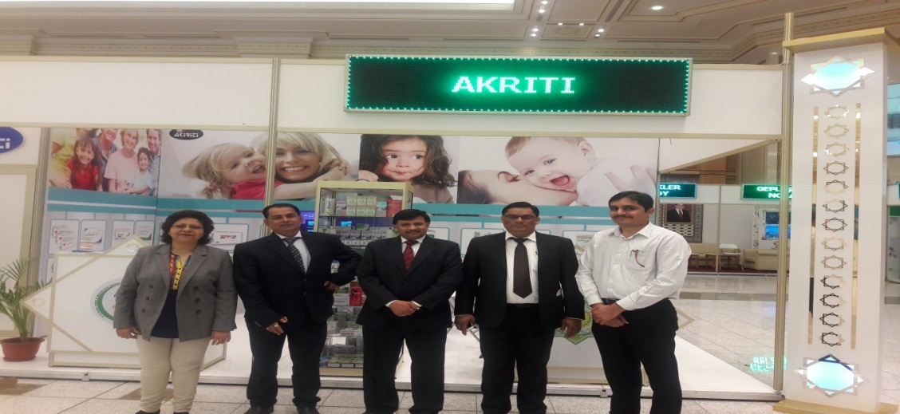
Health 2017: Ambassador of India to Turkmenistan Dr. T V Nagendra Prasad and Embassy Officials visiting the Exhibition

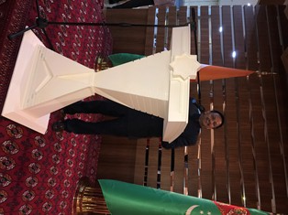
Health 2017 Ambassador addressing the delegates during interactive meeting
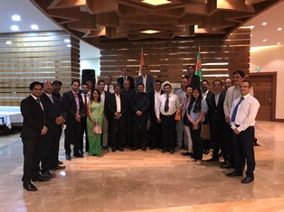
Health 2017: Delegates with Ambassador during the interactive meeting
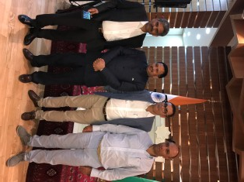
Health 2017: Delegates with Ambassador during the interactive meeting

