|  |  |  |
| --- | --- | --- |
|  | C:\Users\User\AppData\Local\Microsoft\Windows\Temporary Internet Files\Content.Word\ICCR.JPEG |  |

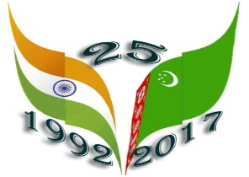

Embassy of India

Ashgabat

***Film Festival at Ashgabat Kino Theater***

Thursday, April 20, 2017 marked the 25th Anniversary of the Diplomatic Relations between India and Turkmenistan. To mark the occasion Embassy of India in Ashgabat, in association with Ministry of Culture, Government of Turkmenistan, and Indian Council for Cultural Relations (ICCR), Ministry of Tourism, Government of India, India Tourism Office, Frankfurt and announced the organization of “Indian Cultural Week” from 16th May, 2017 to 23rd May, 2017.

Series of events began with inauguration of exhibition titled “Vastram: Splendid World of Indian Textiles” followed by performance by Bollywood Group “Dance Era” on 17th and 18 May, 2017. In continuation of the events Embassy of India Ashgabat, in association with Ministry of Culture, Turkmenistan, organized the film festival 19th to 21st May, 2017 at Ashgabat Theater. The Theater located in heart of the city and has sitting capacity of 500

The event was inaugurated by H. E. Dr. T V Nagendra Prasad, Ambassador of India to Turkmenistan on 19th May, 2017, in presence of Mr. Bayram Atayev, Chairman of Association of the “Kinovideohyzmat” of Ministry of Culture of Turkmenistan.

The entry to the films shows was free. Turkmen are fond of Bollywood movies and therefore, as expected the shows were full to the capacity. Apart from the Local Turkmen, members of diplomatic community, including several Ambassadors and foreign national residing in Ashgabat attended the inauguration ceremony and film shows.

Incredible India Posters and publicity materials were distributed during the event.

***

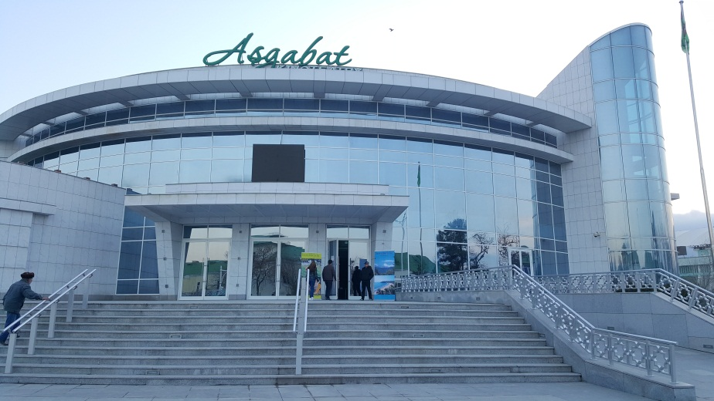

Ashgabat Kinotheatre : Venue of the Film Festival

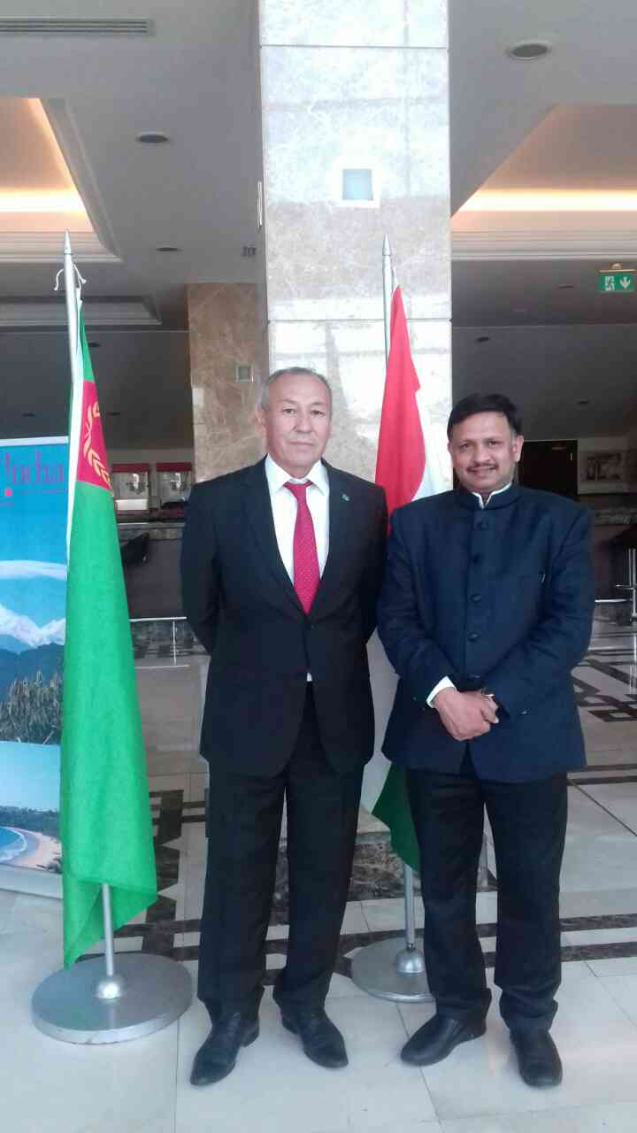

H. E. Dr. T V Nagendra Prasad, Ambassador of India to Turkmenistan with Mr. Bayram Atayev, Chairman of Association of the “Kinovideohyzmat” of Ministry of Culture of Turkmenistan.

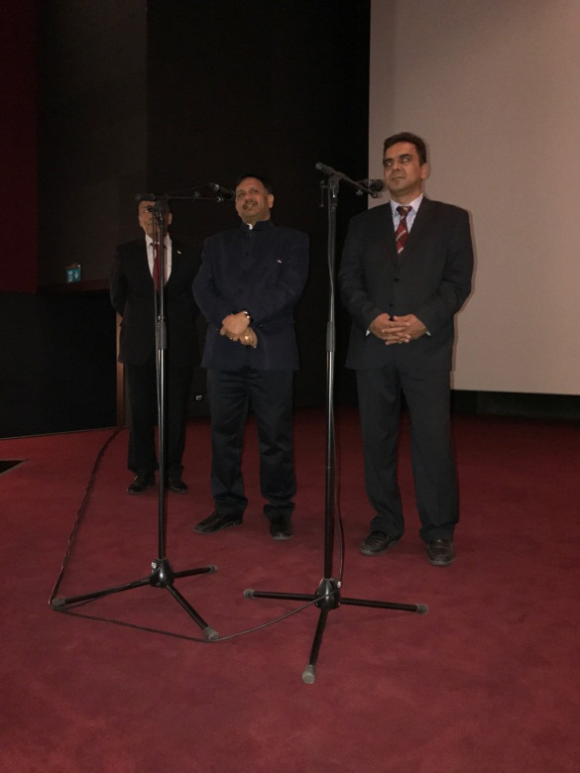

H. E. Dr. T V Nagendra Prasad, Ambassador of India to Turkmenistan speaking on the occasion of inauguration of Film Festival on 19th May, 2017

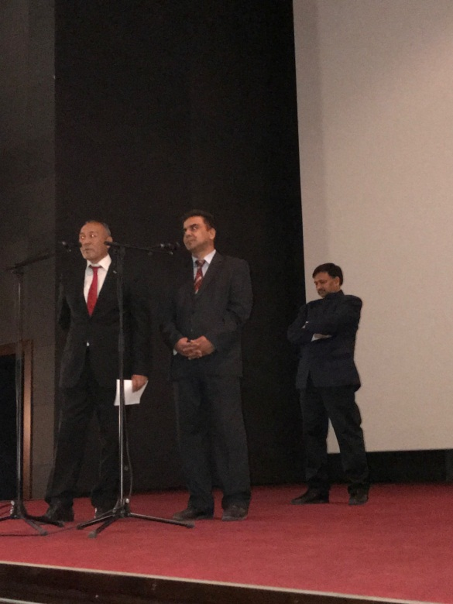

Mr. Bayram Atayev, Chairman of Association of the “Kinovideohyzmat” of Ministry of Culture of Turkmenistan speaking at inauguration of Film Festival on 19th May, 17