High Commission of India
Port Louis
***
Press Release

Agreement Signed Between HSCC, India and Government of Mauritius
In implementation of the five projects agreed under Government of India’s existing Special Economic Package to Mauritius, an agreement between M/s HSCC, India and the Ministry of Health & Quality of Life of Mauritius appointing M/s HSCC as Project Management Consultant for the new ENT Hospital project was signed today at the Ministry of Health & Quality of Life. Government of India has agreed to extend a grant of USD 14 million for the new ENT Hospital Project.
The Hon’ble Minister for Health and Quality of Life of Mauritius Dr. Mohammad Anwar Husnoo, High Commissioner of India Shri Abhay Thakur, Senior Chief Executive of the Ministry of Health and Quality of Life Mr. G. Gunesh and the Chairman & Managing Director of HSCC India Mr. Gyanesh Pandey, attended the signing ceremony.
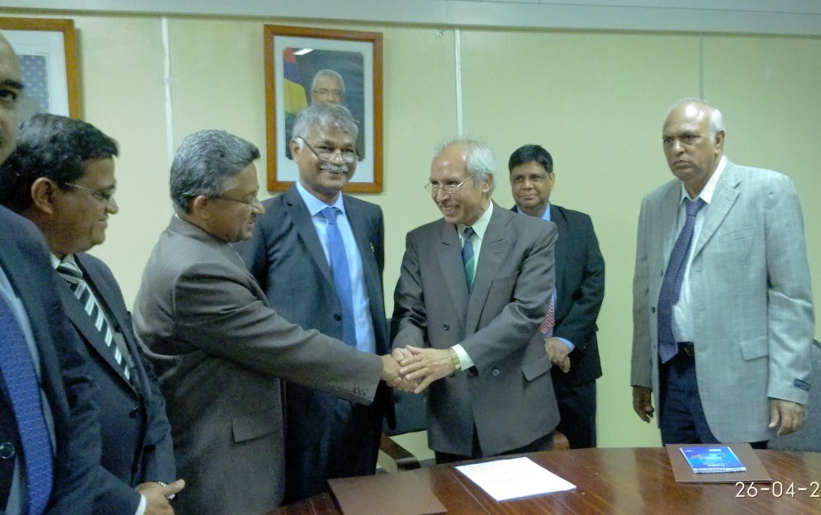

26 April 2017
Port Louis, Mauritius

