Friendship concert 28th January 2017 at Watan Theatre
A friendship concert was held on 28th January 2017 at Watan theatre by the visiting 'Silicon Group' led by Mr Sandeep Banerjee. The concert was by Indian Council of Cultural relations in association with the Embassy of India and the Ministry of Culture of the Government of Turkmenistan. It was on the occasion of the 68th Republic Day and 25 years of Independence of Turkmenistan. The musical evening began with the lighting of the lamp by Ambassador T V Nagendra Prasad, Mrs Ambassador and Mr Chariev, Director of the Theatre. The performance involving Tabla, Sitar, Saarangi and Nal was received very well by the local audience.
***

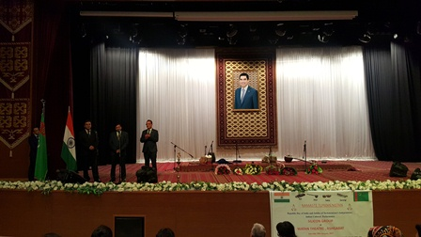
Performance at Watan Theatre on 28th January, 2017
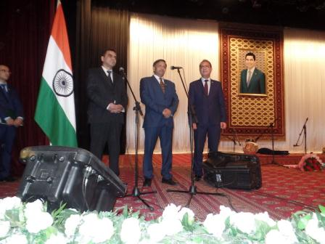
Performance at Watan Theatre Inagural Address by Ambassador H . E T V Nagendra Prasad
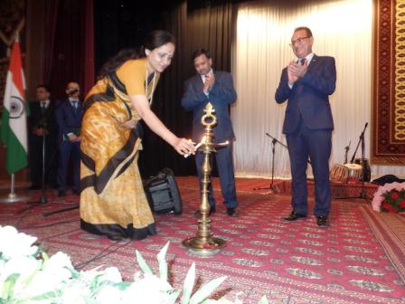
Performance at Watan Theatre Lightning of lamp
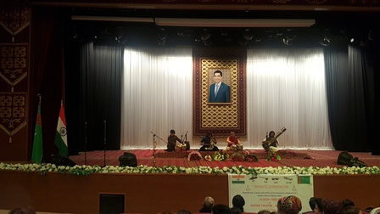
Performance at Watan Theatre

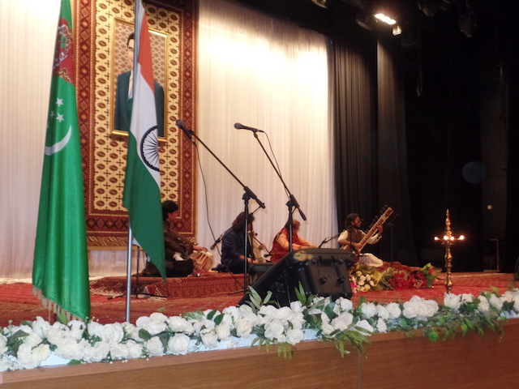
Performance at Watan Theatre

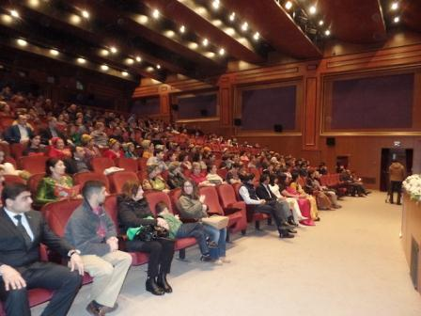
Performance at Watan Theatre -All engrossed in music

