68th Republic Day Celebrations in Ashgabat, Turkmenistan

The 68th Republic Day celebrations were held at the Embassy Residence on Thursday, 26 January, 2017. Indian communities in Turkmenistan, Embassy officers, staff and Embassy Officials' families participated. Ambassador Dr. T.V. Nagendra Prasad hoisted the National Flag followed by the national anthem. Ambassador read out the address of Hon'ble President Shri Pranab Mukherjee to the nation on the occasion. About 75 people assembled at the Residence for the celebrations. It also had patriotic songs and refreshment.

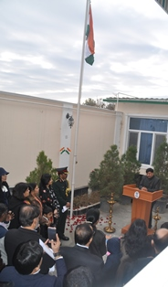
Ambassador, H.E T V Nagendra Prasad addressing after flag hoisting

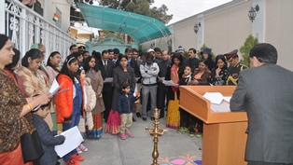
Address by Ambassador H.E T V Nagendra Prasad

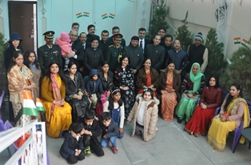
Embassy family picture

