High Commission of India
Nairobi
***

Celebration of Pravasi Bharatiya Divas and Vishwa Hindi Diwas in Nairobi
The High Commission of India organized an event to celebrate Pravasi Bharatiya Divas and Vishwa Hindi Diwas on Sunday, 15 January, 2017 at the Apa Pant Auditorium of High Commission of India residential complex in Nairobi. The event was attended by over 120 people including PIOs, prominent Indian nationals and friends of India.
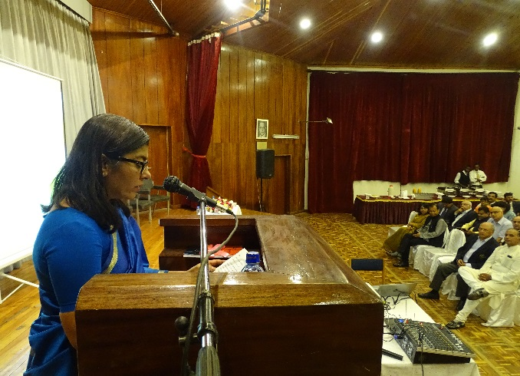
High Commissioner Ms. Suchitra Durai highlighted the key role played by the Indian diaspora in Kenya in promoting bilateral relations and their 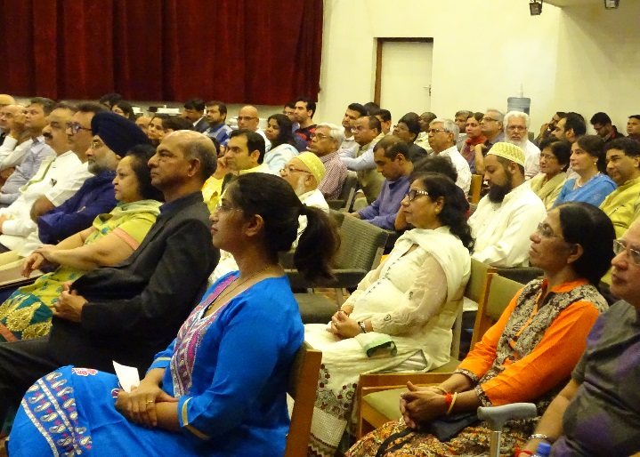significant contribution in socioeconomic development of Kenya. High Commissioner added that the recent State visit of President Uhuru Kenyatta to India has further enhanced robust and multi-faceted partnership. Mr. T. Ramamurthy, Director Nakumatt Holdings made a presentation on “Be a Kenyan in Kenya” and Mr. Karan Yadav, First Secretary briefed participants on the Overseas Citizen of India (OCI) scheme of the Government of India.
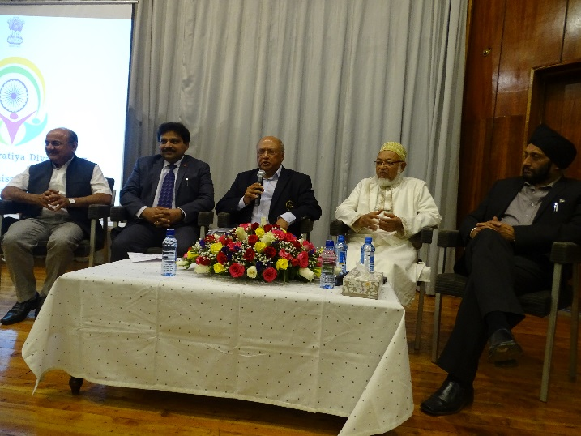
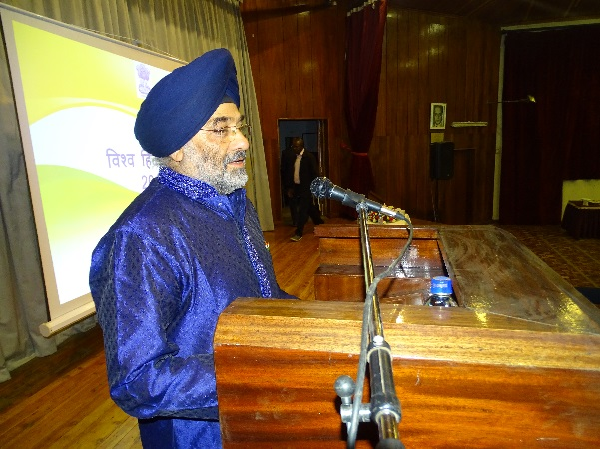
Mr Sharad Rao, Chairman, Judges & Magistrates Vetting Board of Kenya chaired a panel discussion on the topic, “role of Diaspora in enhancing value in relationships”. Hon’ble Mohammed Ali (former MP), Mr. Kamal Gupta (Secretary, Hindu Council of Kenya), Mr Amarjit Singh Behra (Secretary Ramgarhia Gurudwara Committee) and Mr. Shailesh Savani (CEO, Compulinks) shared their views on the topic as panelists. The panel discussion covered India’s historical connect with Kenya particularly in the Coast, contribution of Indians building Mombasa-Uganda railway, role of Indian diaspora in Kenya’s struggle against colonial power as well as support through education, capacity building and sharing of technical expertise in building modern Kenya. While acknowledging the important role of Indian diaspora in Kenya, Ambassador R. Swaminathan advocated the diaspora to support proactively strengthening bilateral ties. A short video on the Pravasi Bharatiya Divas 2017 was also screened.
In the second part of programme, the High Commissioner underscored the significance of Vishwa Hindi Divas and the role overseas Indians can play in promotion of Hindi language in different parts of the world. The gathering was also addressed by Mr. Arvinder Mehta, Chairman of Hindi Samiti of East Africa. A book in Hindi written by a Kenyan Indian Dr. Abhay Sinha titled “Sijui urf I don’t know” was also launched during the function.
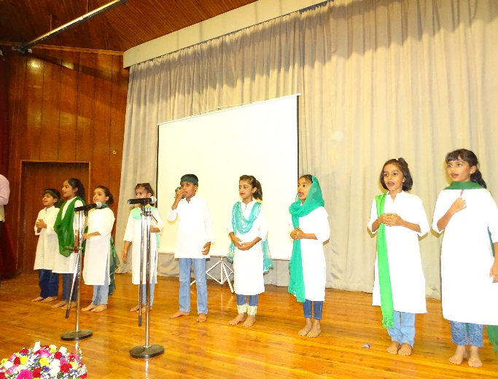
Children from the Hindi Samiti of East Africa presented poems and skits 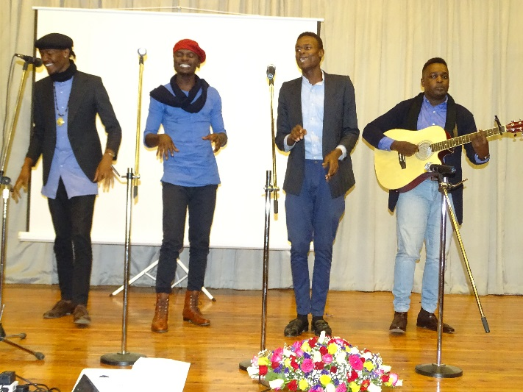in Hindi which were well appreciated by the audience. The highlight of the event was a Hindi song performance by Kenyan students of the University of Nairobi.
***
(Nairobi – 16 January 2017)

