First Global Conference on Sustainable Development

Shri Pon Radhakrishnan, Minister of State for Shipping, Road Transport & Highways led a three member delegation to the UN sponsored Global Sustainable Transport Conference held in Ashgabat on 26th and 27th November, 2016. He was received at the airport by Mr. Berdyniyaz Matiyev, Deputy Minister of Foreign Affairs. During the Conference he had bilateral meeting with Mr.Satlyk Satlykov, Deputy PM for Transport and Communications.
The two-day Conference was attended by three Heads of State, one Head of Government, six Deputy Prime Ministers, two Foreign Ministers, forty two Ministers and Vice-Ministers of transport and infrastructure. Mr.Pon Radhakrishnan was seen off at the airport by Mr. Vepa Hajiyev, First Deputy Minister of Foreign Affairs.

On the sidelines of the visit, Mr. Pon Radhakrishnan, Hon’ble Minister visited Ashgabat Yoga Centre on 26th November, 2016 and expressed his happiness over the successful conduct of the center and immense interest shown by the local community for yoga. Mr. Radhakirshanan also visited the Mahatma Gandhi statue at the same complex and offered floral tributes to the leader.
***

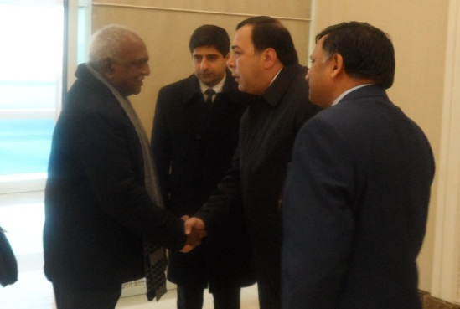

Shri Pon Radhakrishnan, Minister of State for Shipping, Road Transport & Highways being received by at the airport by Mr. Berdyniyaz Matiyev, Deputy Minister of Foreign Affairs of Turkmenistan on 26.11.2016

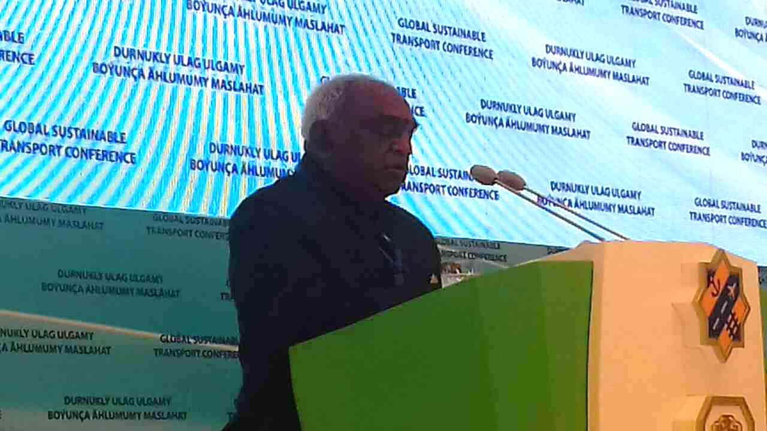

Shri Pon Radhakrishnan, Minister of State for Shipping, Road Transport & Highways being delivering statement at Global Sustainable Transport Conference, Ashgabat on 27.11.2016

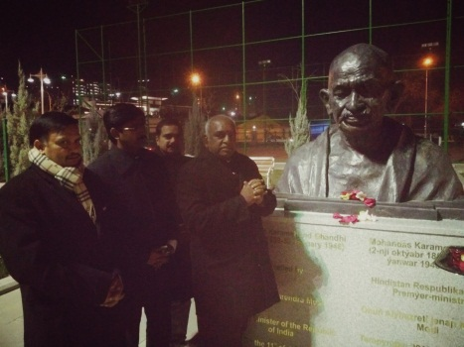

Shri Pon Radhakrishnan, Minister of State for Shipping, Road Transport & Highways and Dr T V Nagendra Prasad, Ambassador of India to Turkmenistan paying floral tribute to Mahatma Gandhi at Mahatma Gandhi Statue at Bagtiyarlik Sports Complex , Ashgabat on 26.11.2016

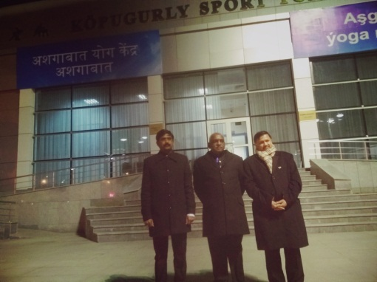
Shri Pon Radhakrishnan, Minister of State for Shipping, Road Transport & Highways and Dr T V Nagendra Prasad, Ambassador of India to Turkmenistan at Ashgabat Yoga Kendra on 26.11.2016

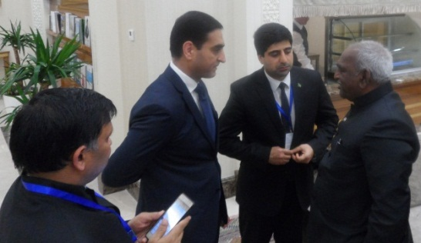

Shri Pon Radhakrishnan, Minister of State for Shipping, Road Transport & Highways being seen off by at the airport by Mr. Vepa Hajiyev, Deputy Minister of Foreign Affairs of Turkmenistan on 27.11.2016

