HIGH COMMISSION OF INDIA
PORT LOUIS
MAURITIUS

PRESS RELEASE
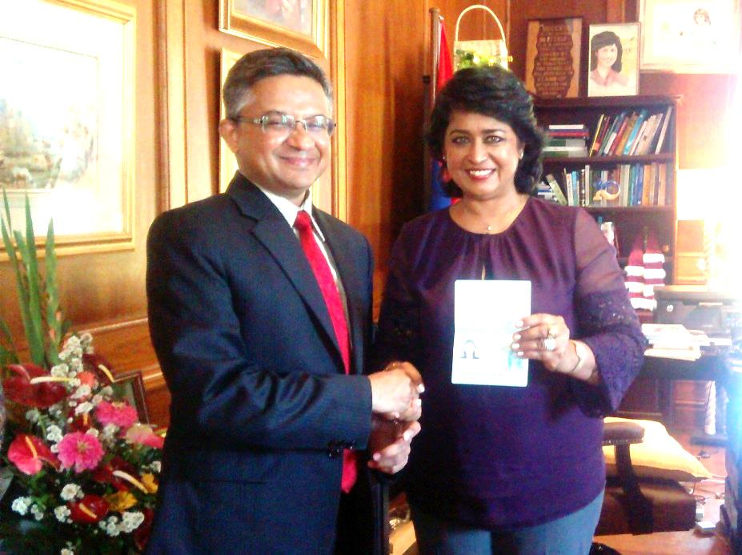

HANDING OVER OF OCI CARD TO H.E. DR. AMEENAH GURIB-FAKIM, PRESIDENT OF THE REPUBLIC OF MAURITIUS

On 17 October 2016, High Commissioner of India to Mauritius, Shri. Abhay Thakur, called on Her Excellency Dr (Mrs.) Ameenah Gurib-Fakim, President of the Republic of Mauritius, to personally hand over the Overseas Citizen of India (OCI) card to the Hon’ble President. High Commissioner conveyed that it is a rare honour that an incumbent Head of State is an OCI Card holder.

H.E President Gurib-Fakim expressed her profound happiness in receiving her OCI card and mentioned that it was a “very special moment” for her since in the process of applying for the OCI card, she had traced her Indian ancestral roots through the Archival records at the Mahatma Gandhi Institute in Mauritius.

High Commissioner briefed H.E President Gurib-Fakim about the main features and benefits of the OCI card scheme. Hon’ble President expressed her hope that the OCI card scheme of Government of India would continue to expand to cover many more Mauritians of Indian origin.

Issued on 17 October, 2016.

***

