Special Yoga Session on 14 May 2016

A special Yoga session was conducted for mothers of differently abled/autistic children at the Yoga Centre in Ashgabat on Saturday, 14 May 2016. The concerned organization ‘Yemne’ appreciated the kind gesture from Embassy of India, Ashgabat and the Yoga teachers.

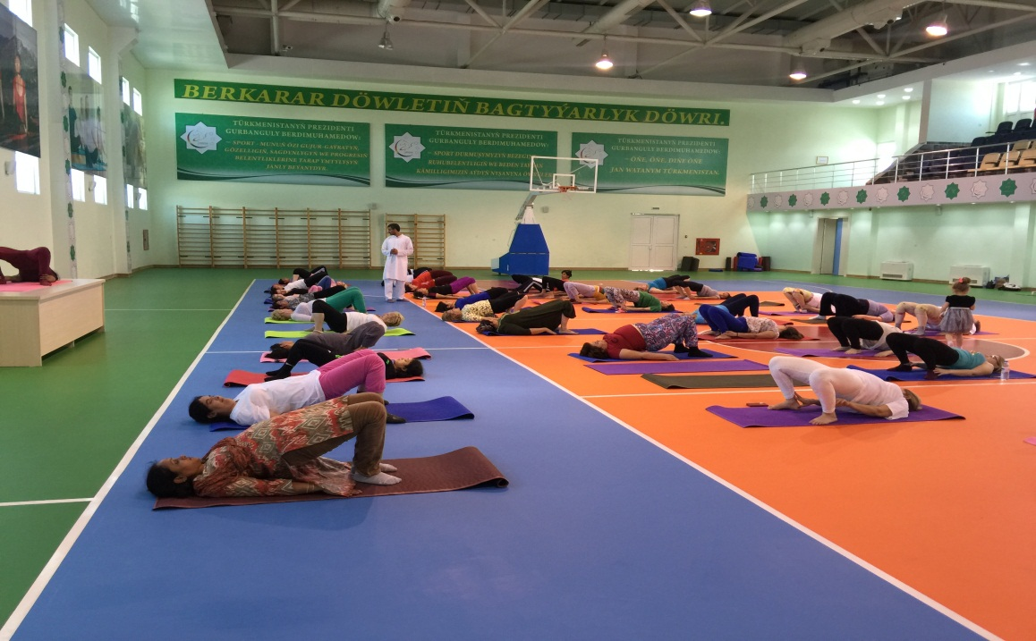
Yoga session

