Exhibition of Indian Films in Ashgabat

19-21 April 2016

Ambassador Dr. T.V. Nagendra Prasad opened the 3-day screening of Hindi films in Ashgabat Theatre in Ashgabat on 19 April, 2016. The event was organised by the Embassy in association with the Ministry of Culture of Turkmenistan. Speaking on the occasion, Ambassador Dr. Nagendra Prasad recalled the popularity of Indian films in Turkmenistan and growing bilateral relations. The opening film attracted houseful audience.
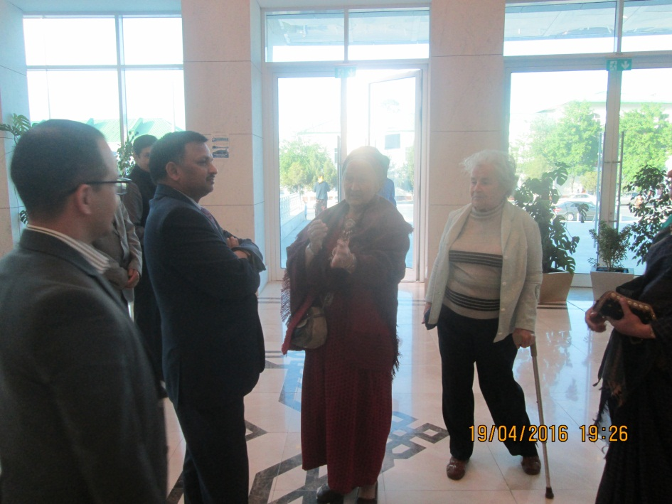

Guests arriving for the Indian Film Week

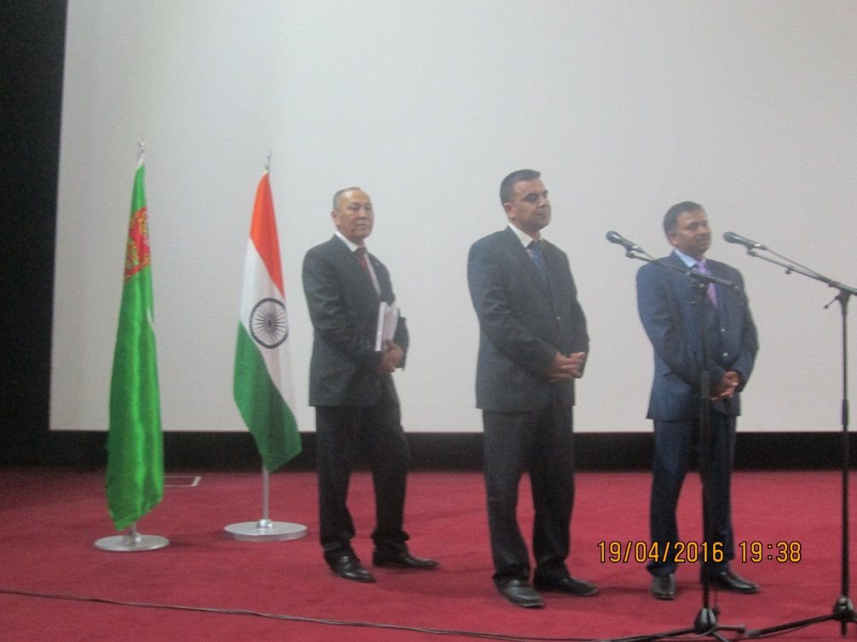
Ambassador Dr. T.V. Nagendra Prasad inaugurating the Film Week

