Celebration of ‘Diplomats Day’ om Ashgabat

The annual ‘Diplomats Day’ was celebrated in Ashgabat (Turkmenistan) on 18.02.2016 by the Ministry of Foreign Affairs, Government of Turkmenistan. A large number of Diplomatic Missions and International Organizations participated in events organized at Institute of International Relations. The events included stalls of different countries, sports events, lectures & cultural events. The function was presided over by Mr.Rashid Meredov, Deputy Prime Minister & Foreign Minister. The events provided a glimpse of the rich historical, social, economic and cultural heritage of different countries.

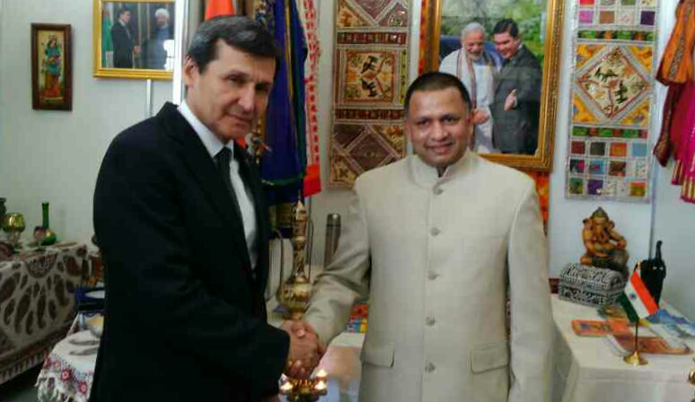
Ambassador Dr. T.V. Nagendra Prasad with DPM & Foreign Minister
Mr. Rashid Meredov

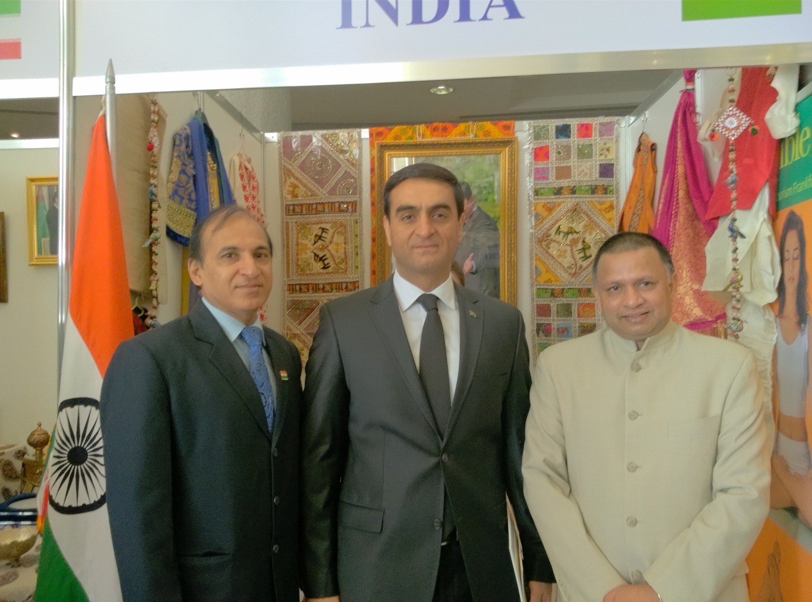

DPM & Foreign Minister Mr. Rashid Meredov with Ambassador Dr. T.V. Nagendra Prasad and Shri Sanjay Shukla, HOC

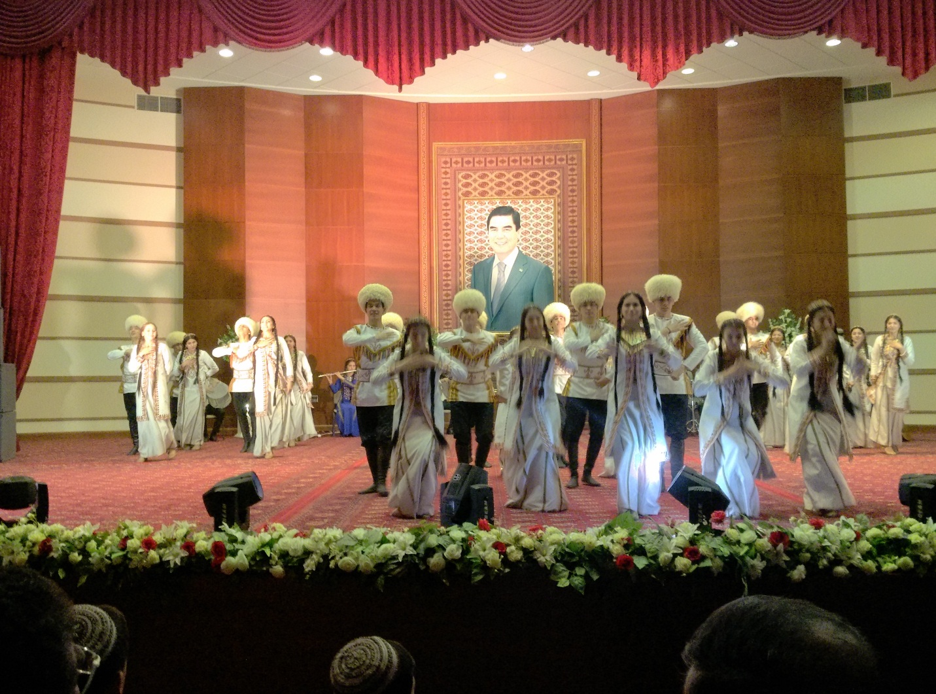
Cultural function
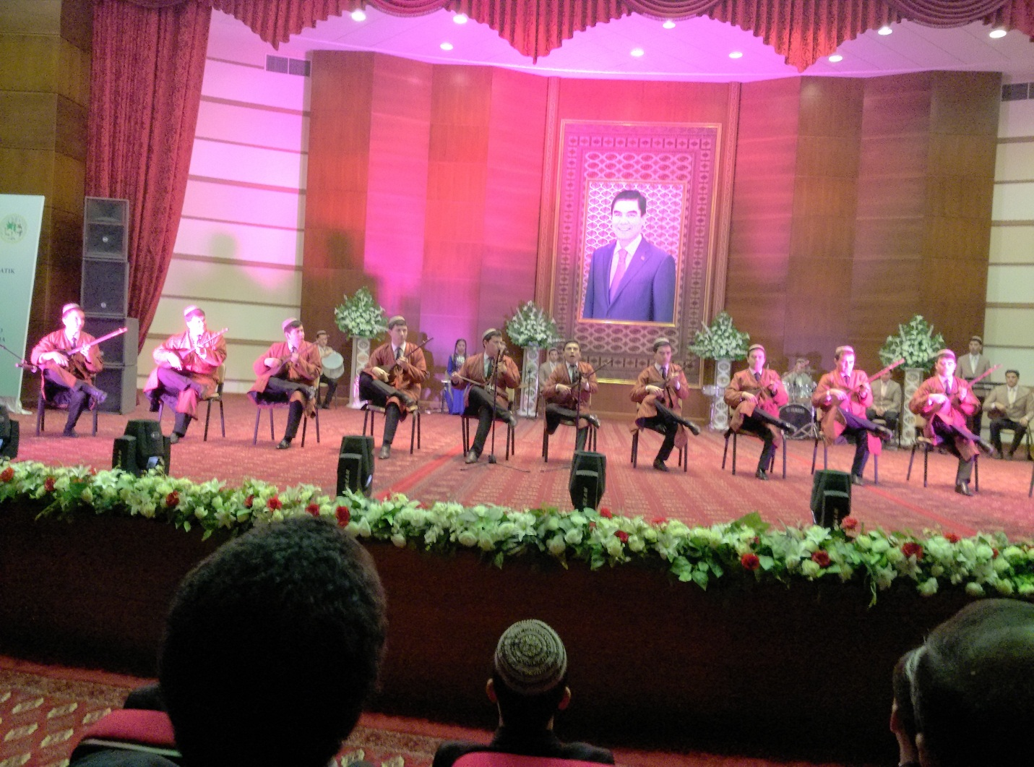
Cultural function

