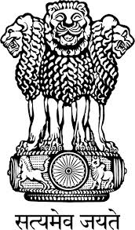
Embassy of India
Belgrade

Press Release

Incredible India at the 38th International Tourism Fair, Belgrade

Embassy of India Belgrade, in collaboration with the Government of India Tourism Office Frankfurt participated in the 38th International Tourism Fair held from 18th to 21st February 2016 at Sajam Fair, Belgrade, with the main theme of Ayurveda Tourism. Serbian Prime Minister H.E. Mr. Aleksandar Vucic inaugurated the Fair.

The Mission’s participation was highly successful in attracting large number of visitors, as probable tourists to India in future. India’s tourism potentials were showcased and the visitors were informed and advised on India’s tourism destinations, which helped the visitors to enrich their knowledge about India. This is the third time in a row that the Embassy has taken the initiative to promote India Tourism at the Fair. The number of Serbian tourists visiting India has shown year on growth of 17% in 2015, and the trend is likely to continue.

Free Consultations on Ayurveda were organised at the Pavilion in cooperation with the Serbian medical practitioners belonging to the Ayurveda Association of Serbia. The initiative was a great success as many visitors availed of the opportunity, and the Mission’s objective to reach out to the large public to inform them of the underlying advantages of embracing Ayurveda system of medicine as the holistic healthcare system was fulfilled. The visitors lauded the Mission’s efforts. The Ayurveda Association of Serbia also awarded Certificate of Appreciation to Ambassador for promoting Ayurveda in Serbia.

India’s participation was widely covered in local audio-visual, print and social media.

Place: Belgrade
Date: February 22, 2016

