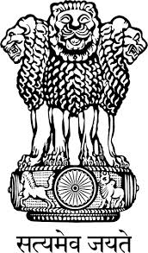
Embassy of India
Belgrade
Press Release
Incredible India at the 38th International Tourism Fair, Belgrade
Embassy of India Belgrade, in collaboration with the Government of India Tourism Office Frankfurt is participating in the 38th International Tourism Fair being held from 18th to 21st February 2016 at Sajam Fair, Belgrade, with the main theme of Ayurveda Tourism.
The India Pavilion is located at Hall No. 1 and showcases ‘Incredible India’ tourism potentials.
The Embassy of India has organised Free Consultations on Ayurveda by the medical doctors of the Serbian Ayurveda Association at the Pavilion.
This is the third time in a row that the Embassy has taken the initiative to promote India Tourism. The number of Serbian tourists visiting India has shown year on growth of 17% in 2015.

Place: Belgrade
Date: February 16, 2016

