ITEC DAY CELEBRATIONS

12 February 2016

ITEC Day celebrations were held on Friday, 12 February 2016 at the Embassy of India Chancery premises between 1730-1900 hrs. The Guest of honour was First Deputy Foreign Minister H.E. Vepa Hajiev. Speaking on the celebrations Ambassador Dr. T.V. Nagendra Prasad said India’s ITEC assistance has been well received by Turkmenistan and its citizens have benefited immensely from this programme and sought feedback from the participants. DFM Vepa Hajiyev thanked India’s assistance to Turkmen citizens in training them in various courses under ITEC and also said that efforts would be made to send more and more Turkmen students to benefit from the ITEC programme. The ITEC Alumni gave their feedback on their participation at ITEC and how it has made them richer both professionally and culturally. A dinner was hosted on the occasion. Alumni participated in the cultural events and enjoyed the evening to the beats of Bollywood music.

…………….

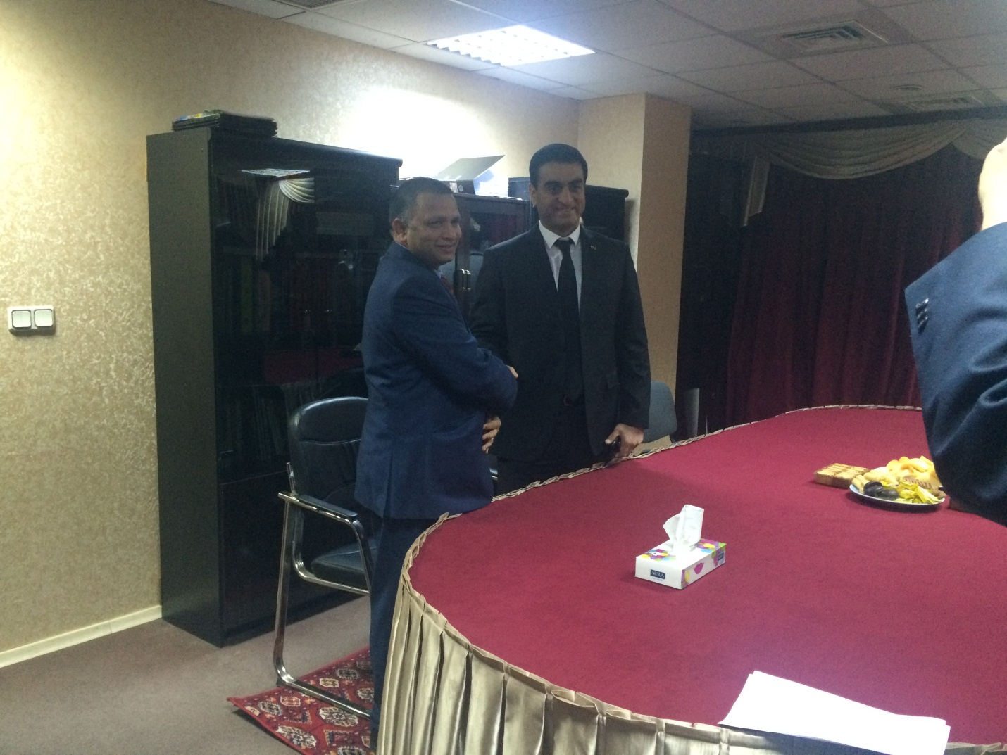

Ambassador Dr. T.V. Nagendra Prasad welcoming First Deputy Foreign Minister
H.E. Vepa Hajiev.
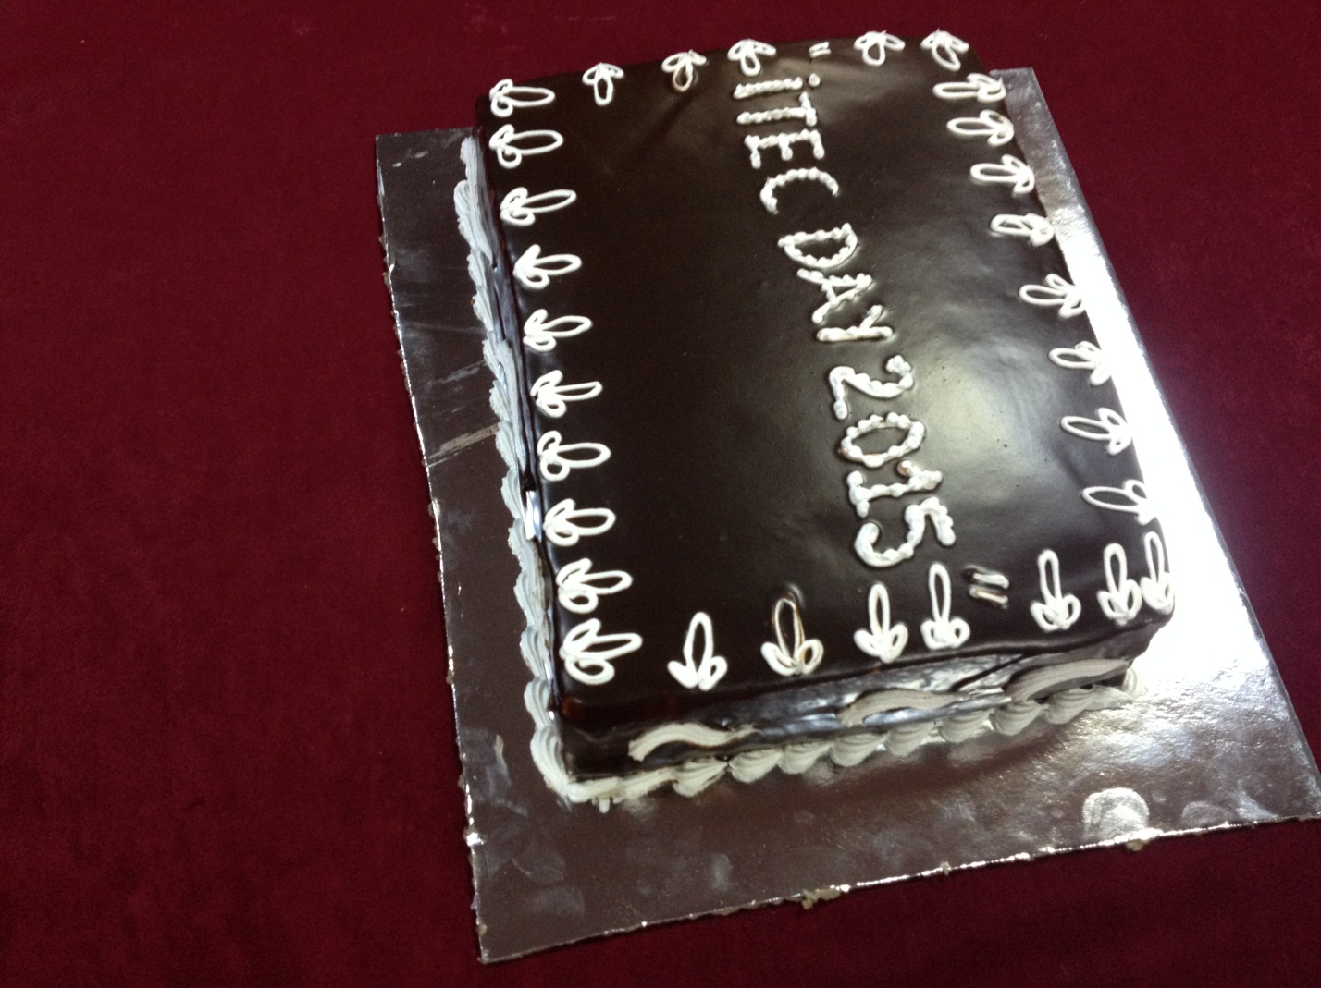
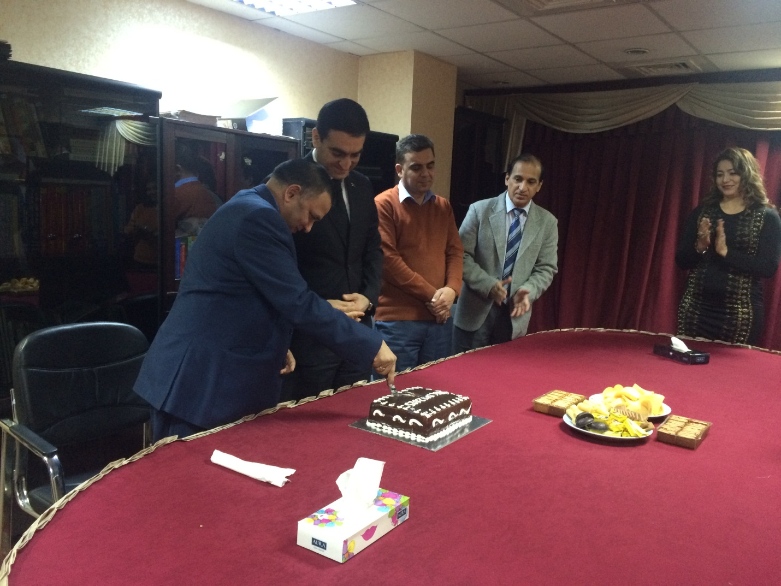
Cake cutting ceremony
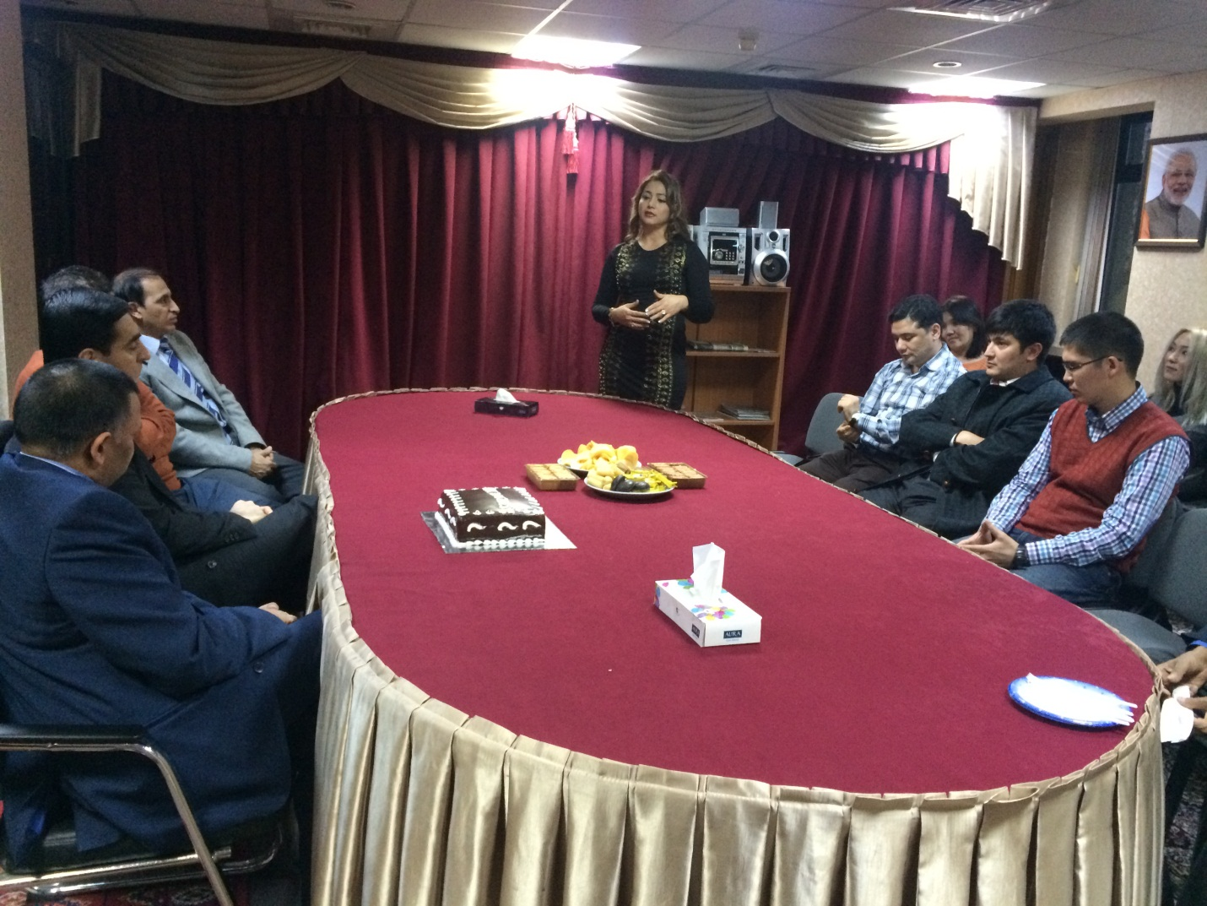
ITEC Alumni speaking on the occasion
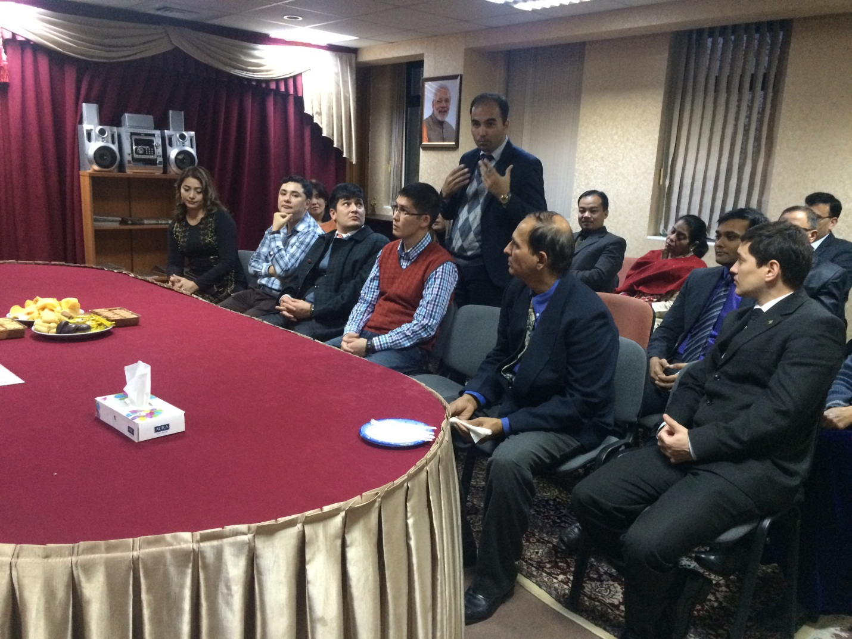

ITEC alumni speaking on the occasion

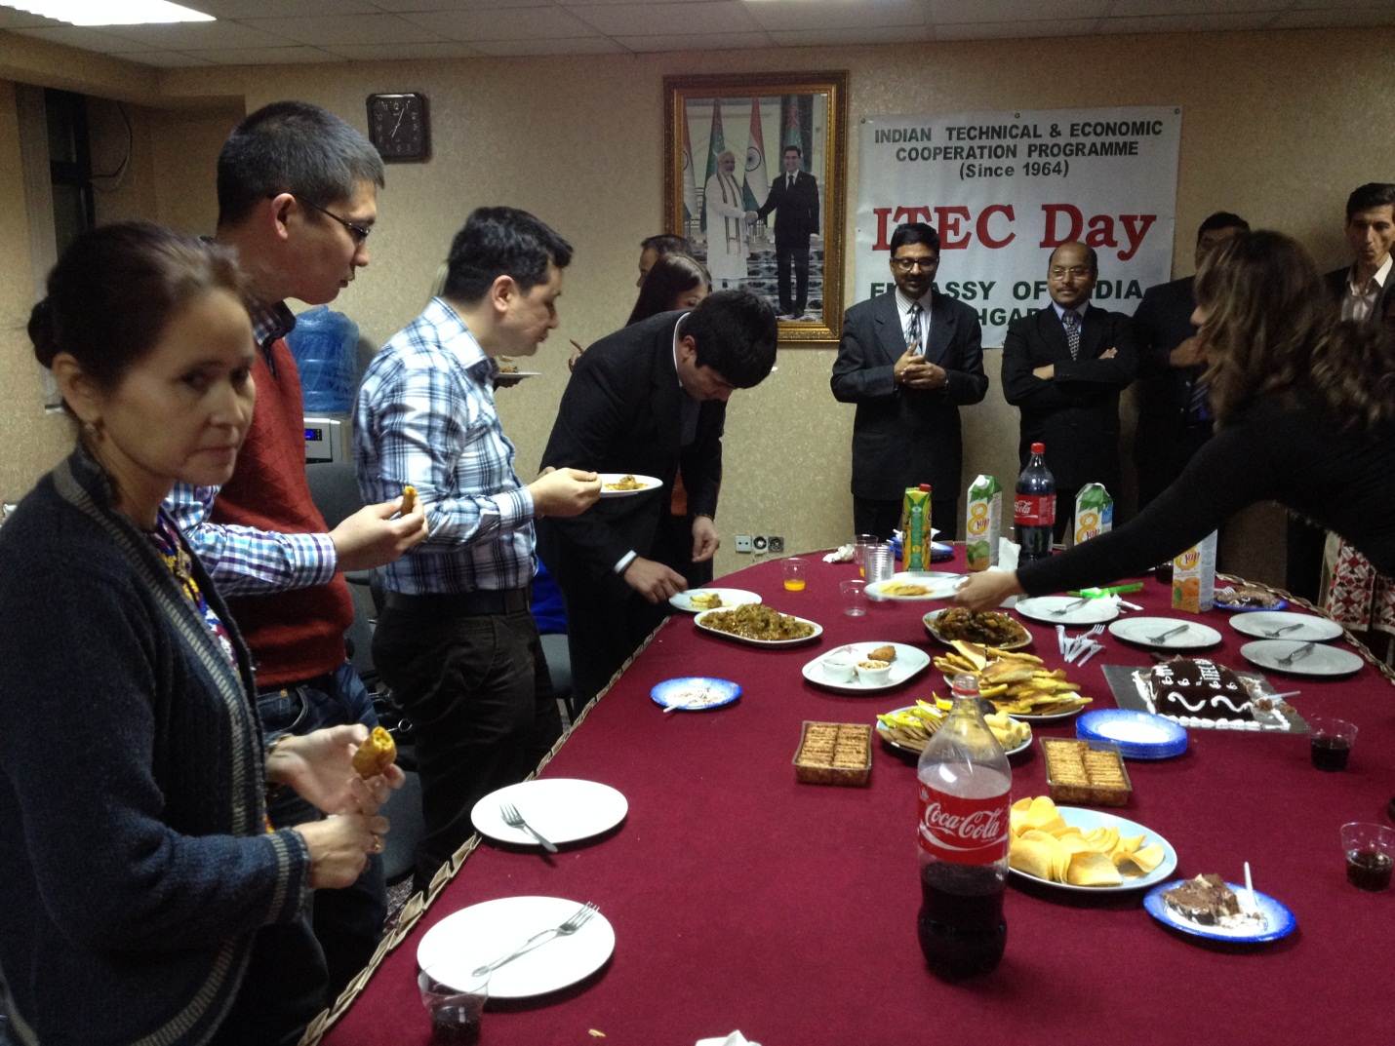

Dinner for the ITEC Alumni

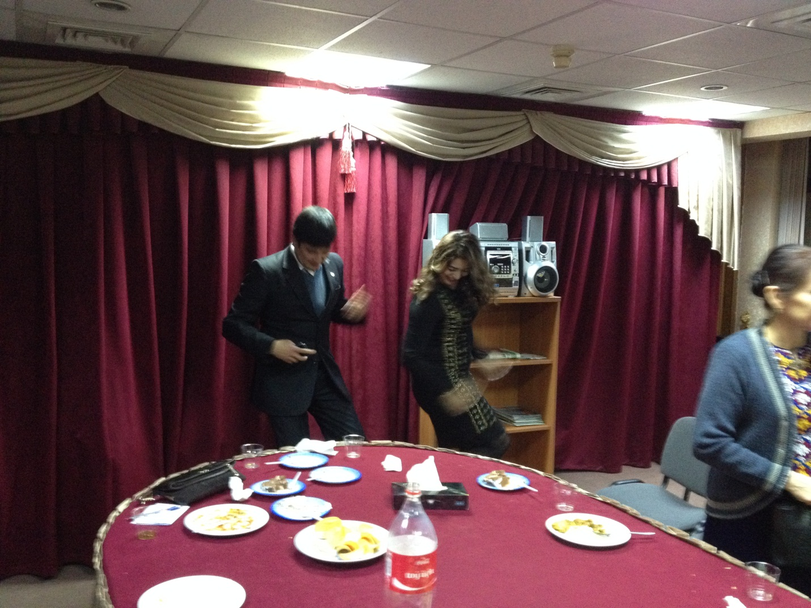

Dancing to the Bollywood music beat

