Yoga Therapy Course

Further to establishment of the Yoga Centre in Ashgabat during the visit of Hon’ble Prime Minister Shri Narendra Modi to Ashgabat in July, 2015, a ‘Yoga Therapy Course’ was introduced for the first time at the State Medical University in Ashgabat as part of the curriculum. The course was conducted by the Yoga Teachers deputed by ICCR for the Yoga Centre from 7 September 2015 to 4 January, 2016. Twenty students had successfully completed the Yoga Therapy Course.

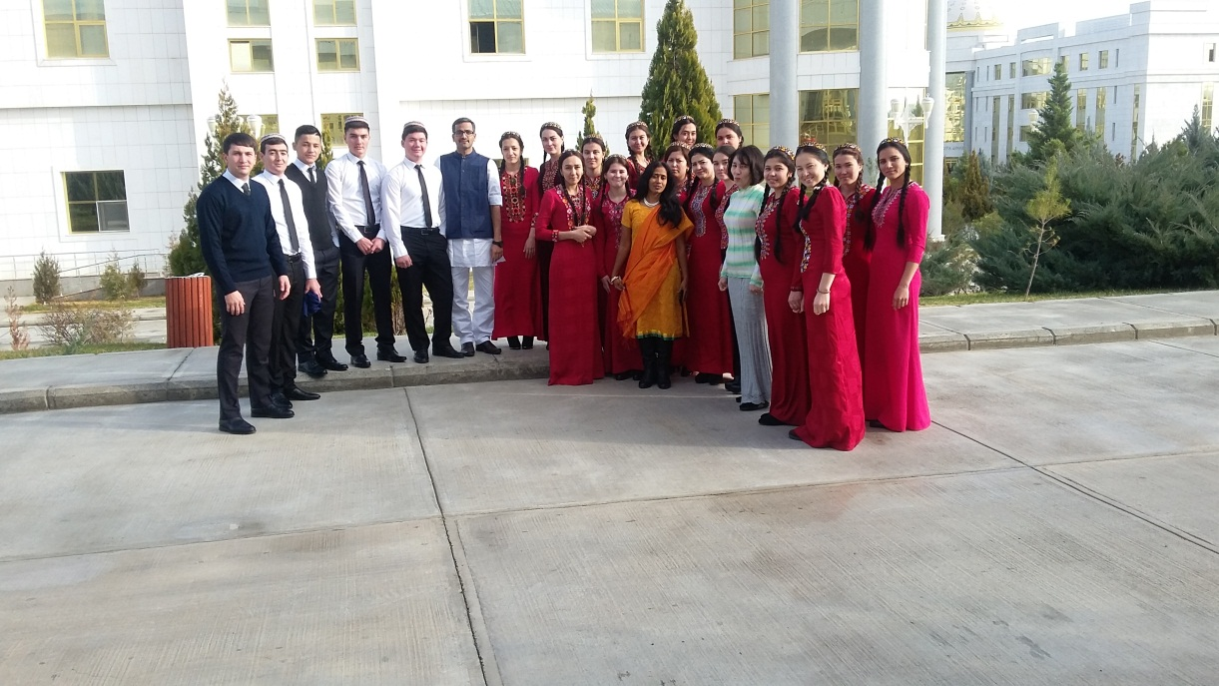
Students who successfully completed the Yoga Therapy Course with Yoga Teachers

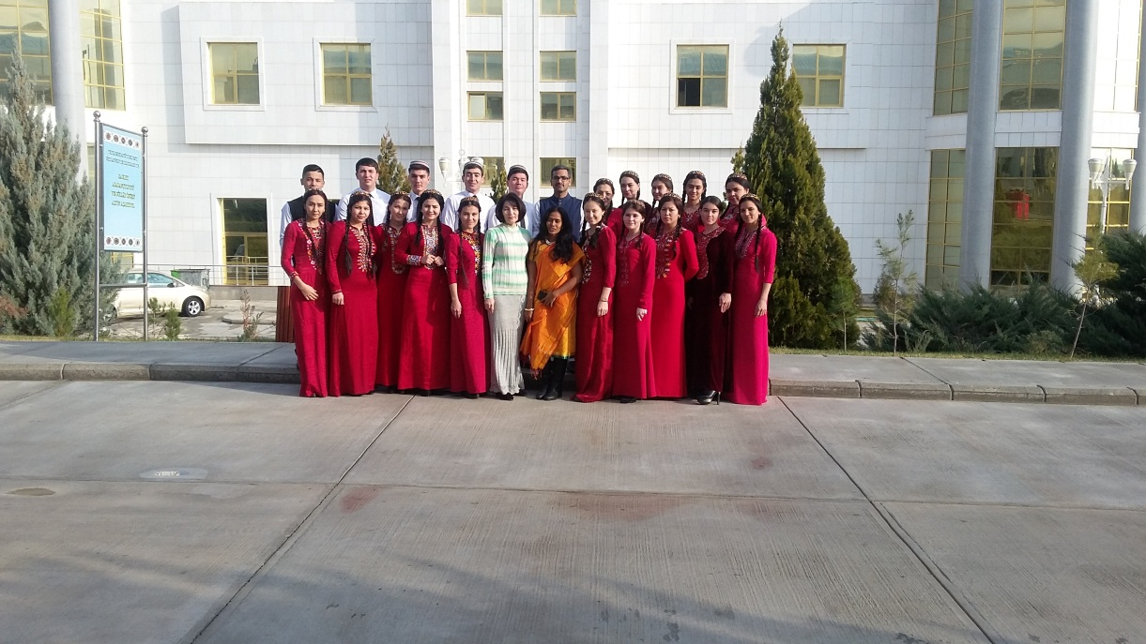
Group photo of students with Yoga Teachers

