APCRDA Delegation visit to Ashgabat
……………
Shri P. Narayana, Hon’ble Minister of Urban Development, led an 8-member APCRDA delegation from Andhra Pradesh to Ashgabat from 5-7 November, 2015 to study town planning of Ashgabat.
The delegation made extensive site visits in Ashgabat to have a first-hand look at various buildings, monuments, infrastructure and functioning of civil amenities departments in the city. Hon’ble Minister also held meetings with Deputy Chairman of the Cabinet of Ministers Mr. Sh. Durdylyyev, Mayor of Ashgabat M. Abilov and other senior officials. The visiting delegation paid tributes to Mahatma Gandhi at the Bagtyarlyk Sports Complex and visited the Yoga Centre.
In his meeting with Turkmen officials, Hon’ble Minister proposed Sister City agreement between Turkmenbashy and Vishakhapatnam.
……..

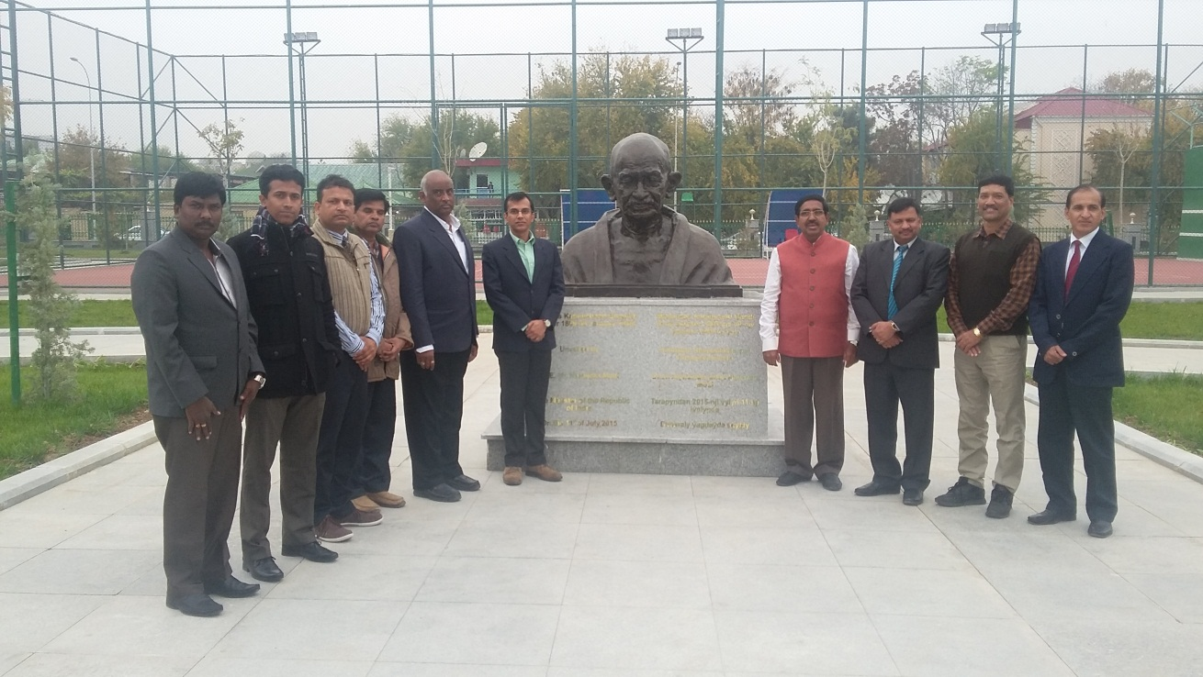
The APCRDA delegation led by Shri P. Narayana,
Hon’ble Minister of Urban Development
at Mahatma Gandhi’s Bust

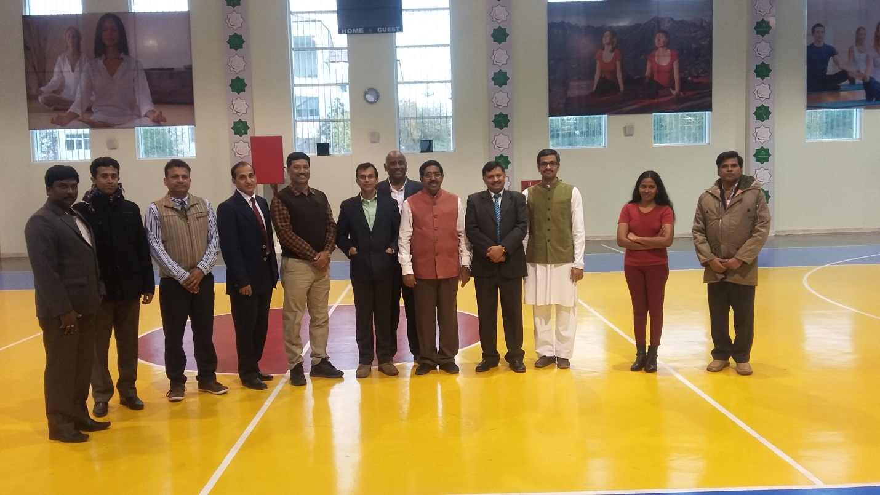

The APCRDA delegation led by Shri P. Narayana,
Hon’ble Minister of Urban Development at the Yoga Centre, Ashgabat

