‘Incredible India Road Show’
Ashgabat, 22 September, 2015
……..

An India Tourism seminar titled ‘Incredible India Road Show’ was held in Ashgabat on 22 September, 2015 to highlight the tourism potential of India to travel operators in Turkmenistan. The event was held at Yyldyz Hotel and inaugurated by Ambassador Dr. T.V. Nagendra Prasad. In his address, Ambassador mentioned about increasing number of tourists from Turkmenistan, direct flight connections and the recent visit of Hon’ble Prime Minister of India Shri Narendra Modi during which an Agreement of Cooperation on Tourism was signed.

Government of Turkmenistan was represented by Mr. Myrat Rhymow, Deputy Chief of International Relations Department of Committee of Tourism who spoke on the growing bilateral relations between the two countries. Other attendees included Travel operators in Ashgabat, diplomats resident in Ashgabat and other officials of Government of Turkmenistan. Besides the presentation by Shri Jitendra Jadhav, Assistant Director, Indiatourism, Frankfurt, a Yoga demonstration was conducted by the two Yoga teachers on the occasion. Embassy of India presented procedures on visa.
…………

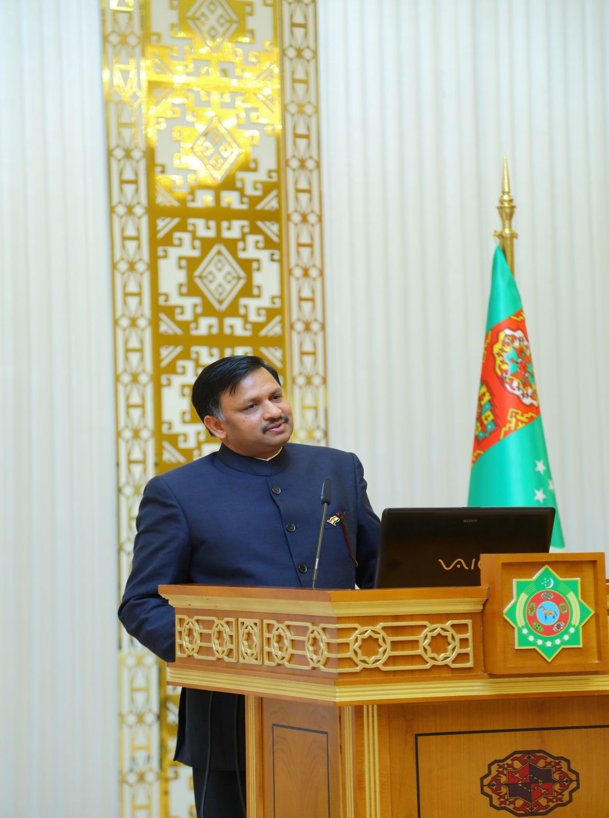
Ambassador Dr. T.V. Nagendra Prasad addressing the gathering

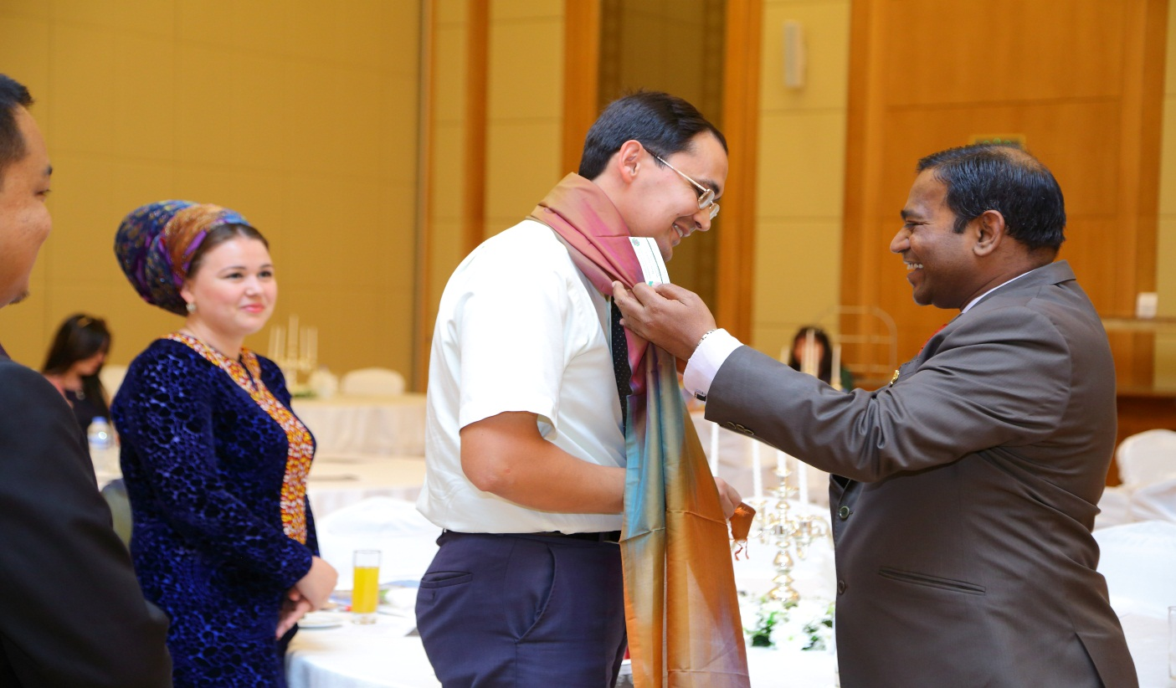

Mr. Myrat Rhymow, Deputy Chief of International Relations Department of Committee of Tourism being welcomed at the Incredible India Road Show

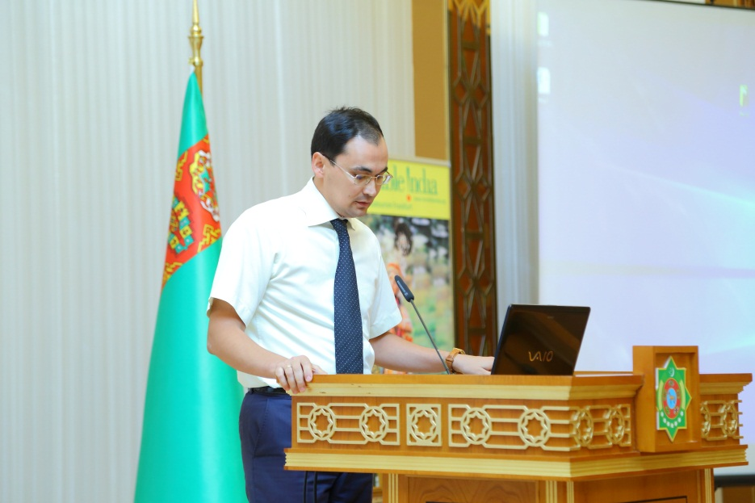

Mr. Myrat Rhymow, Deputy Chief of International Relations Department of Committee of Tourism speaking to the audience

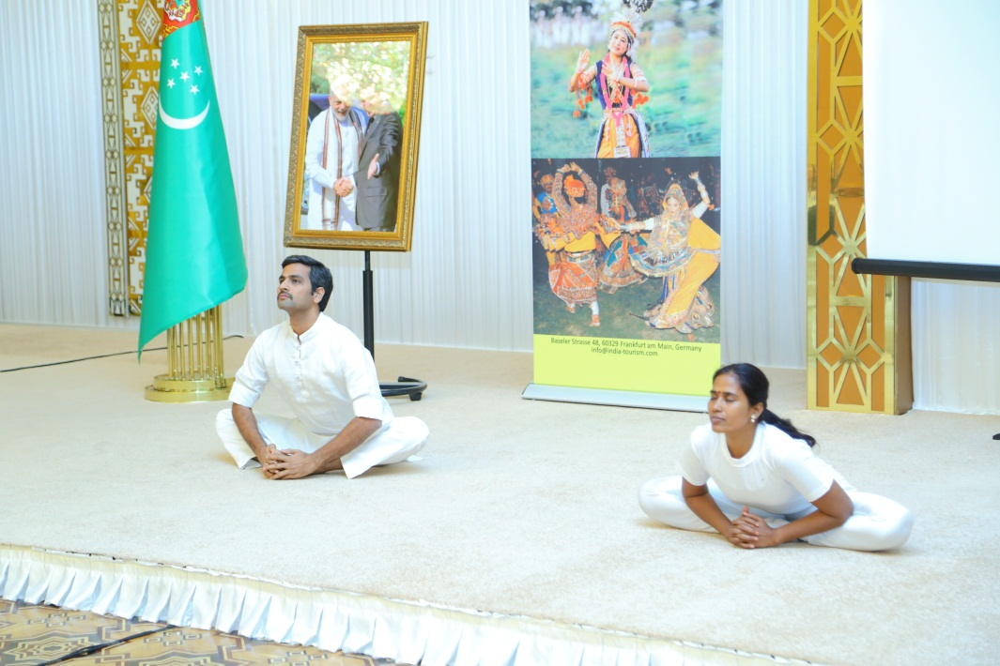
Demonstration of Yoga by Yoga Teachers

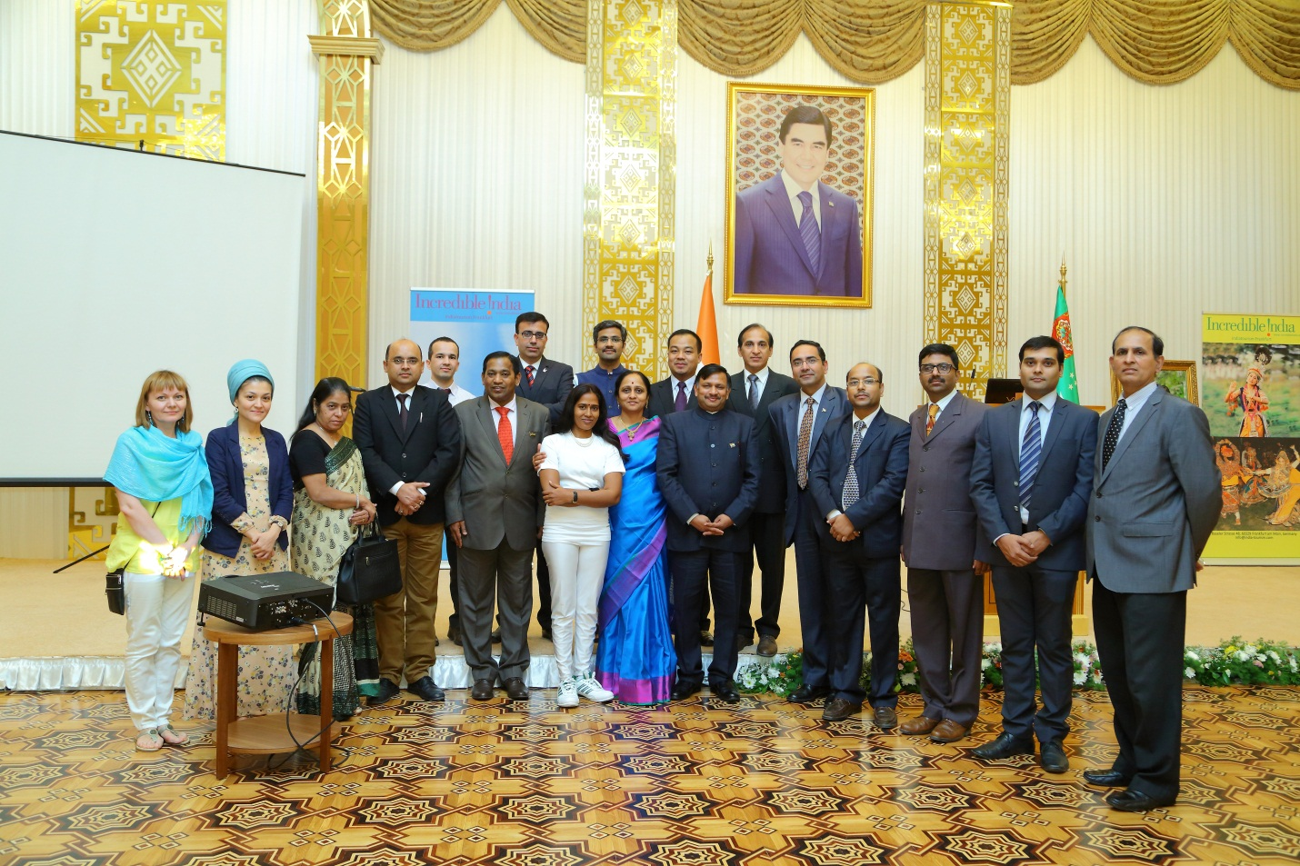

Group photo

