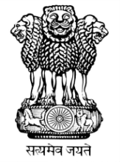 | भारत का राजदूतावास  मिंस्क  EMBASSY OF INDIA MINSK

PRESS RELEASE

Visit of Hon’ble MOS for Commerce and Industry
Smt. Nirmala Sitharaman to the Republic of Belarus
(6-7 September 2015)

The Hon’ble Minister of State for Commerce and Industry Smt. Nirmala Sitharaman visited Minsk, Belarus, from 6-7 September 2015 to co-Chair the 7th Meeting of India-Belarus Inter-governmental Commission (IGC) on Trade, Economic, Scientific, Technological and Cultural Cooperation in Minsk on September 7, 2015.

MOS had a meeting with Belarusian President H.E. Mr. Alexander Lukashenko, besides meetings with her counterpart and Chairman of the Belarusian-part of the Commission, Minister of Industry Mr. Vitaly Vovk and Chairman of the Belarusian Council of the Republic Mr. Mikhail Myasnikovich.

MOS thanked President Lukashenko for giving an opportunity to meet him and the hospitality extended to the President of India in June 2015, which will be remembered for a long time. MOS also recalled the allocation of a credit line of US$ 100 million during the visit of the President. She expressed hope that this will be used in areas of common interest.

Protocol signed at the IGC Meeting by the two co-Chairs outlined the roadmap for improving bilateral trade and economic relations. Simplification of visa procedures for business travelers, setting up a joint working group to discuss issues related with pharmaceutical sector, cooperation in new areas like tobacco, oil and gas exploration, agriculture and light industrial products, were highlighted in the Protocol.

A new target for bilateral trade to reach US$ 1 billion was set to be achieved by 2018.

Picture summary of the visit
Meeting with Belarusian President H.E. Mr. Alexander Lukashenko
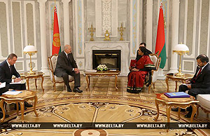

Ceremony of signing of Protocol
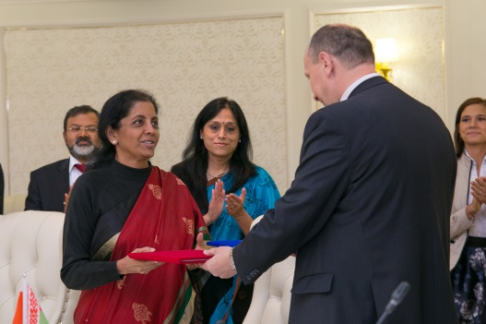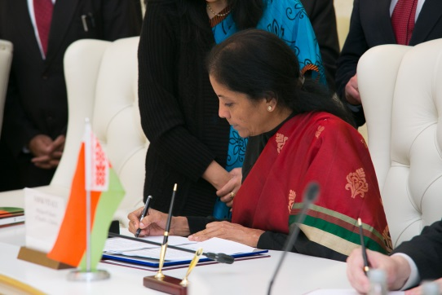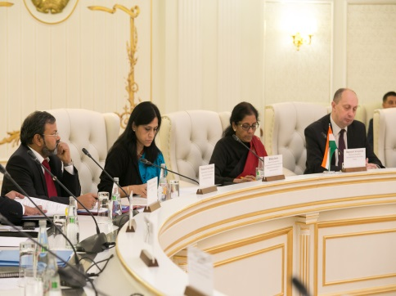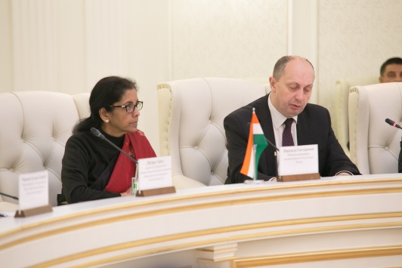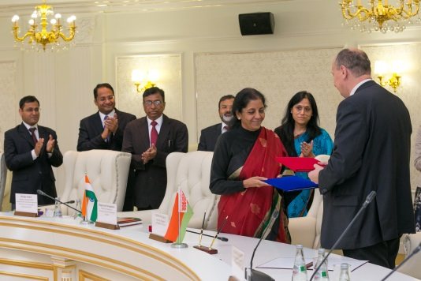
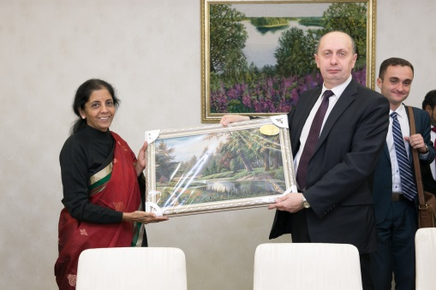 Exchange of Souvenirs

Meeting with Chairman of the Belarusian Council of the Republic Mr. Mikhail Myasnikovich
