Deputy Prime Minister of Turkmenistan Mr. Baymurat Hojamuhammedov’s meeting with
Hon’ble Minister of State (I/C) for Petroleum & Natural Gas Shri Dharmendra Pradhan
in New Delhi on 21.7.2015

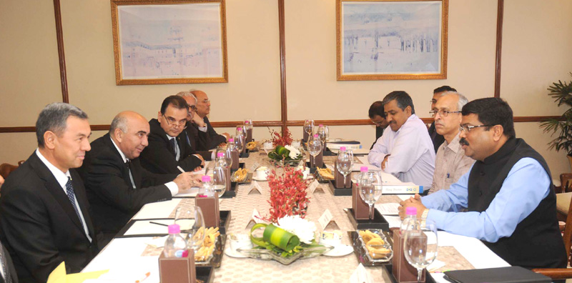
As a follow up on the meeting held between the Prime Minister and the President of Turkmenistan during the Hon’ble Prime Minister’s visit to Turkmenistan on 10-11 July, 2015, Deputy Prime Minister of Turkmenistan (Oil and Gas) Mr. Baymurat Hojamuhammedov visited New Delhi and called on Minister of State (I/C) for Petroleum & Natural Gas Shri Dharmendra Pradhan on 21 July, 2015.

Both sides discussed cooperation in the field of hydrocarbons and agreed to work with greater commitment to enhance bilateral energy ties. They also agreed to explore further possibilities of Indian Companies participating in the Turkmen hydrocarbon sector and the opening of a Fertilizer and Petrochemical Plants in Turkmenistan. They reiterated their commitments towards the TAPI project and promised to work towards the early commencement of the project.

Photo courtesy: Odisha Diary Bureau

