Up gradation and modernization of Turkmen-India Industrial Training Centre (TIITC), Ashgabat
……..
A Memorandum of Understanding (MOU) was signed during the visit of Hon’ble External Affairs Minister of India, Smt. Swaraj to Turkmenistan in April, 2015 to upgrade and modernize the Turkmen-India Industrial Training Centre (TIITC), situated at the Turkmen Architectural and Building Institute, Ashgabat with the financial Assistance from the Government of India. HMT (I) Bangalore supplied the necessary equipments and machines and has completed the Projects in the first week of July, 2015. The Ambassador of India to Turkmenistan H.E. Dr. T. V. Nagendra Prasad presented a report on the completion of the Project to the Minister of Education of Turkmenistan. The HMT (I) Bangalore shall also impart training to Turkmen Trainers to enable them run the Centre smoothly as part of the MOU.

Upgradation and modernization of Turkmen-India Industrial Training Centre (TIITC), Ashgabat

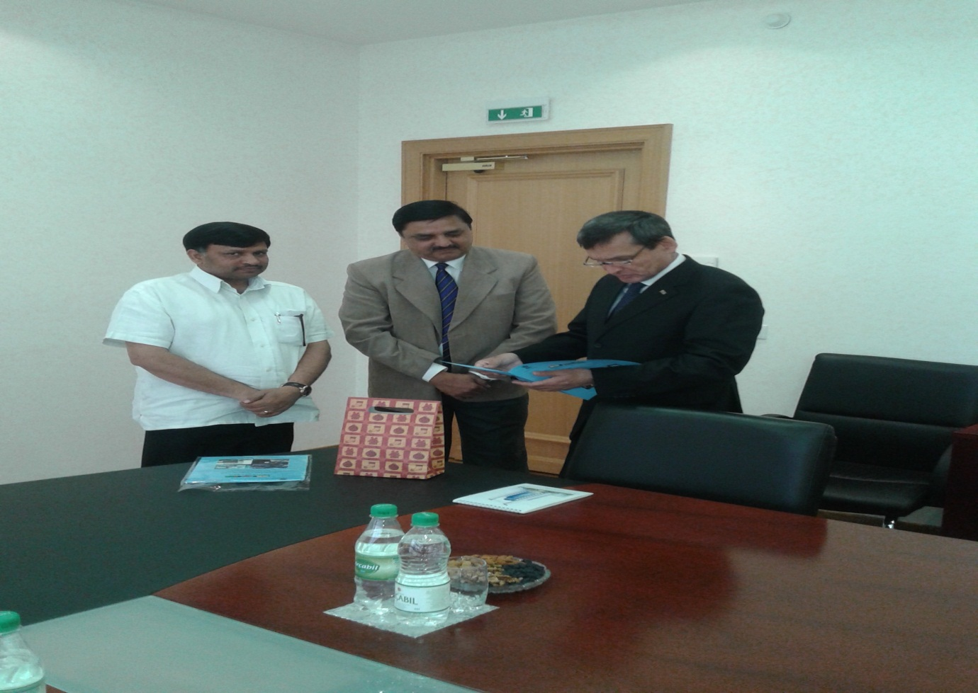
Ambassador Dr. T.V. Nagendra Prasad presenting the completion report of the Centre to the
Hon'ble Education Minister of Turkmenistan
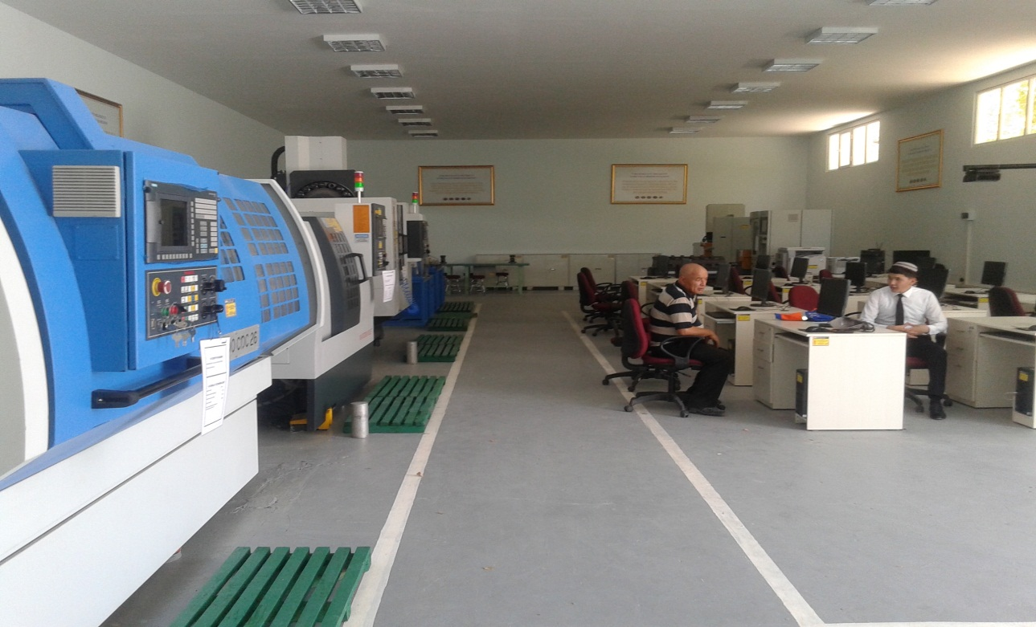
A view of the machinery at the Turkmenistan-India Training and Industrial Centre (TITIC)

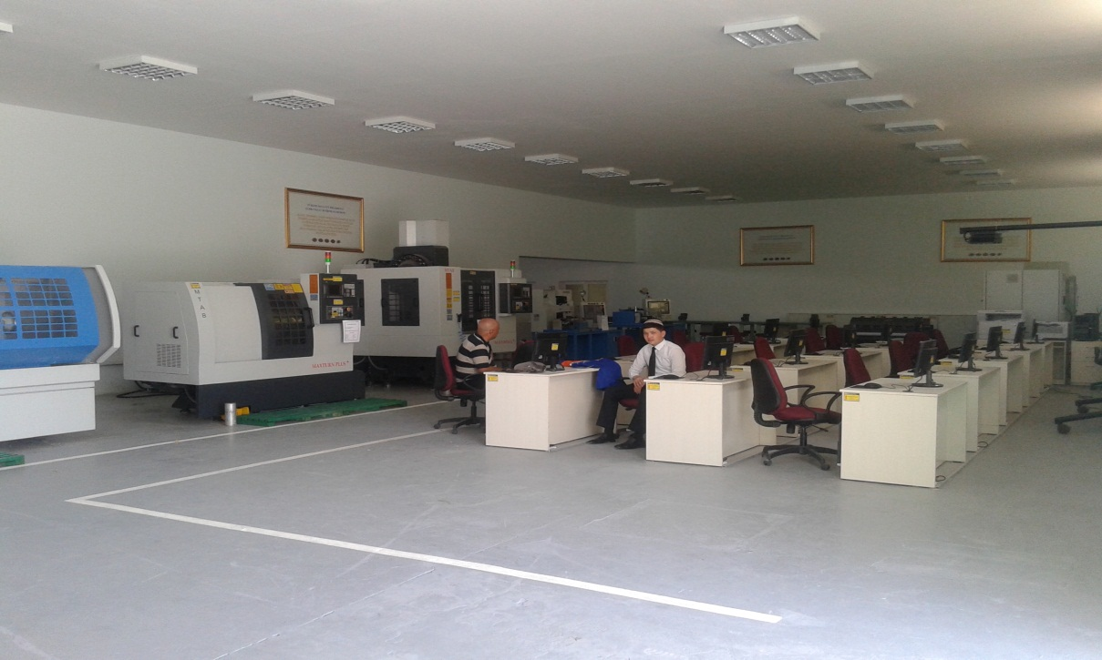
A view of the machinery at the TITIC Centre

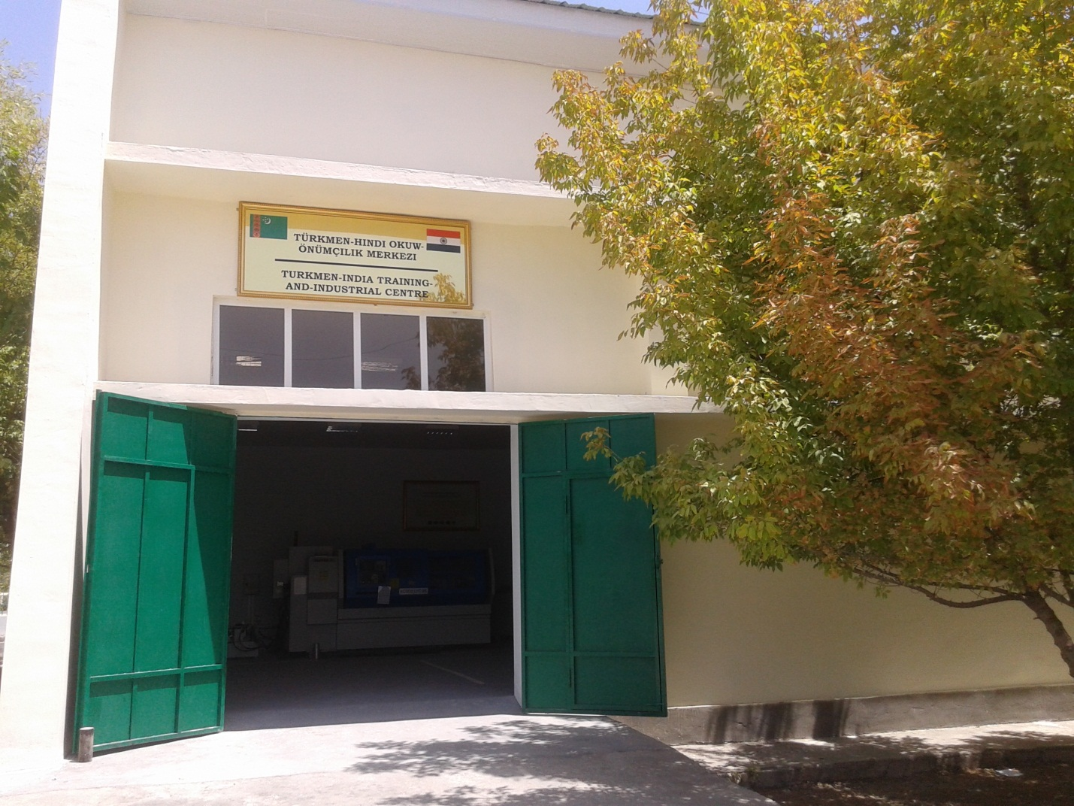
Turkmenistan-India Training and Industrial Centre (TITIC)

