Celebration of first International Day of Yoga

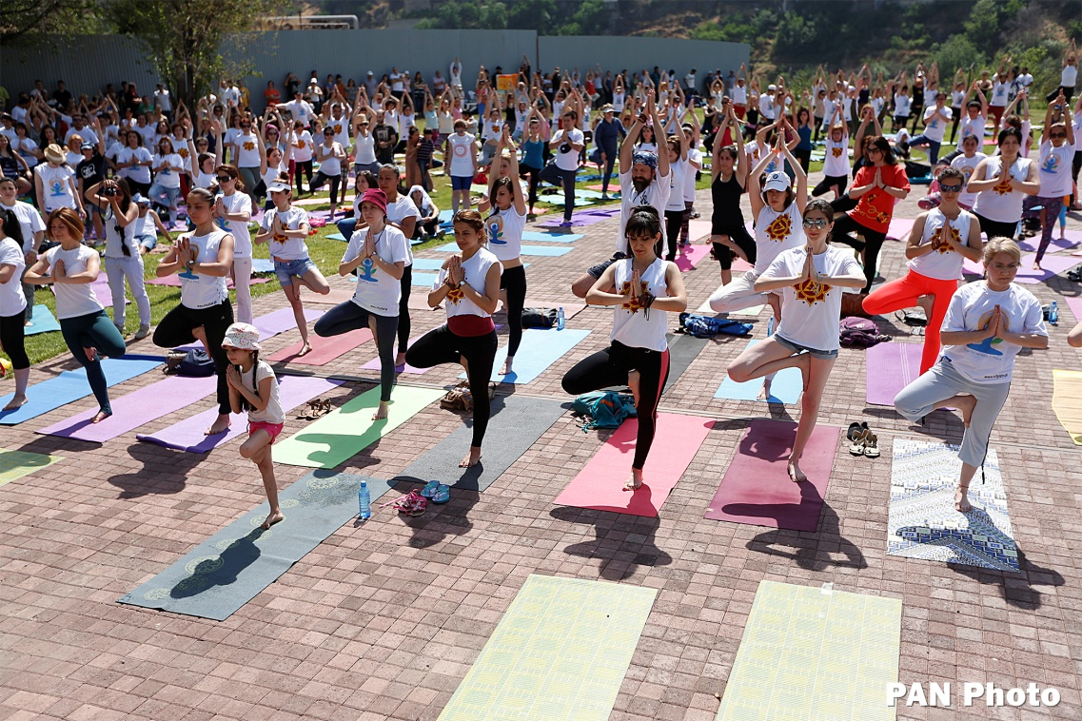

Armenia

The first International Day of Yoga (IDY) was observed in Yerevan (Armenia) at 1000 hrs at Tumo Park on 21 June 2015. The event was graced by Mr. Sergey Manassarian, Deputy Foreign Minister, Mr. Aram Sukiasyan, Deputy Mayor of Yerevan and Prof. M. Narimanyan, the Rector of Yerevan State Medical University (YSMU). Mr. Garik Hayrapepyan, an authorized representative from the United Nations Mission in Yerevan read out UNS-G’s message on this occasion. A day prior to the main event, a yoga ‘flashmob’ was organized by the Armenian Yoga Federation in which Embassy officials also participated and the same was widely covered by the media.

Ambassador Dr. Suresh Babu highlighted the importance of Yoga in the present day and also thanked the participants for their enthusiasm in doing Yoga. DFM, Deputy Mayor and the YSMU Rector also addressed the gathering briefly by underscoring the yoga’s significance and its benefits. Over 250 people belonging to various age groups and from different walks of life performed various Yogasanas ranging from the lighter ones to slightly tricky asanas. The common protocol was demonstrated by Armenian yoga teachers with the description of these asanas by Shri Hari Kumar Sharma, a yoga teacher from India. In coordination with the XP Division of the Ministry, the entire event was live streamed on the IDY website through YouTube Channel. The entire event was widely covered by local TV and web channels.

Ambassadors of Iran, Japan, Lithuania, Turkmenistan, Switzerland, Argentina and a few other expats have also practiced yoga protocol in the scorching sun with temperature touched +34 C. Due to intense sun despite morning hours, the master classes session as earlier planned had to be cancelled.

The IDY was not only received and welcomed by Armenians, but also aroused their curiosity in knowing further about Yoga. A few photographs taken on the occasion are attached with this message.

Georgia
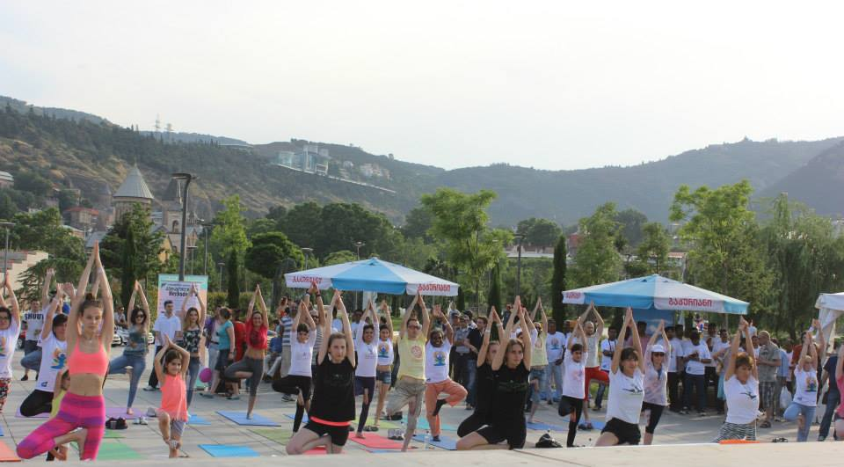

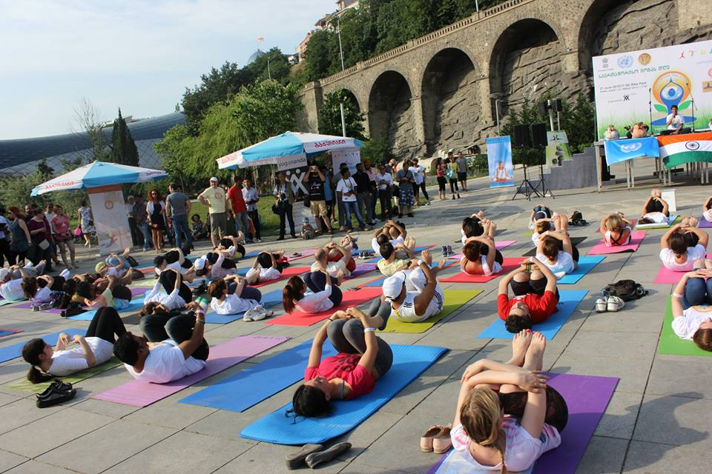

The first International Day of Yoga (IDY) was observed in Tbilisi (Georgia – concurrent accreditation) at 1700 hrs at Rikhe Park on 21 June 2015. The event was graced by Mr. Irakli Lekvinadze, Deputy Mayor of Tbilisi and senior officials from the City Hall. Despite our prior agreement, no representative from the United Nations Mission in Tbilisi was present to read out UNS-G’s message.

Ambassador Dr. Suresh Babu drove to Tbilisi immediately after the event in Yerevan. Last week’s flood disaster in the city and free prowling of wild animals in different areas of the city which run away from the local zoo park and attacked pedestrians, the turnout of participants was modest though large number of Indians and Georgians gathered to cheer up and encourage those who actually performed during the event. Rumours were spread around the city on possible sudden attack by wild animals and have forced enthusiasts to confine to their homes. However, despite best possible efforts by the organizers, about 100 participants mostly younger generation performed various Yogasanas including kapalbharti and meditation. The common protocol was demonstrated by Indian and Georgian yoga teachers with the description of these asanas by a yoga teacher from India who is attached with the leading yoga centre in Tbilisi i.e. Ananda Yoga Centre. Thereafter, master classes session was given by each yoga centre. The somber mood in the city was still evident yesterday, due to flood deaths and loss of property worth of US $ 50 mn and we had to drop all Indian cultural items from the programme. However, local TV and web channels covered the event.

The IDY was not only received and welcomed by Georgians but also aroused their curiosity in knowing further about Yoga. A few photographs taken on the occasion in Tbilisi will be sent separately.

*****

