International Day of Yoga Celebrations at Gorky Park, Minsk
Sunday, June 21, 2015
The Embassy of India in Minsk, with the support of the Government of the Republic of Belarus, is organizing International Day of Yoga (IDoY) in Gorki Park, Minsk on June 21, 2015. The programme shall begin at 0900 hrs.
The Embassy has organized two Curtain Raisers in Minsk – the first in Hotel Belarus on May 5, 2015, and the second in Mitso University on May 20, 2015 to create awareness about the benefits of Yoga. The events were well-received and significantly noticed among the locals (photos attached).
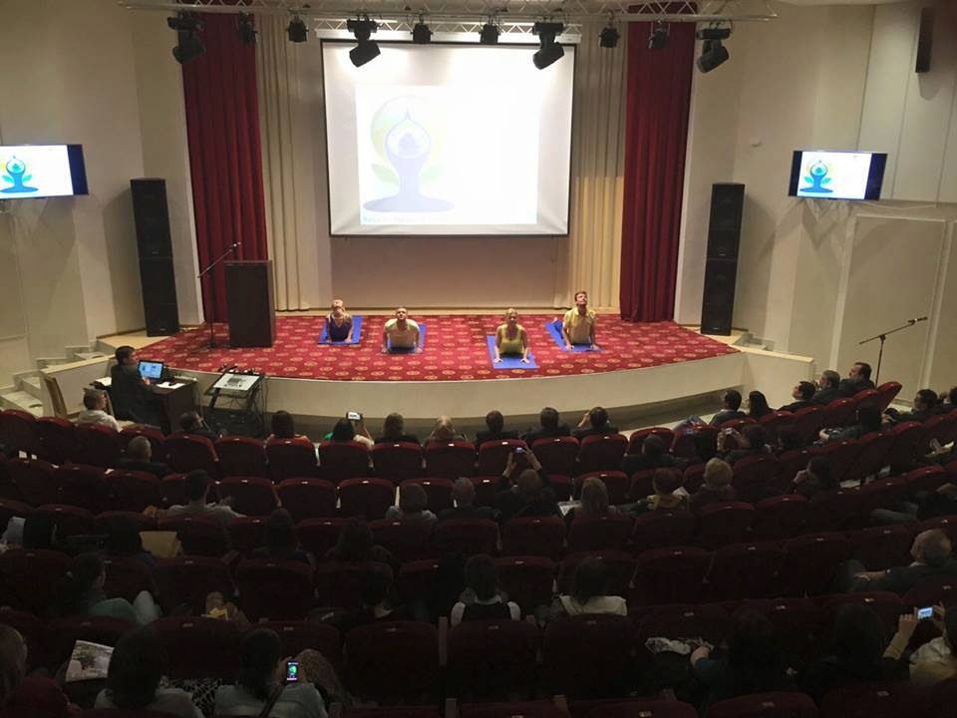
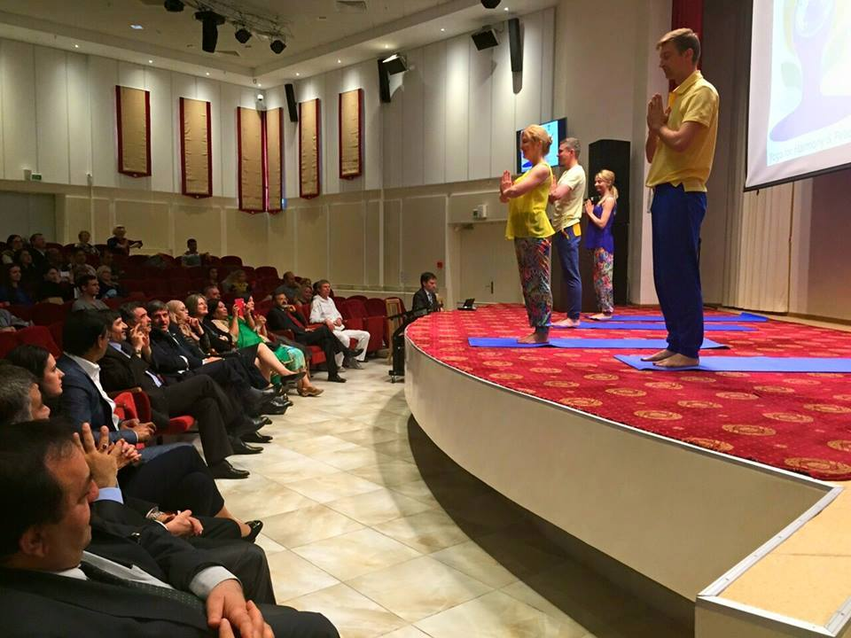

The Embassy has also mobilized local yoga groups to give wider publicity to the event. A website in Russian www.studiayoga.by has been launched by a volunteer to spread the word. The volunteers have done a lot of publicity through leaflets, flyers, information brochures etc during the last one month. Three flashmob events were organized in public places and shopping malls. The local FM Radio has been broadcasting information about the IDoY celebrations.
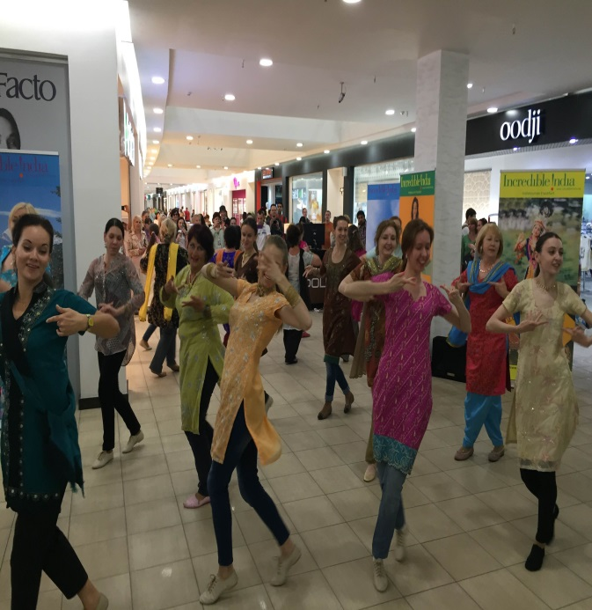
Flashmobs in shopping malls
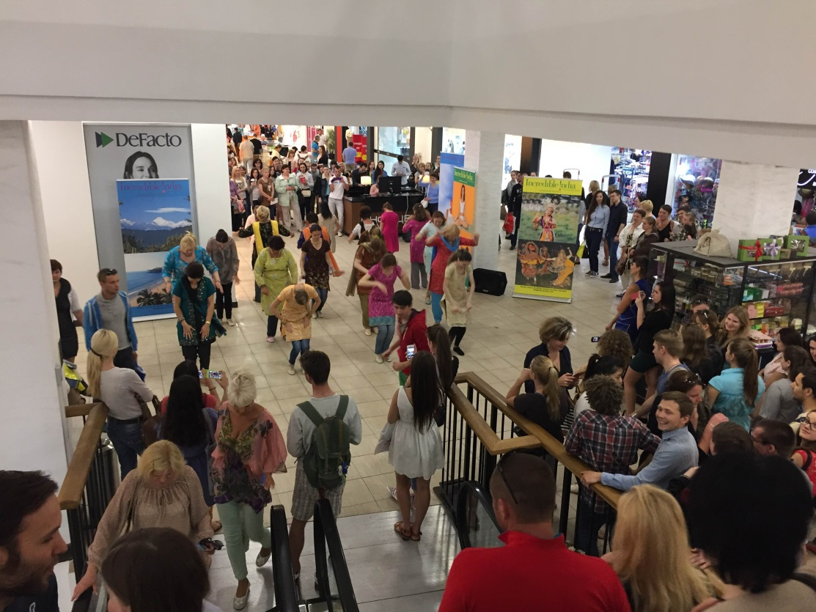
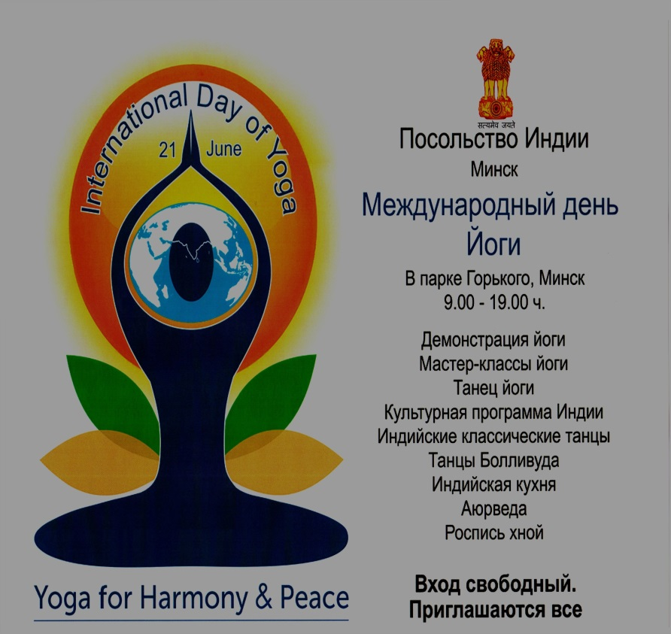

The Government of the Republic of Belarus is actively supporting this event. The Minsk Municipal authorities extended assistance in advertising this event in local buses/trams/metros.
The celebrities were also approached to be part of the event. A popular Hindi film star Prateek Patil (Babbar) confirmed his participation at the celebrations.
The live webcast of the IDoY celebrations in Minsk will be relayed worldwide from 1000 hrs. to 1030 hrs. (Local Time).
The programme on June 21 shall begin at 0900 hrs in Gorki Park with a welcome speech by Ambassador followed by simple yogic postures “Surya Namashkar” (Salutation to Sun) by the qualified instructors. His Excellency Mr. Boris V. Svetlov, Minister of Culture of Republic of Belarus, will be the chief guest of the event.
Nearly 5000 people are expected to be part of this great event.

