Permanent Mission of India
Geneva

Press Release
26 May 2015

India successfully concludes the Presidency of
the 68th World Health Assembly

Hon’ble Minister of Health & Family Welfare H.E. Mr. Jagat Prakash Nadda successfully steered the proceedings of the 68th Session of the World Health Assembly, in his capacity as its President, that took place in Geneva from May 18-26, 2015. It was after a gap of 19 years that India assumed the Presidency of the World Health Assembly, the highest decision making body of the World Health Organisation.

2. The significant outcome of the 68th World Health Assembly is the adoption of a Global Action Plan on Anti-Microbial Resistance (AMR), which prepares a blueprint with specific actions and timelines for WHO as well as Member States to address the growing threat of AMR. The UN General Assembly is expected to hold a High-level Segment on AMR in 2016 to further highlight the need for comprehensive implementation of the Plan. Among other major outcomes of the 68th World Health Assembly include bringing adverse health impacts of air pollution to the main agenda of the World Health Organization and extension of the implementation timeframe of the Global Strategy & Plan of Action on Public Health Innovation & Intellectual Property (GSPOA). The Assembly also endorsed the Director General’s action plan to strengthen the emergency response capacities of WHO and approved a 8% increase in WHO’s programme budget for 2016-17.

3. India played a constructive role in the adoption of consensus resolutions on AMR and Air pollution and also co-sponsored the resolution on GSPOA. India used the opportunity of its Presidency to reiterate its commitment to WHO and announced voluntary contributions to the tune of US $ 2.1 million towards the new WHO contingency fund, the pooled fund for implementation of R&D demonstration projects and the Member State Mechanism on SSFFC Medical Products.

4. In his capacity as the President of the 68th World Health Assembly, Hon’ble Minister and the Director-General of WHO Dr. Margaret Chan, jointly inaugurated a photo-exhibition on “Yoga for All, Yoga for Health”, on May 19th, 2014. This is the first major event on Yoga at the United Nations level since the adoption by the UN General Assembly last year of a resolution that declared June 21 as the International Day of Yoga, and a precursor to the first observance of the International Day of Yoga on 21st June this year in Geneva.

5. Hon’ble Minister also led the Indian delegation at the Commonwealth Health Ministers Meeting, 8th NAM Health Ministers Meeting and BRICS Health Ministers Meeting that were held on the sidelines of the Assembly. He also had bilateral meetings with his counterparts from China, UK, USA, Sweden, The Netherlands, South Africa, Brazil, Timor-Leste and Turkmenistan.

*****

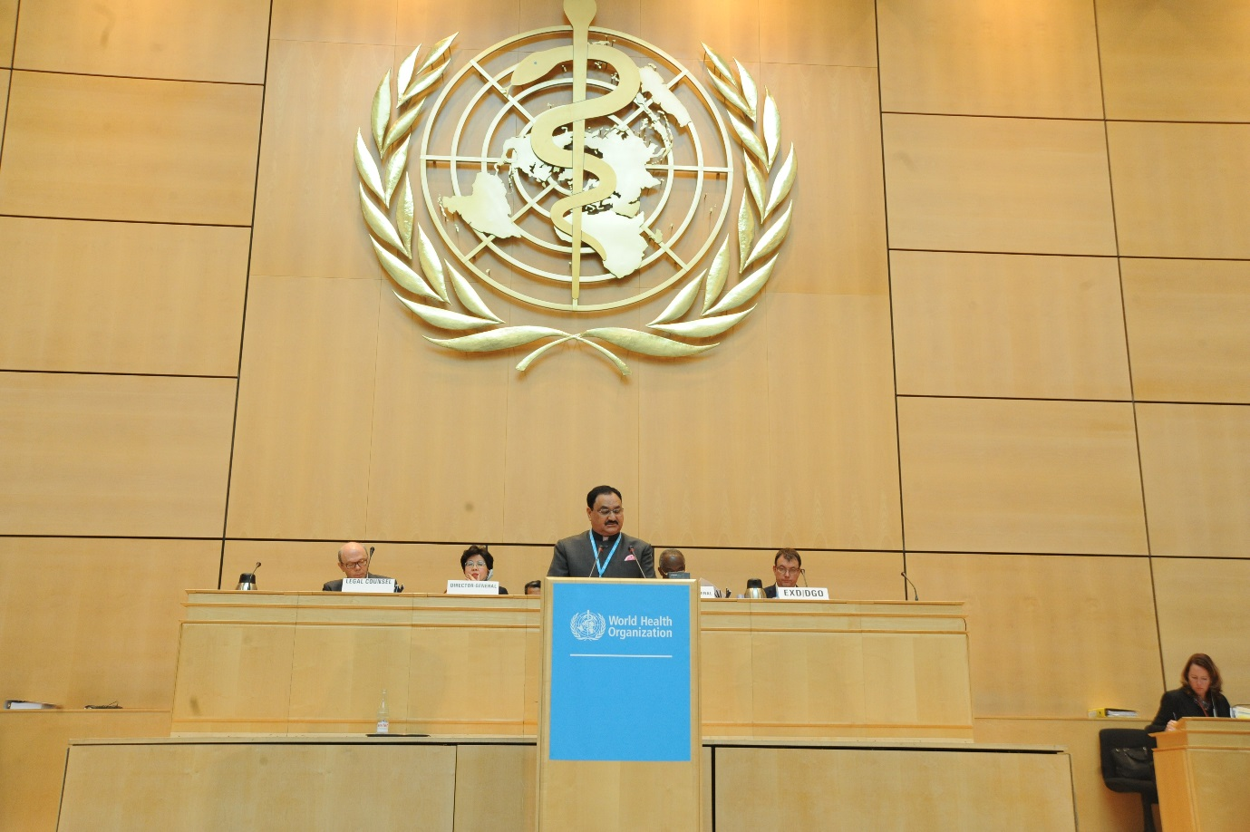
Hon'ble Minister of Health & Family Welfare, Shri Jagat Prakash Nadda addressing the 68th World Health Assembly after taking over the Presidency of the Assembly, Geneva, 18 May 2015

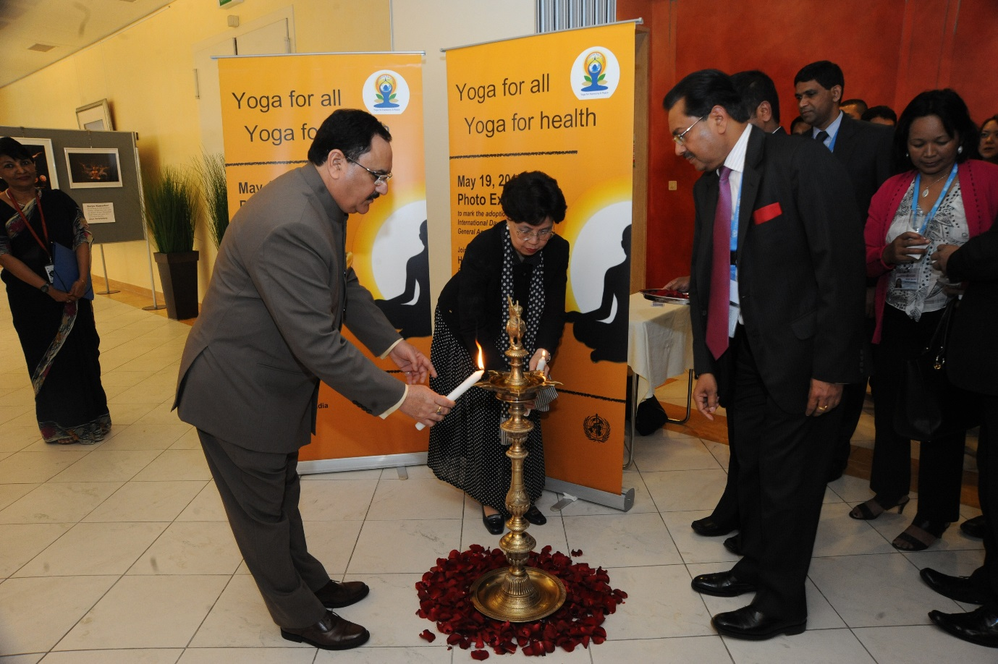
Hon'ble Minister of Health & Family Welfare, Shri Jagat Prakash Nadda inaugurating a Photo Exhibition – ‘Yoga for All, Yoga for Health’, jointly with the Director-General of World Health Organization, Dr. Margaret Chan, Geneva, 19 May 2015

