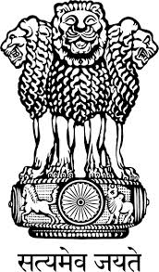

Embassy of India
Belgrade
Press Release

RITES Limited visits Serbia
A delegation of RITES Ltd., a Government of India Enterprise under the aegis of Indian Railways, led by Mr. S. K. Luthra, Executive Director visited Serbia from 7-9 April, 2015 to explore possibilities of cooperation with Serbian Railways in its developmental projects. RITES Limited is a multi-disciplinary consultancy organization in the fields of transport, infrastructure and related technologies.
The RITES delegation met with the Serbian Ministry of Construction, Infrastructure and Traffic, during which both sides discussed the possibilities of involving RITES in Serbian infrastructure and road projects. Presentations were also organised with Energoproject, Mostogradnja, ZGOP, Serbian Traffic Institute and PE Serbian Roads, for possible cooperation.
The delegation made on-site visits to railway lines on Belgrade-Novi Sad-Subotica and Belgrade-Ruma-Sid routes. The delegation also visited the factory ZELVOZ in the city of Smederevo and another factory for production of rail vehicles in the city of Kraljevo. Meetings were also held with the municipal administrations of these two cities, which presented the rail developmental plans. The delegation also met with Mr. Predrag Kovacevic, incharge of PPP projects of the Belgrade City Council.
The Indian side deeply appreciated the depth of knowledge and expertise available in the Serbian organizations and industry. Both sides agreed to work towards finding areas of cooperation, both in Serbia, and tap mutual strengths for projects in outside markets.

Belgrade
April 21, 2015
***

