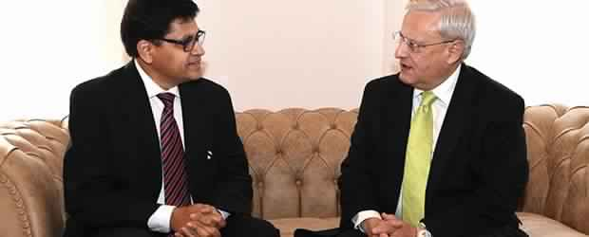

High Commissioner of India to Malta Azar A.H.Khan with Minister of Sustainable Development, Environment and Climate Change Leo Brincat

On January 17, 2015, High Commissioner Azar A. H. Khan, held discussions in Malta with the Minister of Sustainable Development, Environment and Climate Change Leo Brincat prior to Minister’s visit to New Delhi to participate in the 15th Delhi Sustainable Development Summit from February 5-7 February 2015.

