Embassy of India
Moscow

PRESS RELEASE

India Show in Moscow, 24-26 September 2014

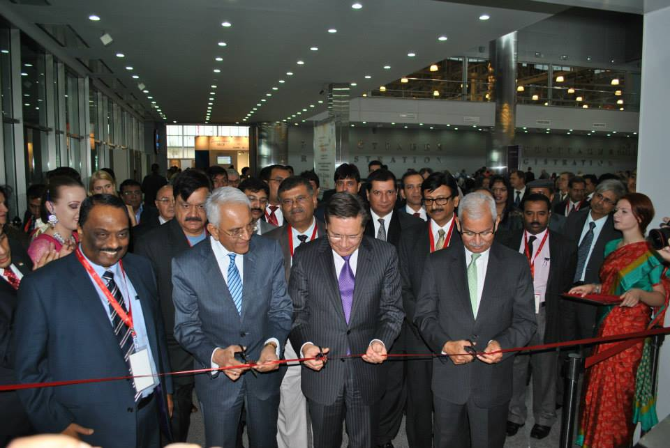

A multi-sector exhibition of Indian products and services was held from September 24 to 26 at the Crocus Expo Centre in Moscow. It was sponsored by the Department of Commerce of the Government of India, coordinated by the Federation of Indian Exporters’ Organization [FIEO] and featured over 100 Indian companies in pharmaceuticals, leather, engineering, chemicals, textile, apparels, agro-products and other sectors. It presented products of Indian industry and provided a platform for business-to-business interactions between Indian and Russian companies.

The exhibition was inaugurated on September 24 by Shri Rajeev Kher, Commerce Secretary of India, H.E. Mr. Alexey Likhachev, Deputy Minister of Economic Development of the Russian Federation and Shri P.S. Raghavan, Ambassador of India to the Russian Federation.

Parallel events were organized on the sidelines of the exhibition to draw attention to untapped potential in specific economic sectors and to bring together relevant Indian and Russian stakeholders to discuss strategies for greater cooperation in these sectors.

In a workshop on pharmaceuticals, manufacturers, regulators and medical practitioners of both countries discussed the opportunities that India’s modern pharmaceuticals industry provides for greater India-Russia cooperation in this sector, including in the context of Russia’s Pharma 2020 strategy.

A seminar on banking, investment and trade facilitation enabled information exchanges on banking facilities for bilateral trade and investment. A seminar on the Indian leather industry brought out India’s strengths in leather manufactures and their potential in the Russian market.

Two regions of Russia – Yaroslavl and Samara – brought high-level official and business delegations to India Show. They presented the opportunities for bilateral trade and investment exchanges thrown up by the economic developments in their regions. H.E. Mr. S.N. Yastrebov, Governor of Yaroslavl region and H.E. Mr. Alexander Kobenko, Deputy Head of Samara Region led their respective delegations.

The launch of the ‘Make in India’ campaign by the Prime Minister of India was featured in a special event organized by the Embassy at the Crocus Expo Centre on September 25. The Ambassador of India and the Director General of FIEO presented to an audience of Russian officials and companies, as well as the Indian business community in Russia, the unique opportunities for foreign entrepreneurs and investors provided by India’s manufacturing capacity, technical manpower strengths and R&D capabilities, now reinforced by enabling policies of the new Government in India.

********
September 27, 2014

