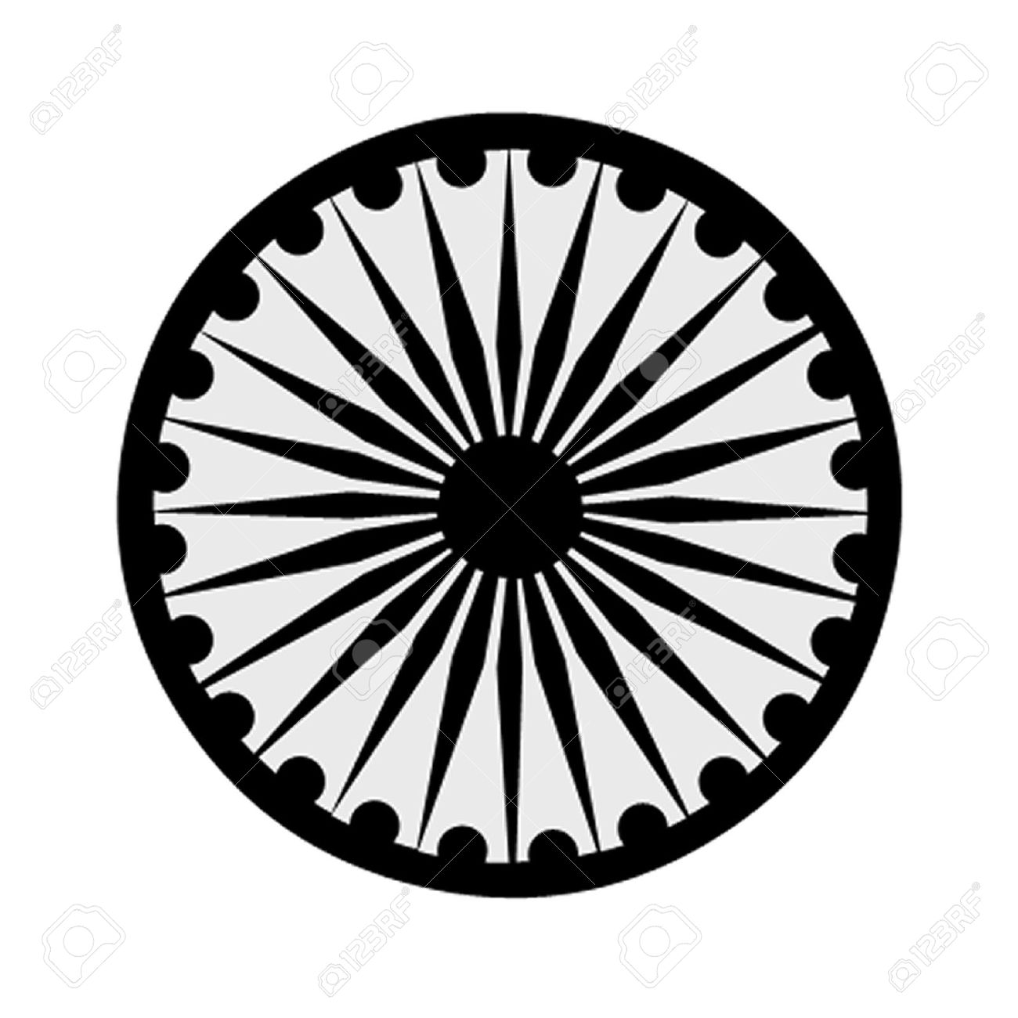 | HIGH COMMISSION OF INDIA, BRUNEI DARUSSALAM  P.O. BOX 439, LAPANGAN TERBANG LAMA  BANDAR SERI BEGAWAN BB 2339685  Telephone: 2339947 / 2339685  Fax: 2339783  E-mail: hoc.brunei@mea.gov.in  Website: www.hcindiabrunei.gov.in

Press Release
Celebrating India@75 – Bharat ka Amrit Mahotsav: Blood Donation Drive
by High Commission of India in collaboration with BSBIA
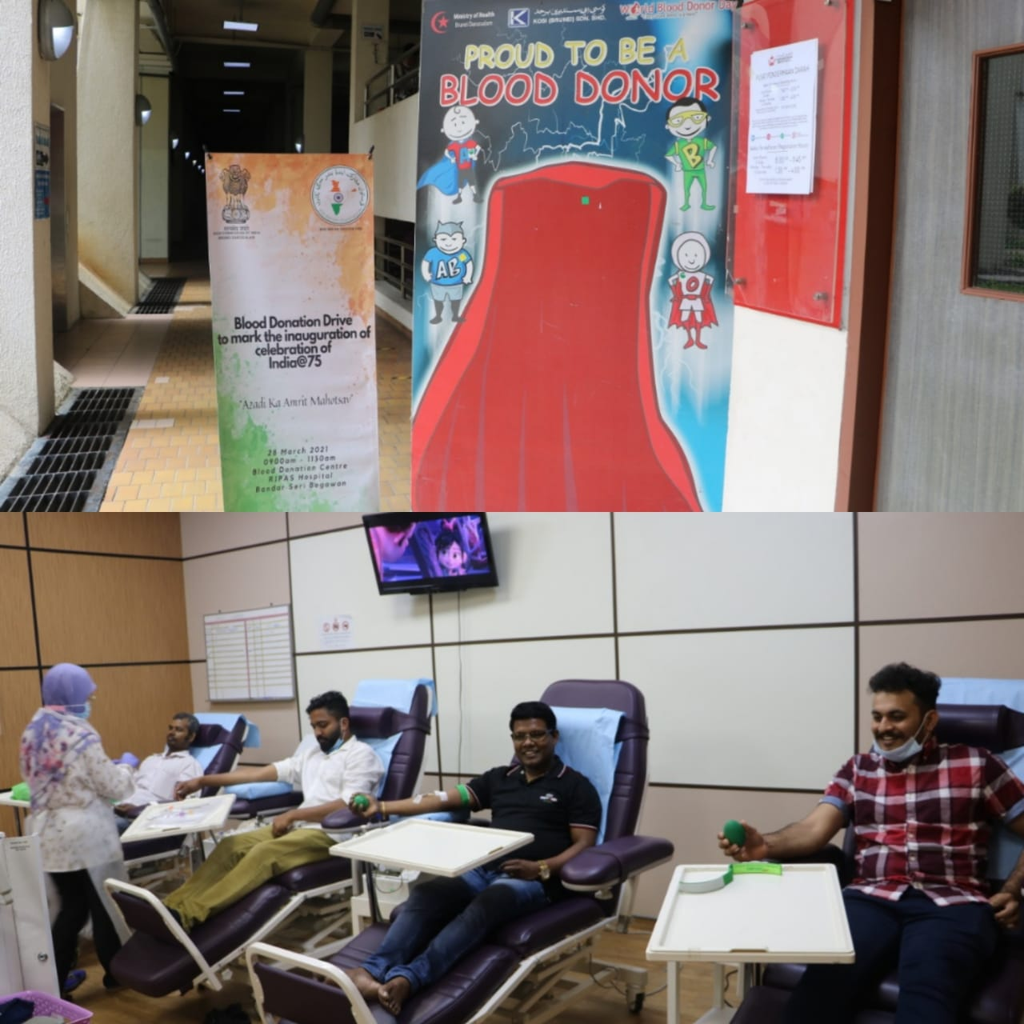

The High Commission of India in collaboration with the Bandar Seri Begawan Indian Association (BSBIA) organized a blood donation drive on 28 March 2021 at Raja Isteri Pengiran Anak Saleha (RIPAS) Hospital from 8:30 am till noon to launch the commemorative activity for the celebration of India@75 “Azadi ka Amrit Mahotsav.” 56 people of Indian origin including members of the High Commission donated blood to participate in the commemorative activity. The event also helped replenish blood reserves before the start of the fasting month of Ramadan.

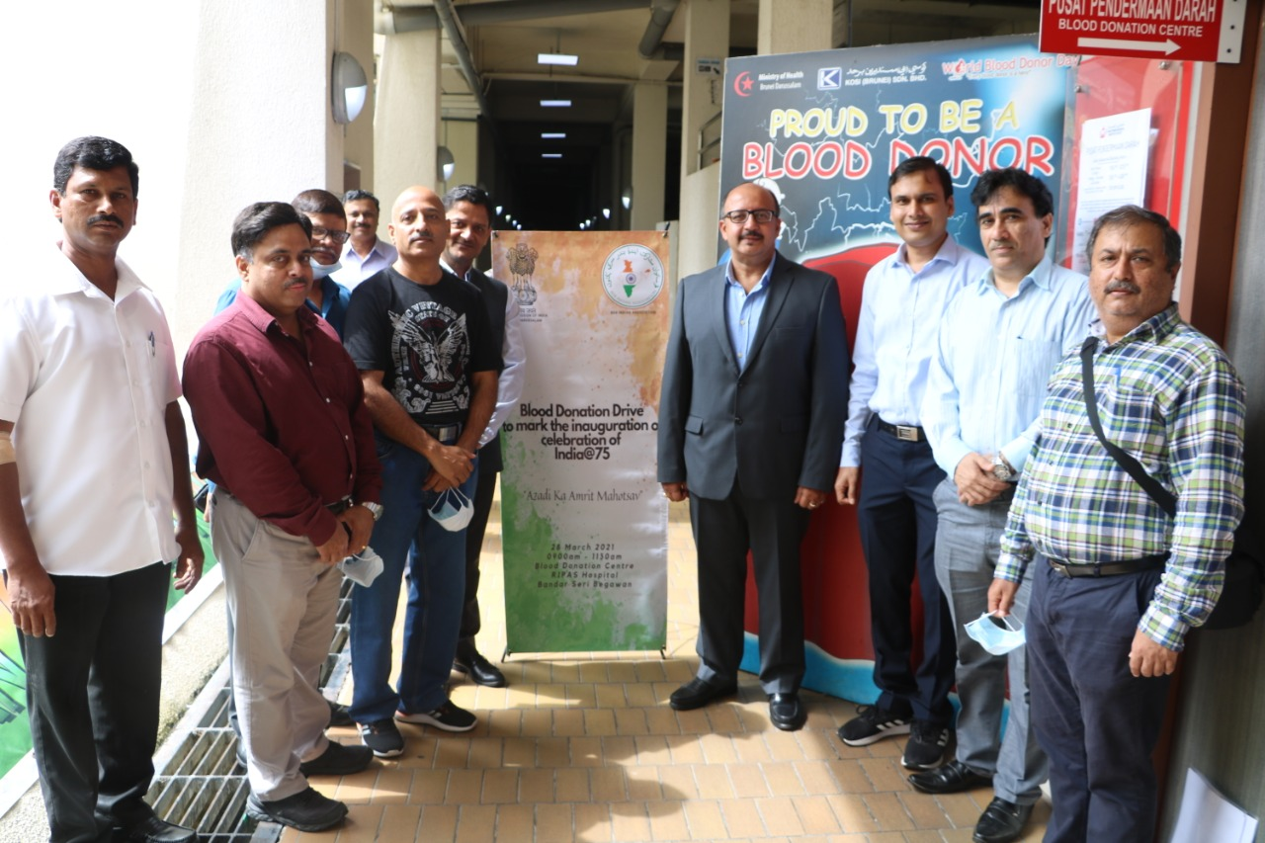

Hon’ble Prime Minister of India His Excellency Mr. Narendra Modi had launched “Azadi ka Amrit Mahotsav” on 12 March 2021 from Sabarmati Ashram, Ahmedabad, India. The Amrit Mahotsav is a series of cultural events and digital initiatives undertaken by the Government of India to commemorate the 75th anniversary of India’s independence. The Amrit Mahotsav has been launched exactly 75 weeks before the 75th anniversary of India’s independence, i.e. 15 August 2022, and will be celebrated till 15 August 2023. The celebration during the Amrit Mahotsav will be inspired by the five pillars of ‘Freedom Struggle’; ‘Achievements at 75’; ‘Ideas at 75’; ‘Actions at 75’; and ‘Resolves at 75’ as the guiding force.
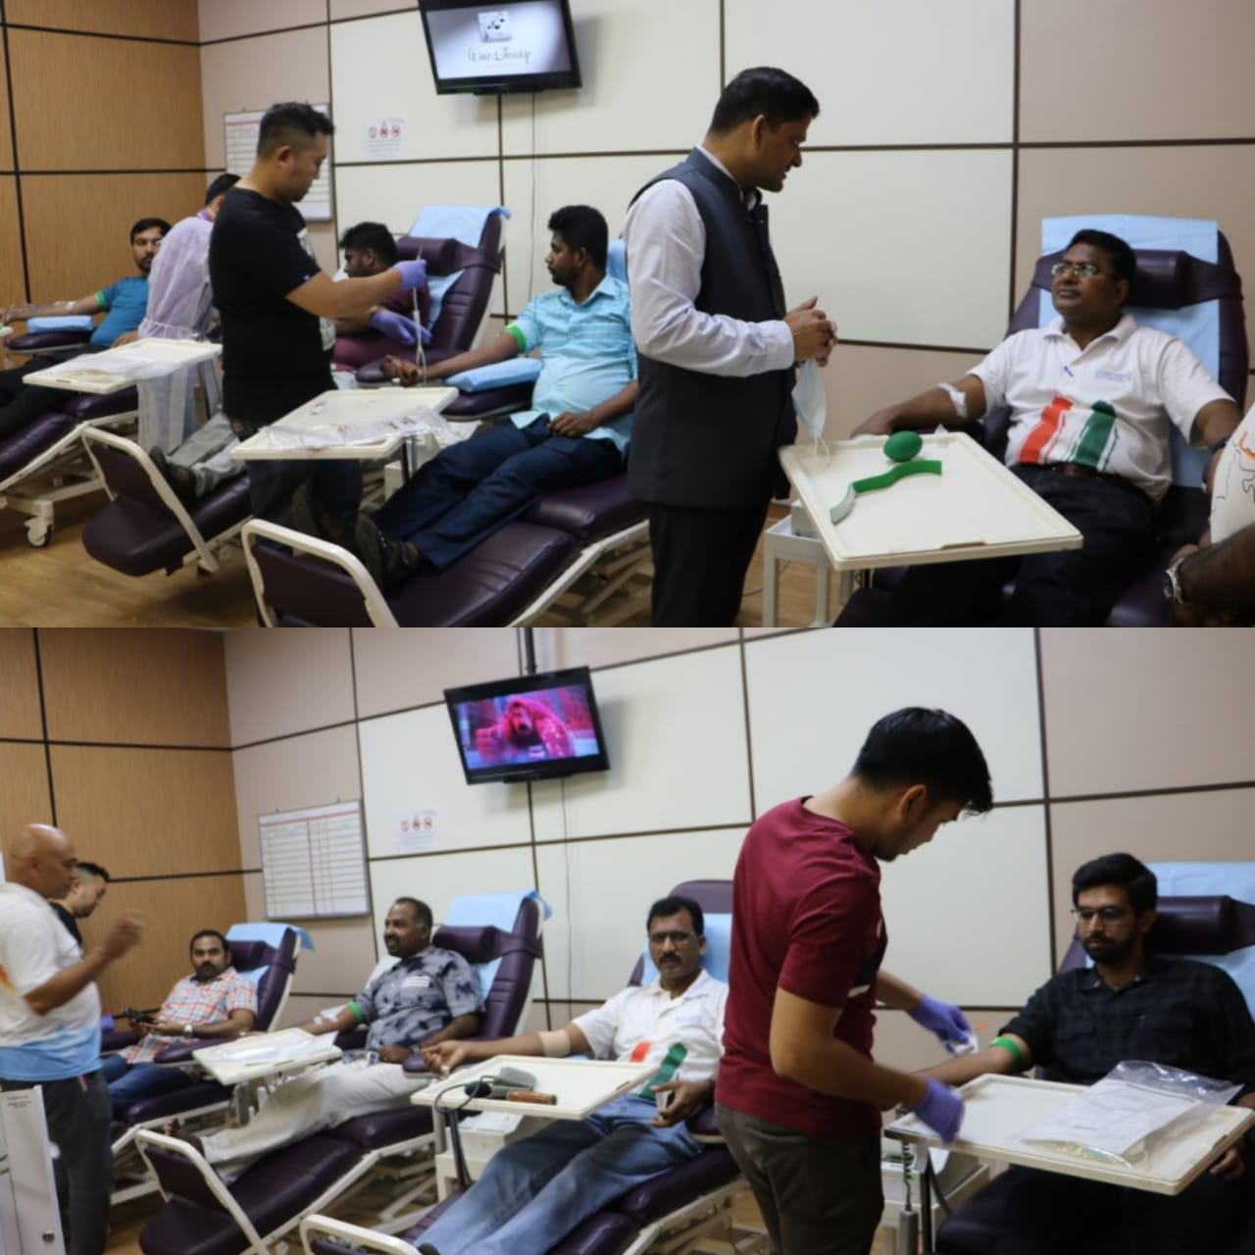

The event saw enthusiastic participation from the members of the community who came in large numbers to be a part of the celebration of India@75. High Commissioner Ajaneesh Kumar encouraged and urged the community to donate blood at regular intervals for the welfare of the society in the spirit of ‘Vasudev Kutumbkum - the world is one family,’ ethos enshrined in the Indian culture.
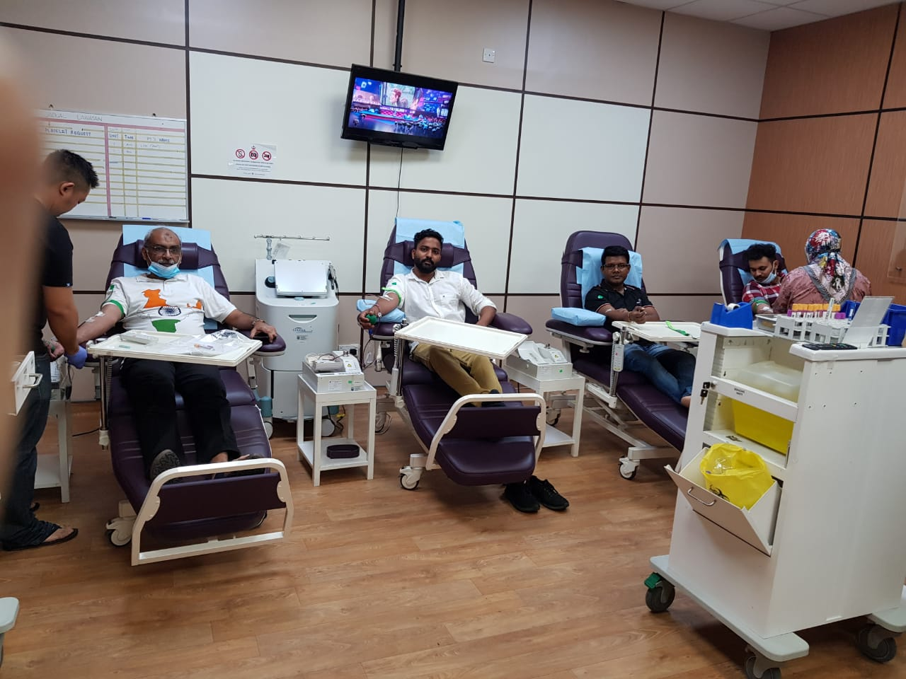

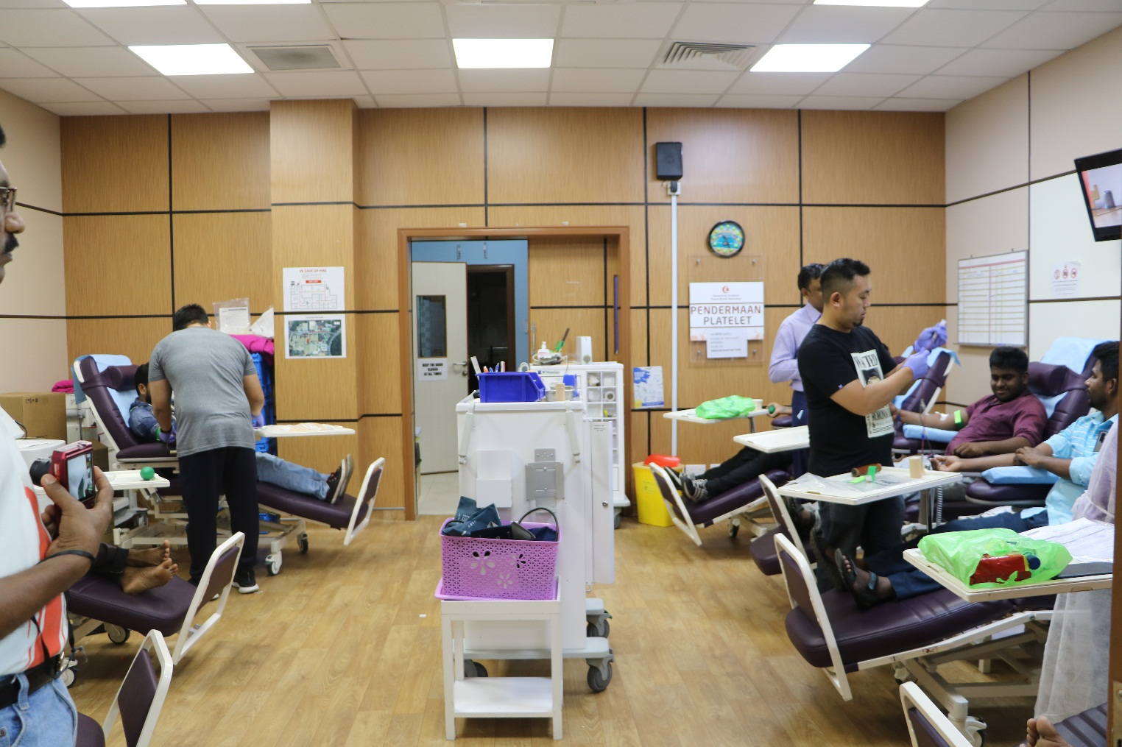

*******

Brunei Darussalam, 28 March 2021

