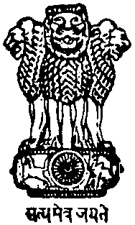
भारत का राजदूतावास, जिबूती
Embassy of India
Ambassade de l’Inde
HB2 Lootah Village Complex
Haramous
PO Box 1947, Djibouti
Tel : 21-25-0-31
Email: hoc.djibouti@mea.gov.in

Celebration of Pravasi Bharatiya Divas 2020
and Vishwa Hindi Diwas in Djibouti

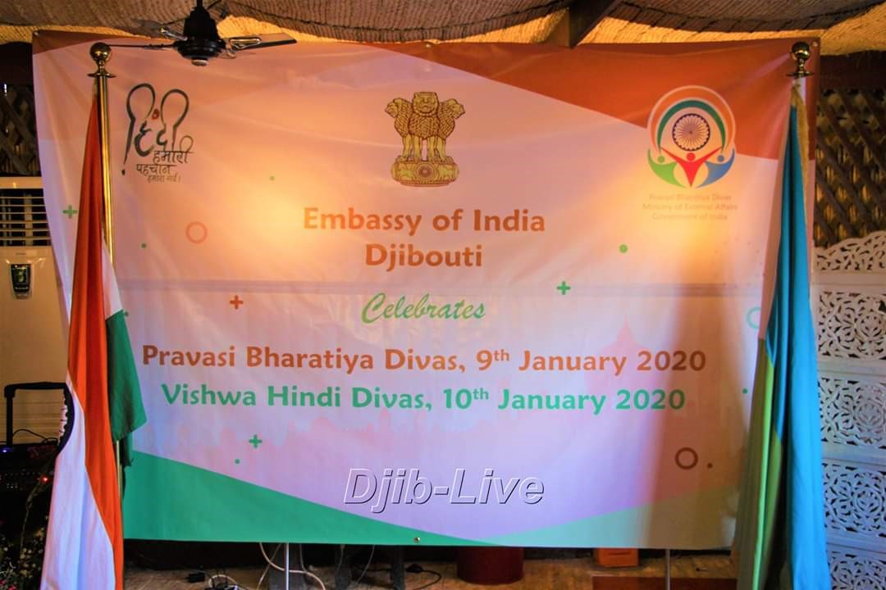

Pravasi Bharatiya Diwas 2020 and Vishwa Hindi Diwas were celebrated by Embassy of India, Djibouti on 9 January at Hotel Les Acacias, Djibouti.

The event took off with the live telecast of interaction of External Affairs Minister, Dr. S. Jaishankar with the Indian diaspora. A short film on Indian Diaspora across seven seas titled “Building Bridges Roots to Routes” was also screened.
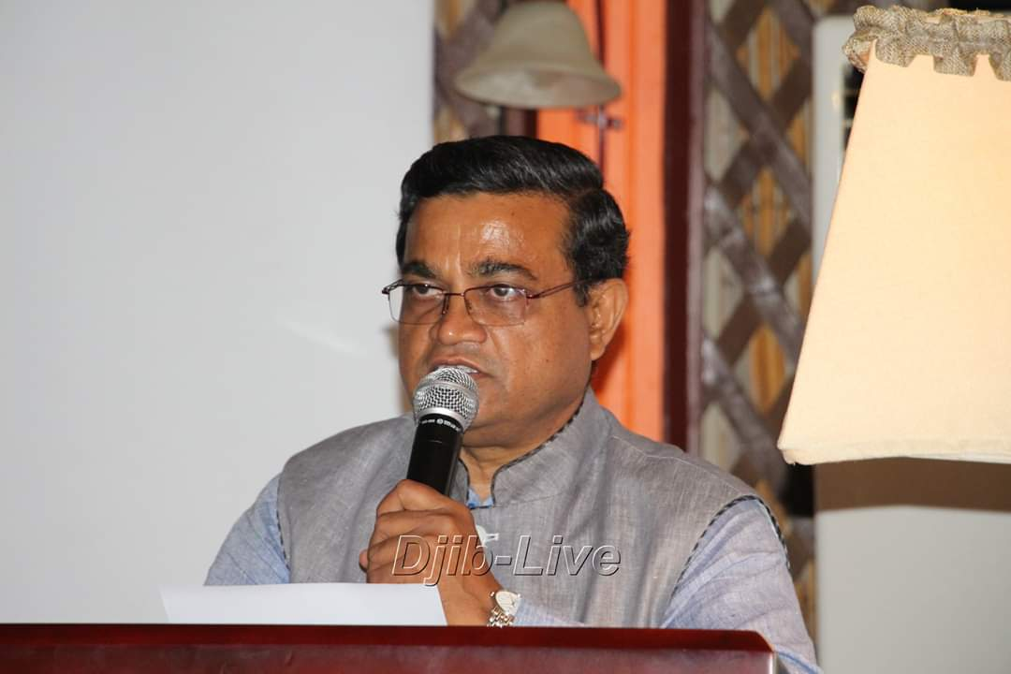

Thereafter, H.E. Shri Ashok Kumar, Ambassador of India Mr. Ashok Kumar the read Honorable Prime Minister’s Message on the occasion and briefed the guests about the Indian Diaspora Community and assured that the Indian Embassy in Djibouti welcomes any assistance and suggestions on behalf of the community. He also proposed to initiate Hindi classes at the Embassy with the help of a local volunteer.
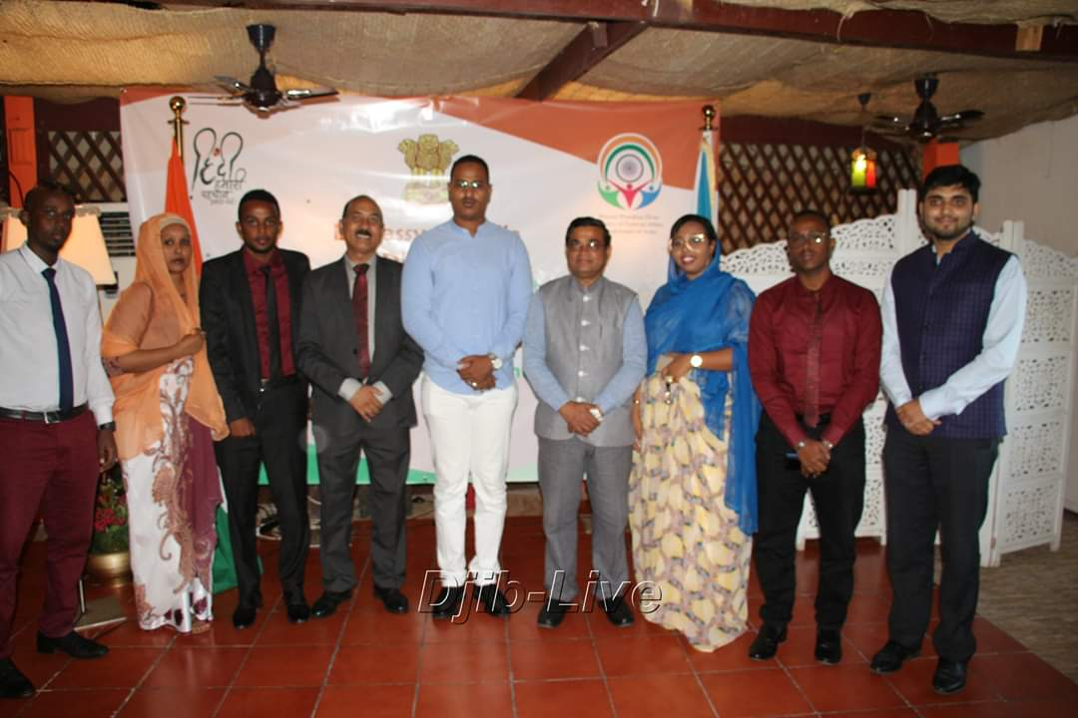
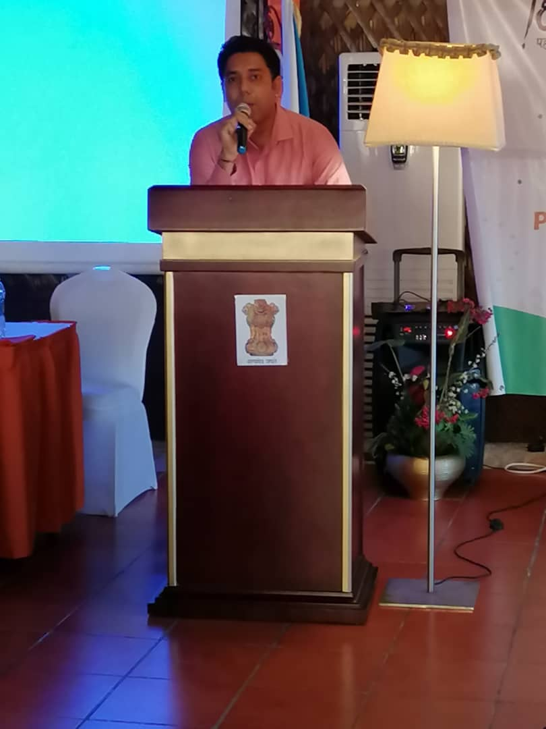

Members of Indian Community enthusiastically participated in the Vishwa Hindi Diwas and recited poems and read motivational passages.
Ambassador H.E. Mr. Ashok Kumar also felicitated the winners of the Quiz Competition on Dr. B. R. Ambedkar which was held in November 2019. An exhibition of Hindi Books was also organized. About 60 people including Indian nationals, PIOs, and friends of Djibouti participated in the event.
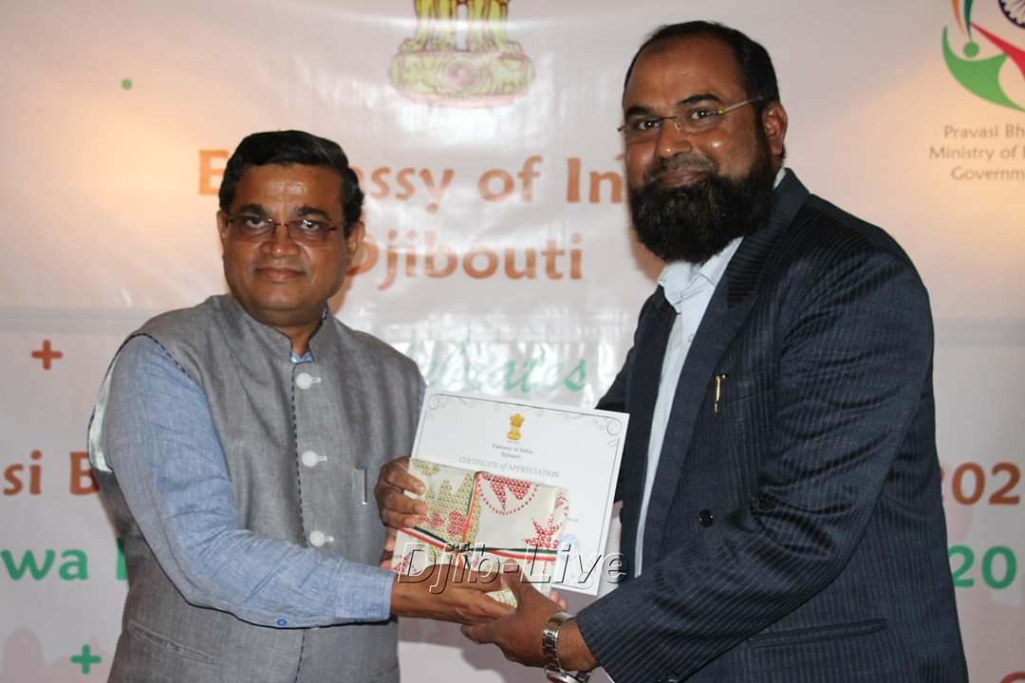 | 