EMBASSY OF INDIA
DJIBOUTI
PRESS RELEASE
Celebration of Constitution Day

The Mission organized an event to celebrate the Constitution Day on 01 December 2019 at Sheraton hotel. Mr. Abdo Sikeih Direih, member of the National Assembly of Djibouti and Mr. Ali Dini, President of the Bar Council of Djibouti were the Guest Of Honour. The eminent guests paid their homage to Dr. B.R. Ambedkar by offering floral petals. A documentary on Dr. Bhim Rao Ambedkar titled “Mooknayak” was screened to familiarize the audience with the eminent personality of Dr. Ambedkar and his contribution in the drafting of the Constitution as Chairman of the Drafting Committee.
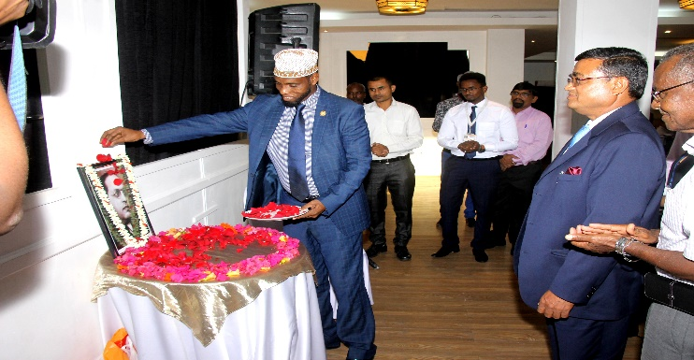
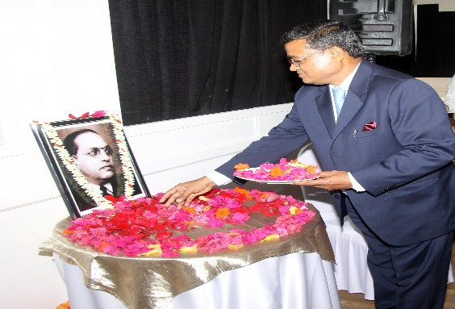
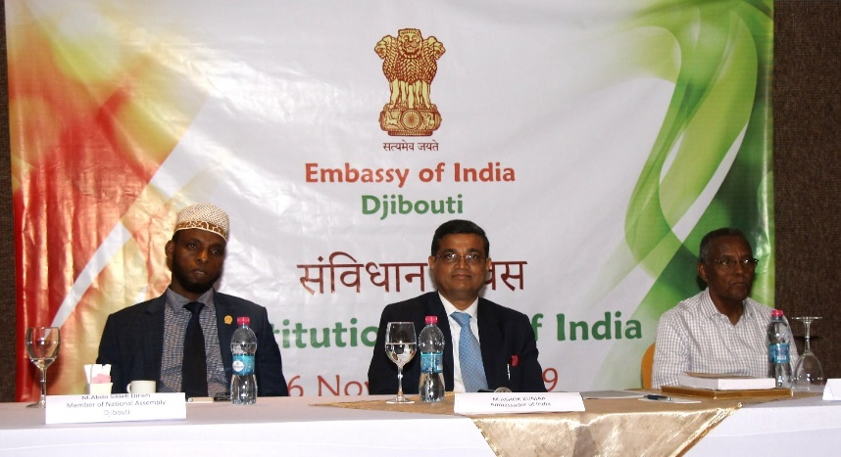

2. In his remarks, Mr. Ali Dini drew some comparisons between the Indian and Djiboutian Constitution and stressed on the importance of Rights enshrined in the Constitution.
3. Ambassador Mr. Ashok Kumar read the Preamble and recalled the social, economic and political contexts, which inspired the Constituent Assembly for the drafting of the constitution and striking a harmony and balance between the rights and duties enshrined in the Constitution of India. He pointed out that constitution is the bedrock for the governance of the country and urged people to have full faith in the Constitution and its values and remain guided by it.
5. Chief Guest of the function Mr. Abdo Sekieh Dirieh spoke on the India – Djibouti relations and acknowledged India’s support and contribution in building the relationship he also cherished the traditional friendship between the people of India and Djibouti. He emphasized the solid foundation laid by the Constituting of India for its governance, making it a model state in terms democracy and emerging economy.

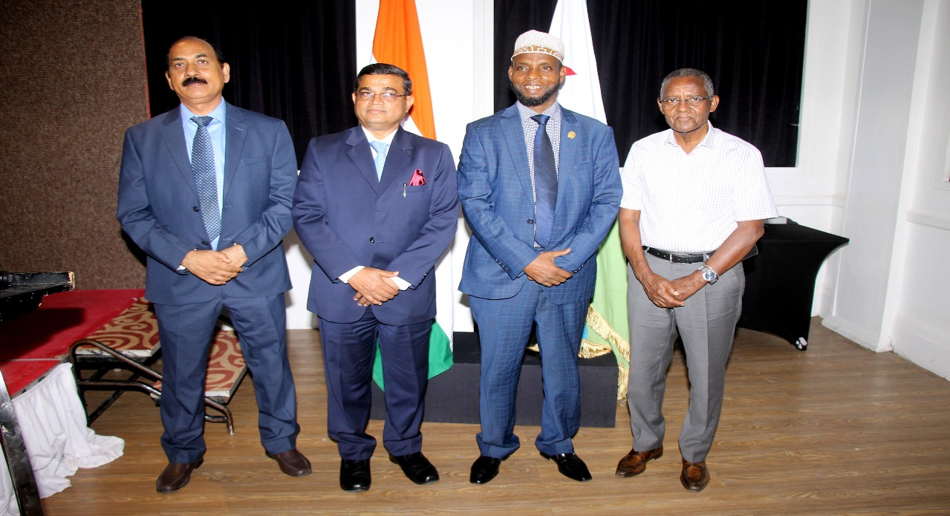

About 60 guests participated in the function, which comprised of members of Indian Community, Members of Bar Council, Lawyers, teachers and Government officials.
