Celebration of 5th International Day of Yoga in Abuja, Nigeria

The International Day of Yoga (IDY) 2019 was organized today, jointly by the Ministry of Youth and Sports Development of Nigeria and the High Commission of India, at the iconic venue of the Moshood Abiola National Stadium, Abuja. On this occasion, nearly 1500 yoga enthusiasts from all walks of life, Nigerian dignitaries and friends of India, children of Nigerian schools, members of the diplomatic corps and Indian Community participated in a yoga session based on the internationally accepted ‘Common Yoga Protocol’.

2. Dr. Ademola Are, Director, Grassroots Sports Development Department, Ministry of Youth and Sports Development, said that Yoga ‘united’ the people of India and Nigeria. Noting that the High Commission of India and the Government of Nigeria had joined hands to celebrate the IDY on a grand scale, he affirmed that henceforth the IDY will be held in a similar manner in Abuja as well as in various provinces of Nigeria. High Commissioner Shri Abhay Thakur said that Prime Minister of India Shri Narendra Modi, in his message to the President of Nigeria H.E. Mr. Muhammadu Buhari on the occasion of the 5th IDY, had brought out the importance of Yoga as a vehicle to promote international peace and harmony.

3. On the occasion, a ‘Yoga Photo Exhibition’ of Nigerians performing Yoga Asanas was displayed at the National Stadium, and artefacts from various states of India were exhibited.

*****

15 June 2019

Photographs of the 5th International Day of Yoga, Abuja

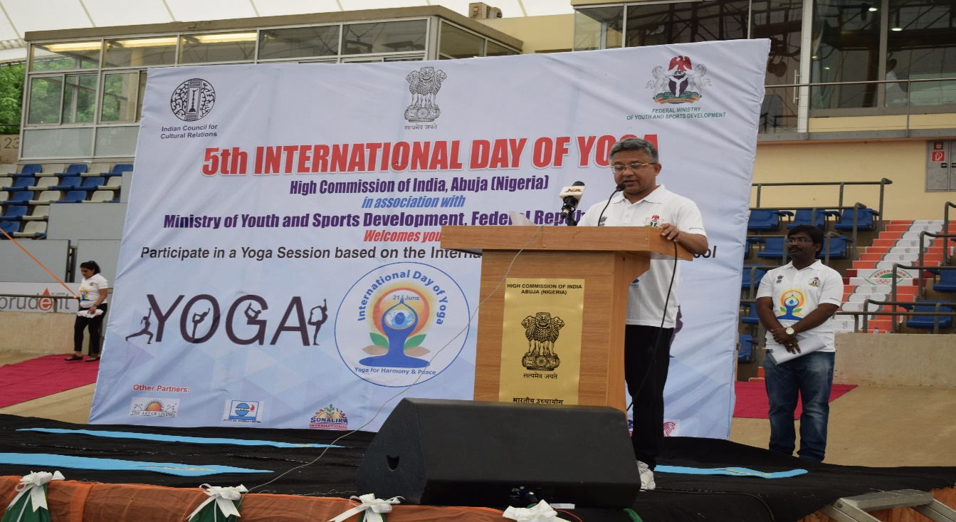
High Commissioner Shri Abhay Thakur addressed the audience on 5th International Day of Yoga

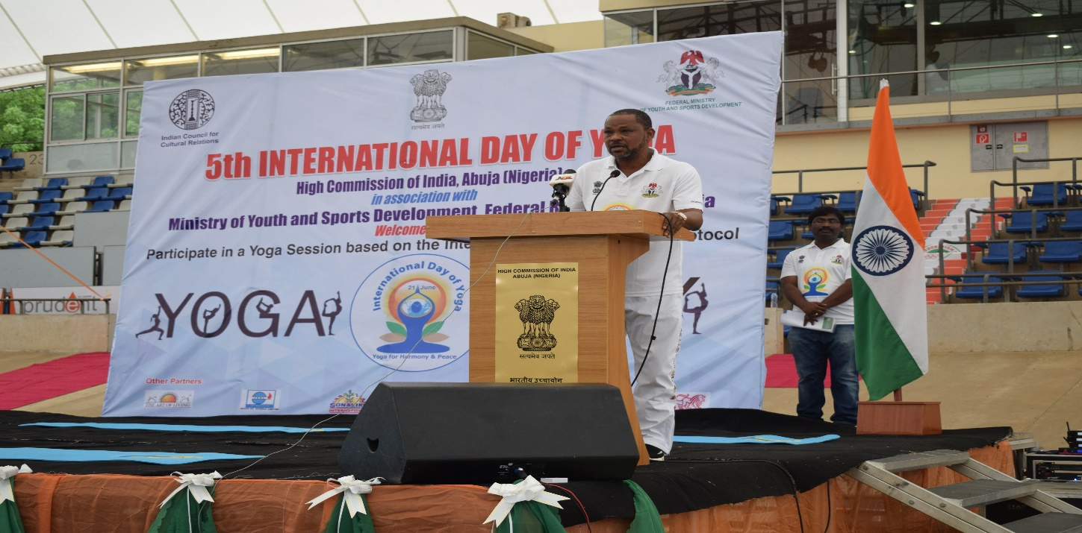
Dr. Ademola Are, Director, Grassroots Sports Development Department, spoke about the importance of Yoga and how Yoga is ‘uniting’ the people of India and Nigeria
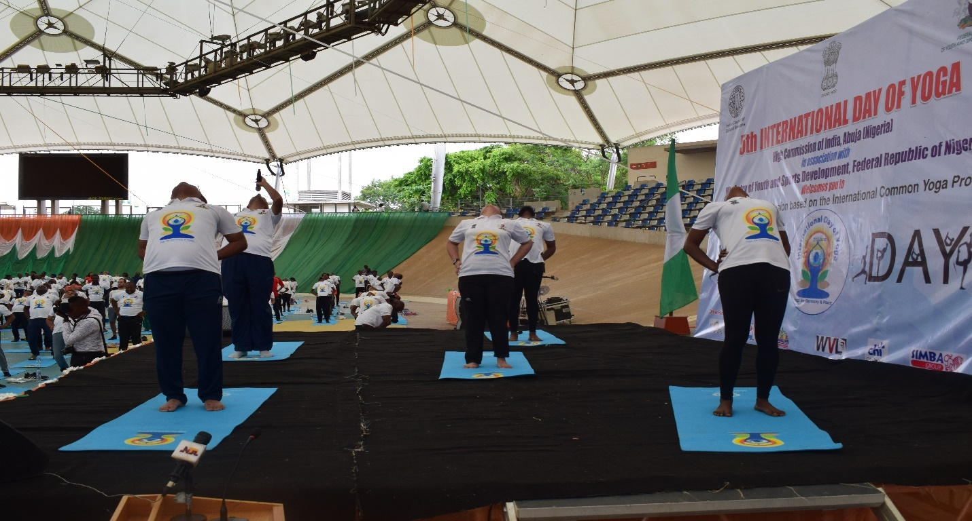
Shri Alok Chandra Ranjan, Teacher of Indian Culture and Shri Akshay Jain from Art of Living Foundation Nigeria, and other Yoga guides demonstrating the ‘Common Yoga Protocol’

Ambassador of Japan H.E. Mr. Kikuta among the members f the diplomatic corps on the IDY

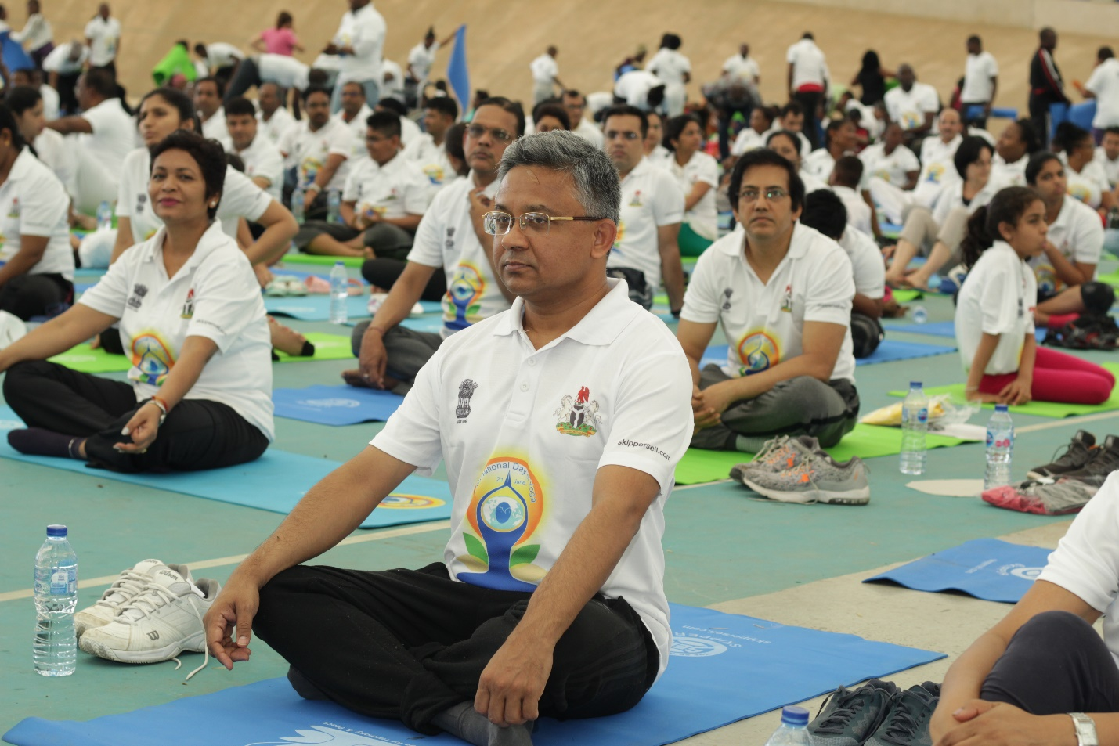
High Commissioner Abhay Thakur and members of the Indian Community in Abuja at the Yoga session

Dr. Ademola Are, Director, Grassroots Sports Development Department,Federal Ministry of Youth and Sports Development, and Nigerian friends of India performing Yoga during the event

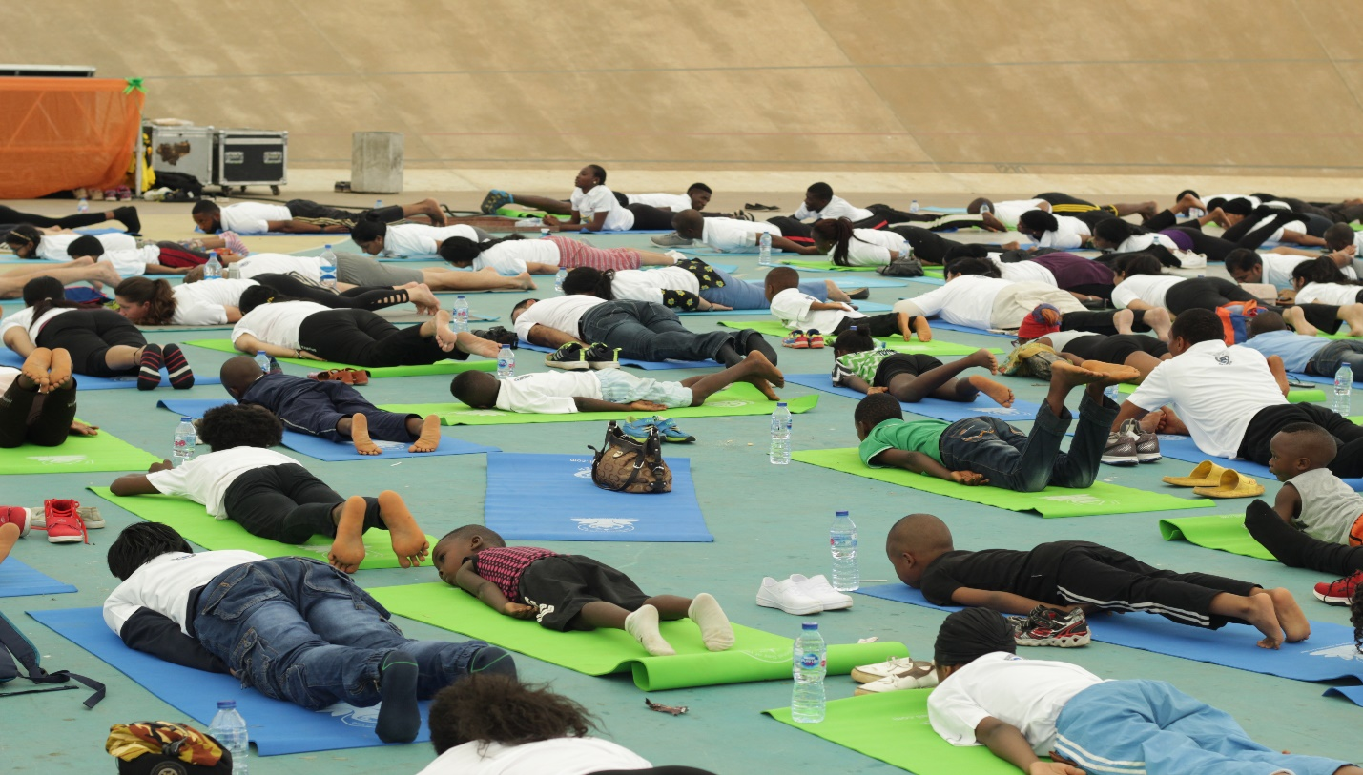
Children from various Nigerian schools participated in large numbers and performed Yoga

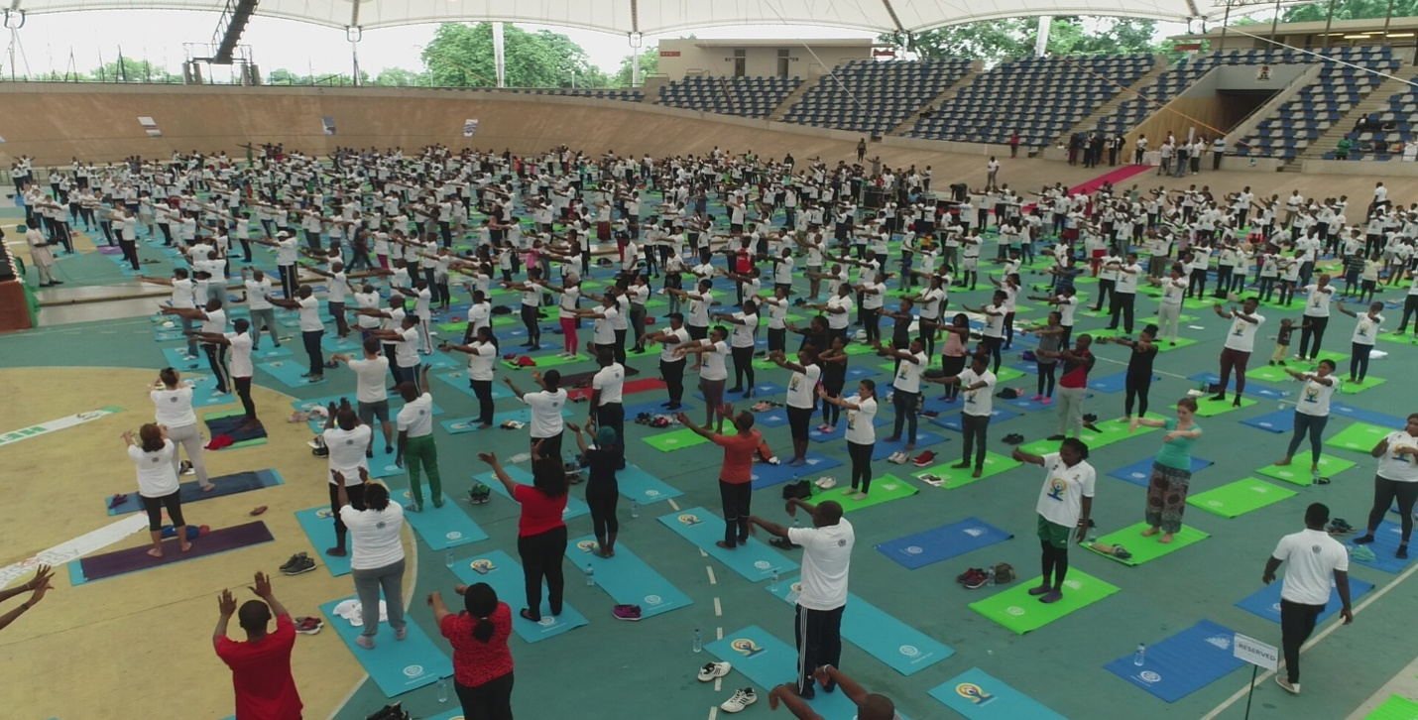
Huge turnout at the 5th IDY at the Velodrome, Moshood Abiola National Stadium, Abuja
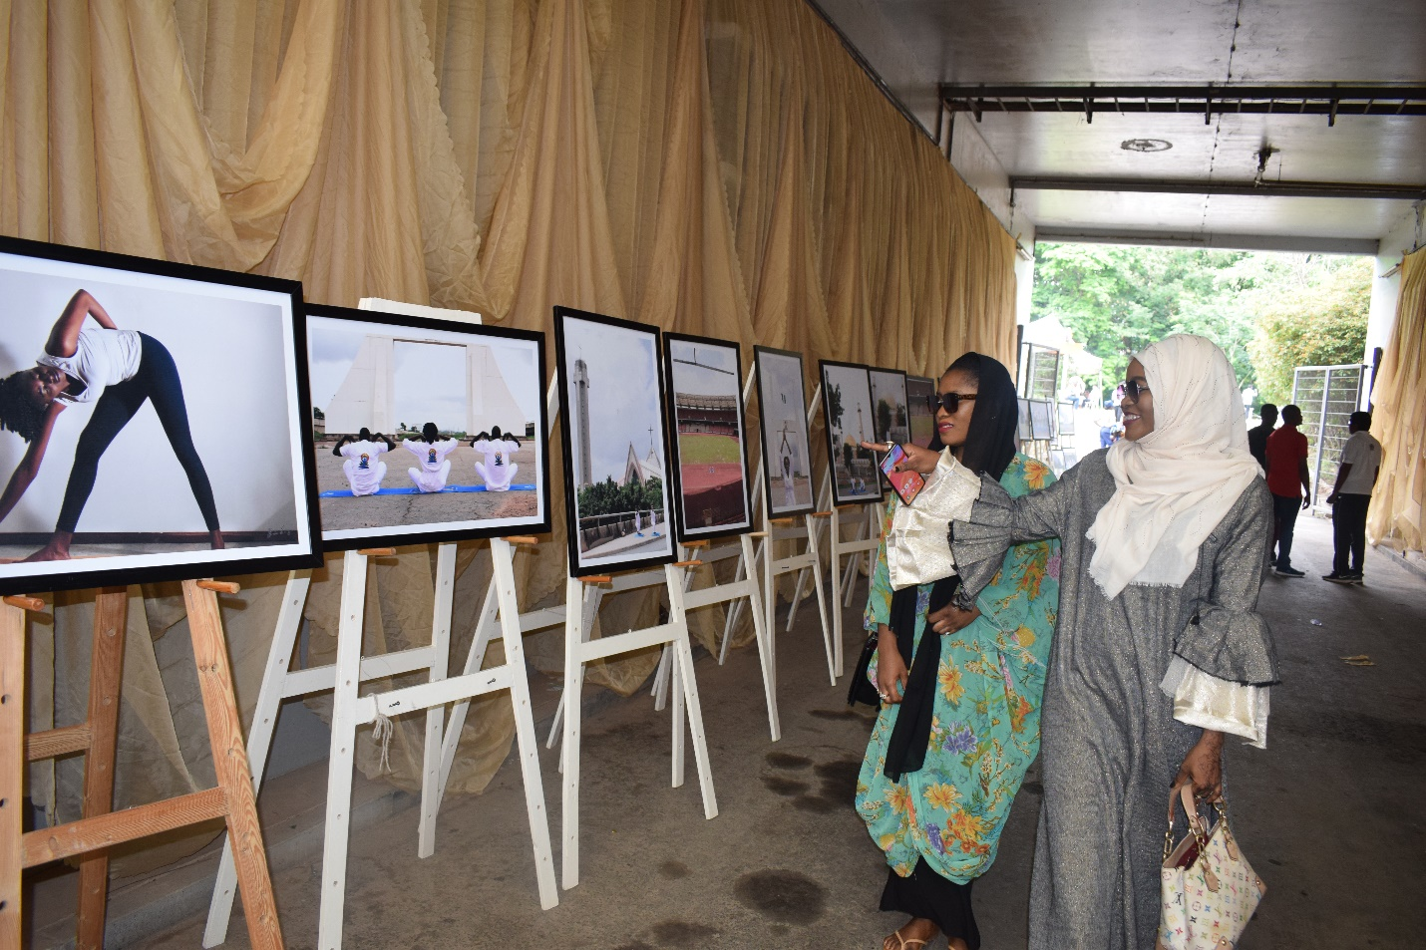
‘Yoga Photo Exhibition’ on display at the National Stadium

*****

15 June 2019

