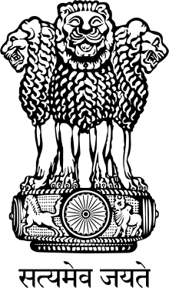

High Commission of India
Kampala

PRESS RELEASE

GIFT OF MEDICINES BY GOVERNMENT OF INDIA TO GOVERNMENT OF UGANDA
Following the official visit to Uganda by Shri Narendra Modi, Prime Minister of India in July last year, Government of India has gifted medicines worth US$ 1.4 million to the Government of Uganda. Eleven containers containing 57 different medicines have been received by the Ugandan Government. The medicines were handed over by Shri Ravi Shankar, High Commissioner of India to Uganda to Dr. Jane Ruth Aceng, Minister of Health, Uganda at the National Medical Stores in Entebbe on 23 January at a ceremony organized by the Ugandan side. The medicines will be distributed by the National Medical Stores to the network of Government-run hospitals across Uganda. In her remarks, the Minister of Health conveyed the appreciation of Government of Uganda for this valuable gift which will go a long way in supporting the treatment of Ugandan people for a variety of ailments.

The gift of medicines to Government of Uganda is a testimony to our commitment to supporting Uganda and Africa in humanitarian assistance, capacity-building and economic development.
********
