Embassy of India
Muscat
*****

PRESS RELEASE

INDIAN COAST GUARD SHIP VIKRAM GOODWILL VISIT TO MUSCAT

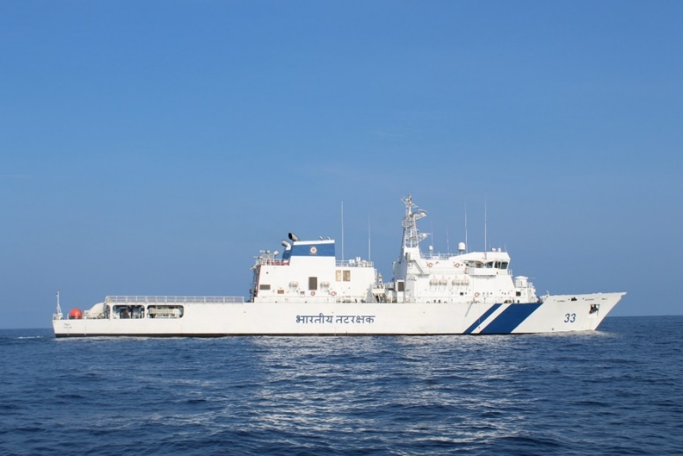
Indian Coast Guard ship (ICGS) Vikram is scheduled to enter Muscat, Oman on Wednesday, 26 December 2018, on a three-day goodwill visit. The visit is aimed at enhancing interactions and cooperation between the Indian Coast Guard (ICG) and Royal Oman Police Coast Guard (ROPCG).

2. ICGS Vikram (“Vikram” means ‘Valorous”), the 1st in the series of 98 meters Offshore Patrol Vessel (OPV) is a newly commissioned ship of Indian Coast Guard. The ship has a compliment of approximately 100 personnel and is commanded by Commandant Raj Kamal Sinha.

3. ICGS Vikram has been designed and built in India by M/s Larsen & Toubro at its Defence shipyard at Kattupalli. The ship is fitted with most advanced state-of-the-art technology, navigation and communication equipment, sensor and machinery. The vessel is fitted with a 30mm gun for the fighting efficiency of the ship. The features include an Integrated Bridge System (IBS), Integrated Platform Management System (IPMS), Automated Power Management System (APMS) and High-Power External firefighting system. ICGS Vikram class OPVs are long-range surface ships which operate in Indian maritime zones including island territories. Their role is to conduct coastal and offshore patrolling, policing maritime zones, Search and Rescue, surveillance, anti-smuggling and anti-piracy operations with limited wartime roles. The ship is designed to carry one twin engine helicopter and two high speed boats along with two hull inflatable boats. The ship is also capable of carrying limited pollution response equipment to contain oil spill at sea.

4. The ship is on a month long deployment in the GCC which has resulted in the build-up of mutual understanding and comradery amongst Coast Guards of the region. Oman and Indian Coast Guards signed a Memorandum of Understanding on Maritime Crime Prevention at Sea in May 2016 and regularly conduct high level meetings. The next high level meeting is scheduled in India in late 2019. During the three day visit to Muscat, the ship’s crew will utilise the opportunity to undertake various maritime related joint training activities with ROPCG focussing on Marine Pollution Response, Maritime Search & Rescue and Maritime Law enforcement. The close relations developed between the ROGCP and ICG has been very beneficial in coordination of search and rescue efforts in the Arabian Sea.

*****
Muscat, 24th December 2018

