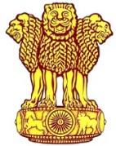 | Embassy of India  Ashgabat | 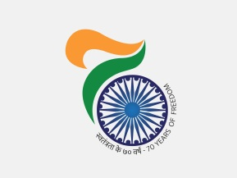

Transit halt of Hon’ble EAM at Ashgabat on September 13, 2018

Hon’ble External Affairs Minister H. E Smt. Sushma Swaraj made a transit halt in Ashgabat on Sept 13, 2018 while on her way to chair the 23rd meeting of the Inter-Governmental Commission on Technical & Economic Cooperation in Moscow. She was accompanied by Shri Vijay Gokhale, Foreign Secretary and other members of the delegation

She was received at the airport by H. E. Mr. Rashid Meredov Deputy Prime Minister & Foreign Minister of Turkmenistan & Ambassador H. E Mr. Azar A H Khan. During the transit halt the two Ministers held bilateral meeting and discussed matters of mutual interest and the way to further enhance and intensify these relations.

***
Ashgabat, Sept 13, 2018

